Summer 2
Reception Writing Tasks

Dear Parents/Carers,

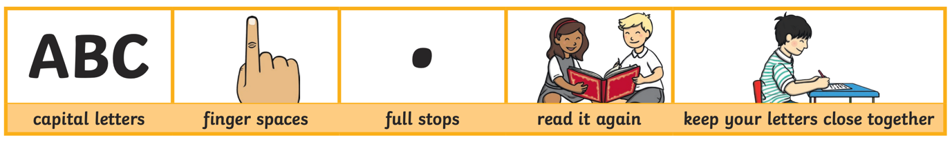
Your child will be expected to complete one writing tasks each day. Please ensure your child is writing in full sentences independently.

Encourage your child to use the above key when writing their sentences.

Success Criteria:
Has your child used capital letters?
Has your child used finger spaces after each word?
Has your child used a full stop at the end of their sentence?
Can your child read what they have written, and does it make sense?
Has your child made sure they have written their letters correctly in a way that can be understood and read by others?

Monday 29th June 2020

Can you use your sounds to label the pictures?
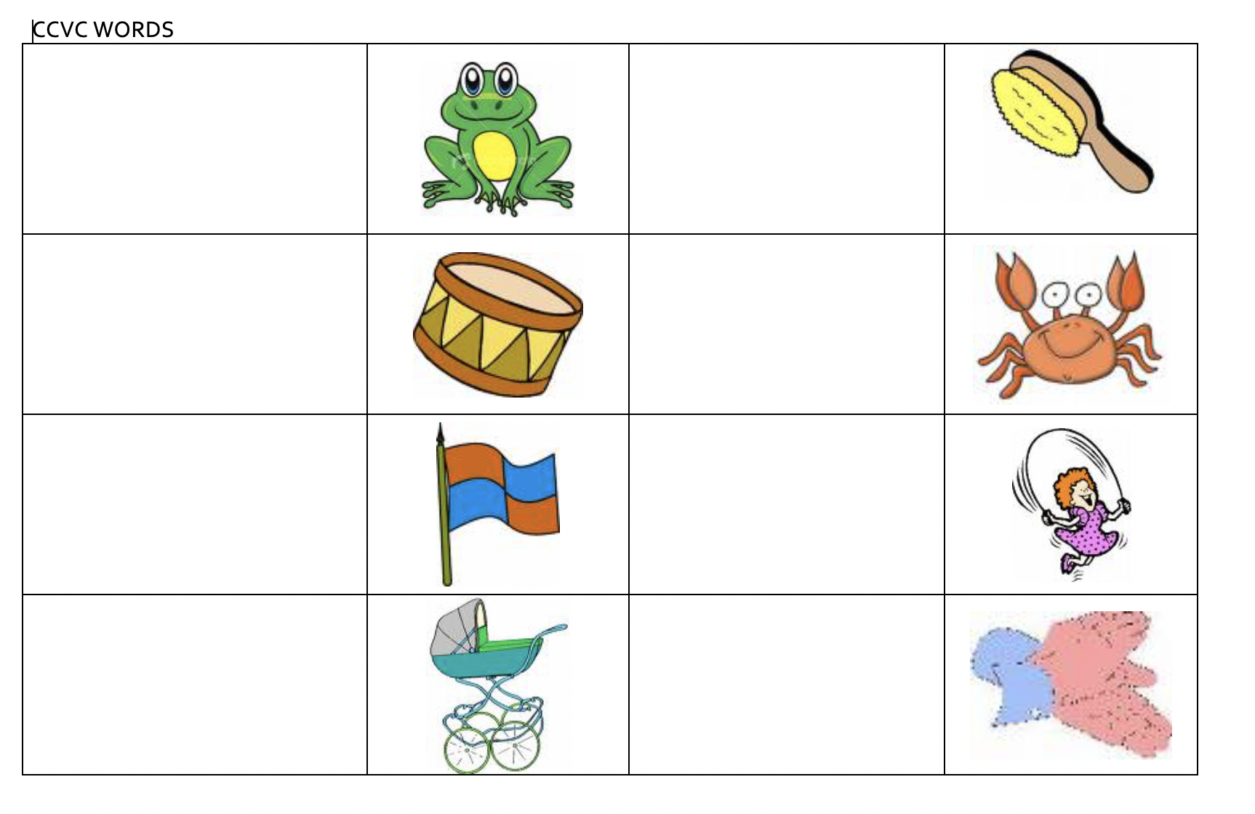

Tuesday 30th June 2020
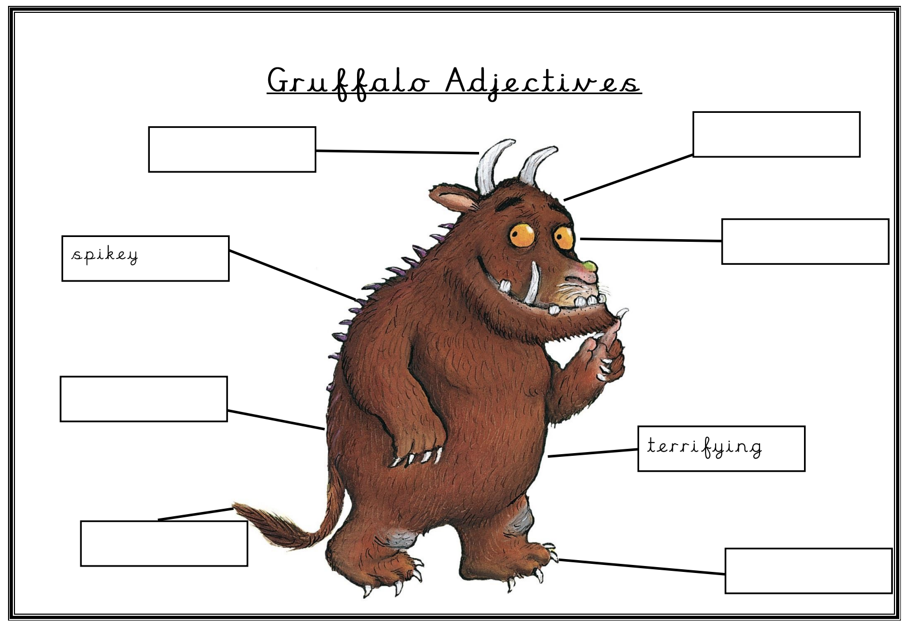

Wednesday 1st July 2020
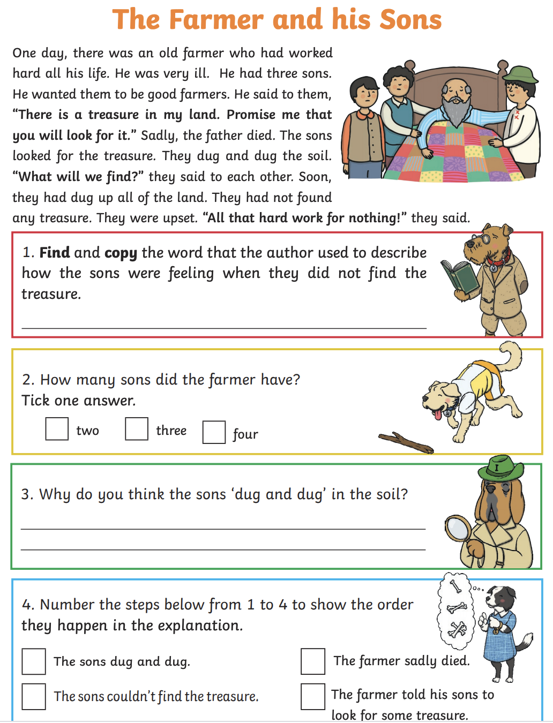

Thursday 2nd July 2020
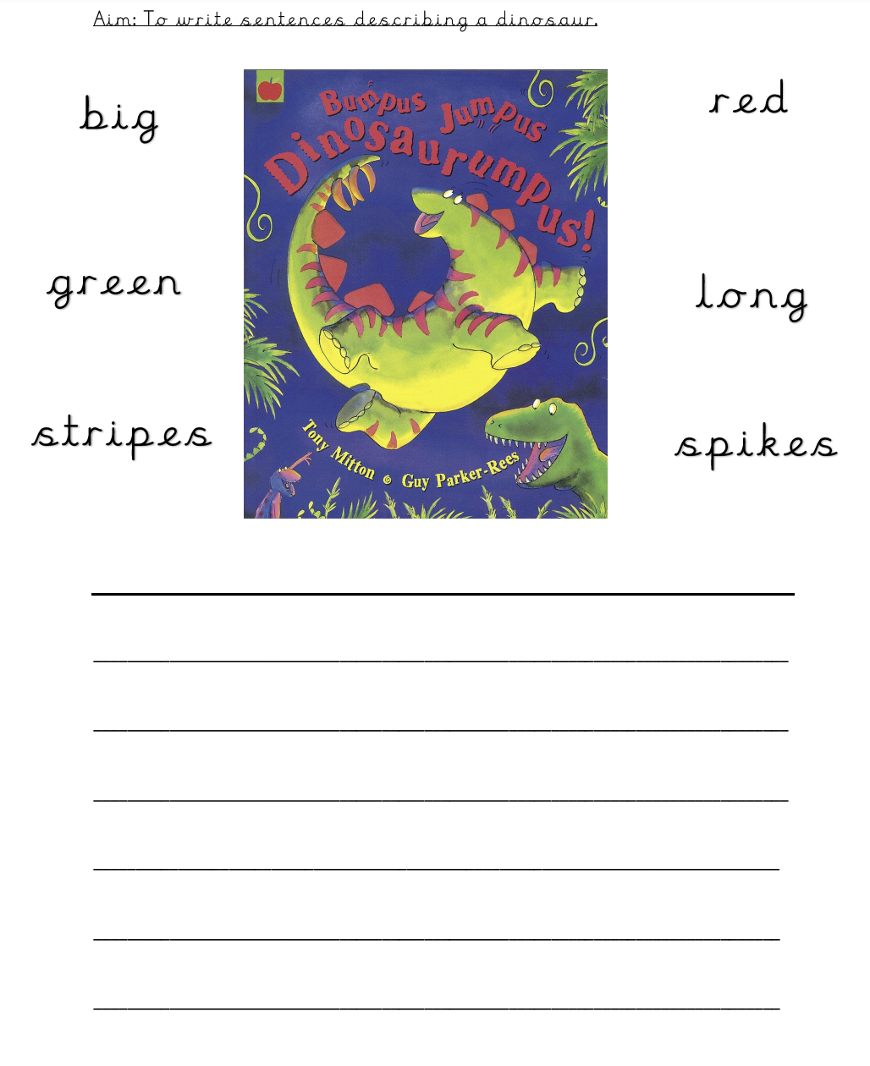

Friday 3rd July 2020

Think of one of your favourite stories and create a storyboard for your chosen story. Draw pictures in the box and write what is happening in each picture on the lines.

