Summer 2
Rec Maths

Notes for parents
(Remember gold prizes from me for neat outstanding work)

If you do not have access to a printer, provide your child with an exercise book to do their work in.

- Write the short date (today's date)
- Write the L.O:
- Miss a line
- Question numbers in the margin and write answers on the line.

(I will be asking your parents if your work looks neat and to send me a picture of your amazing work. I myself will check your work once you come back to school in sha Allah)

Monday 28th June 2020

Write the following numbers in words.
1
6
4
10
3

1
6
4
10
3
8
2
5
9
7

Tuesday 29th June 2020
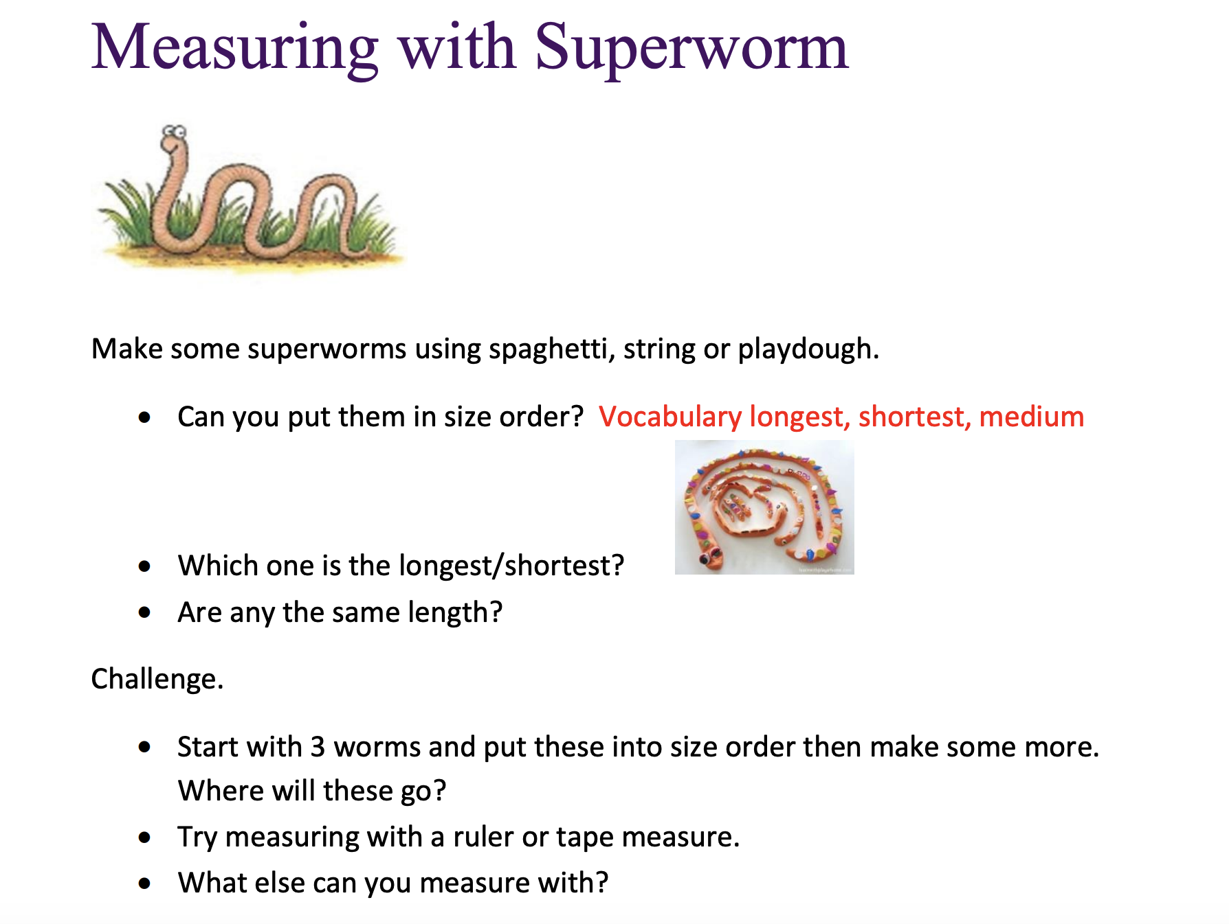

Wednesday 30th June 2020

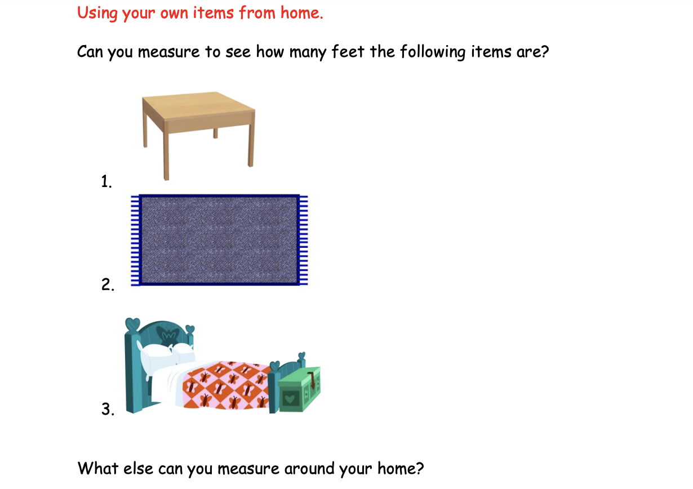

Thursday 2nd July 2020

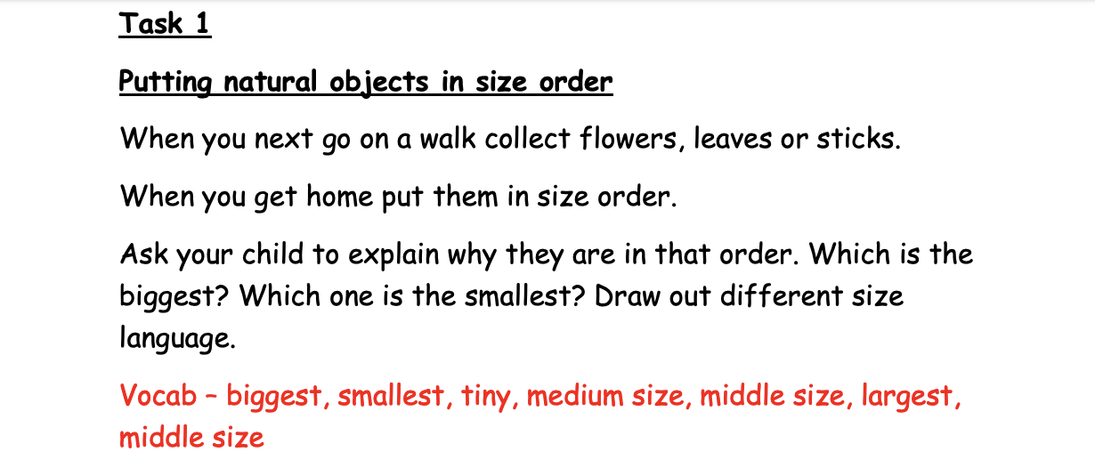

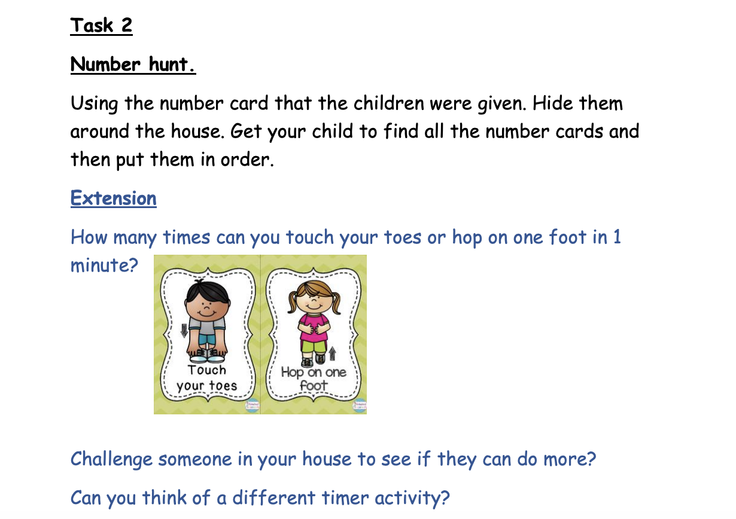

Friday 3rd July 2020
