Week 6 Reception Handwriting

Encourage your child to practice writing a letter a day in their neatest handwriting. Once your child has completed each letter, get your child to practise writing the following words below using cursive handwriting.

Monday 22nd June 2020
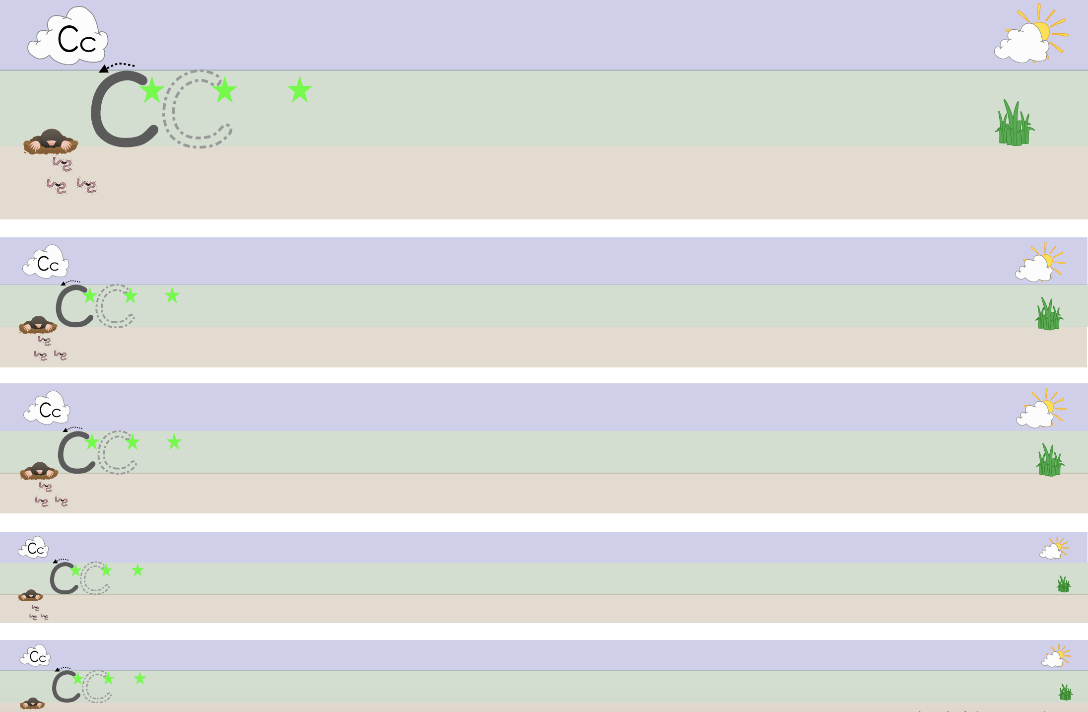

cat, can, cot, cup
Tuesday 23rd June 2020

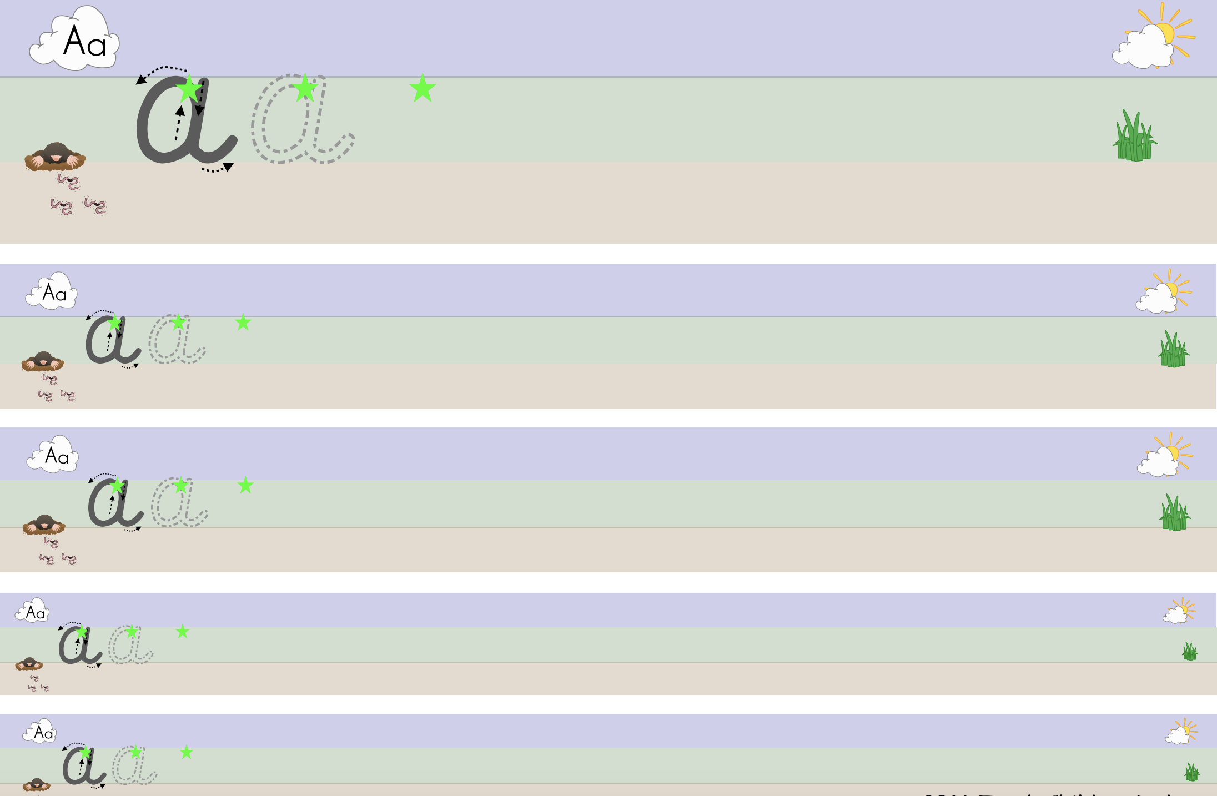

at, an, am

Wednesday 24th June 2020

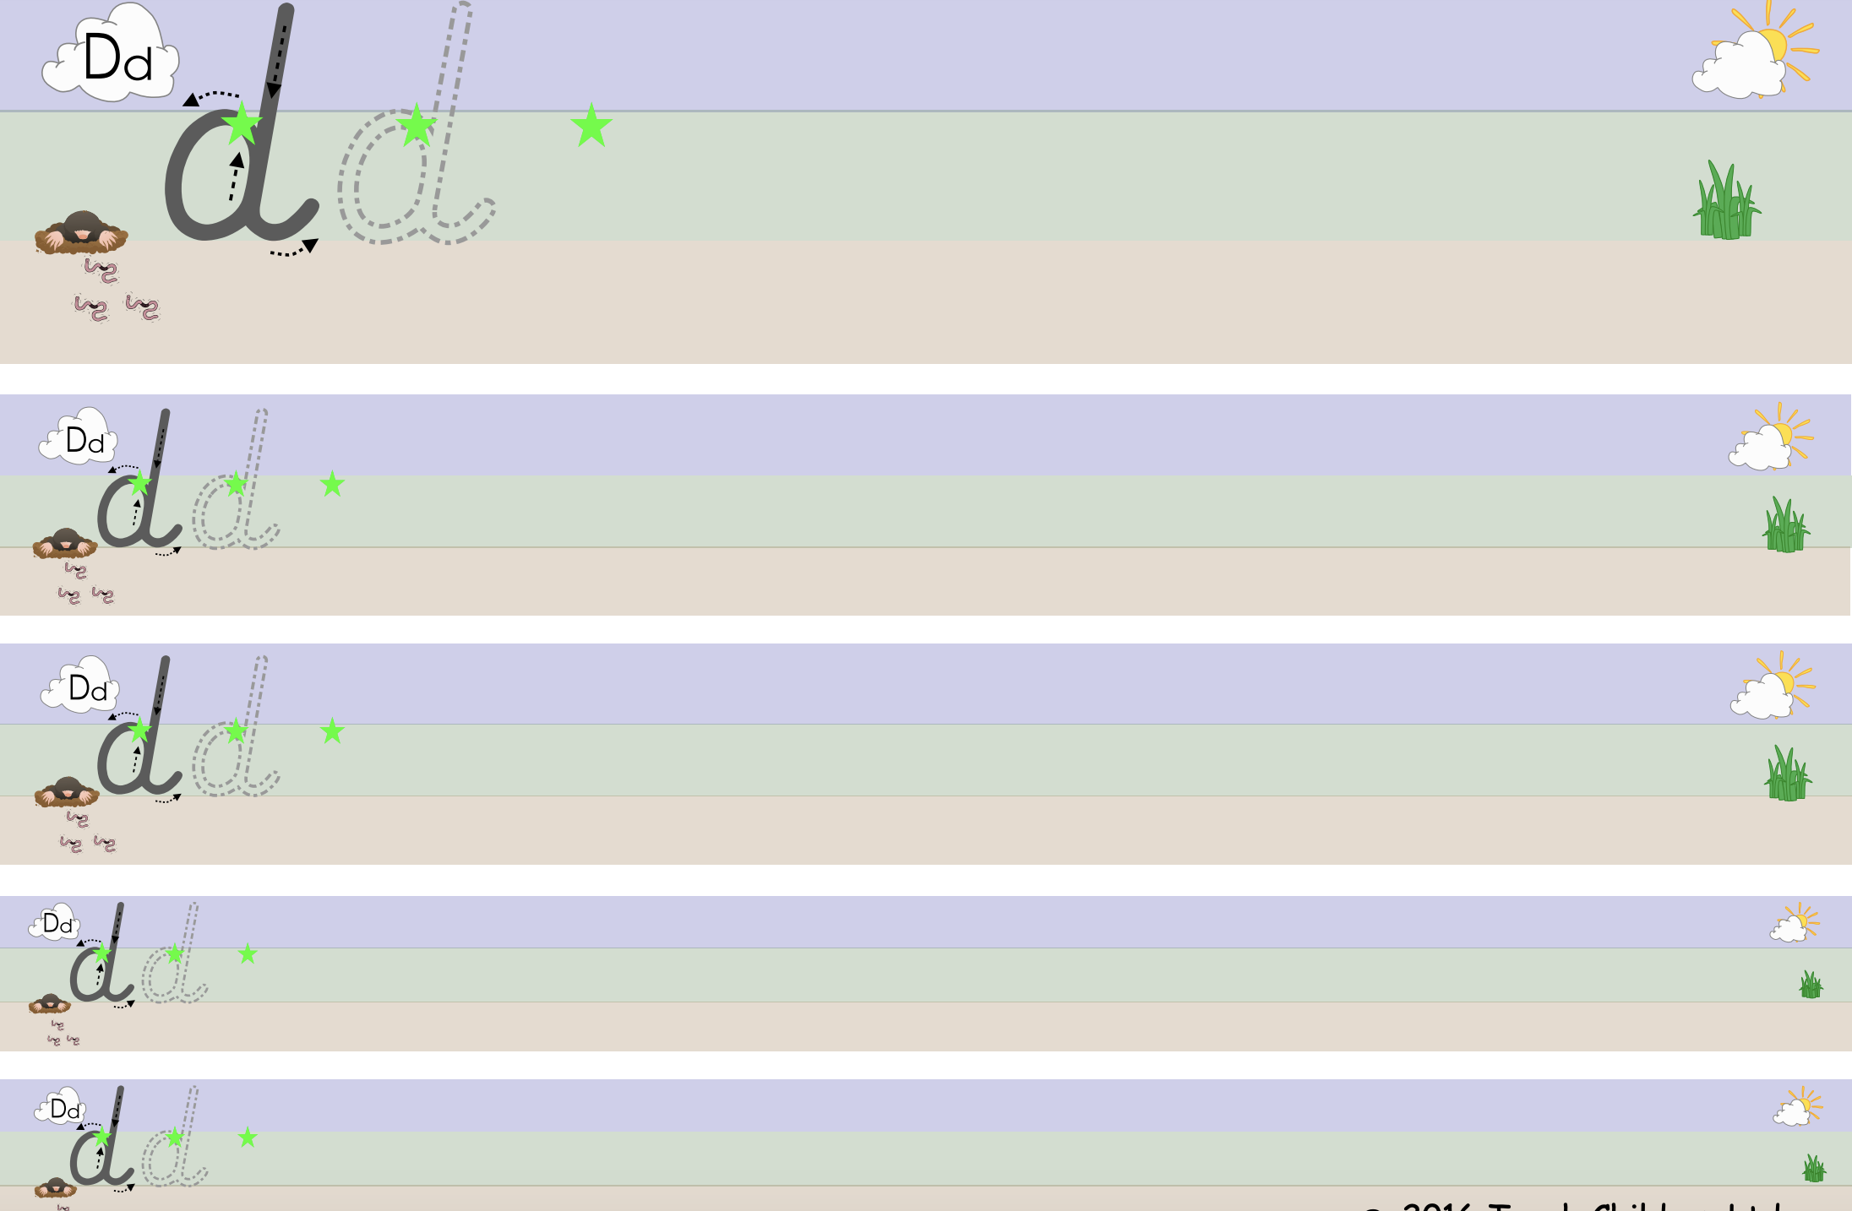

dog, dig, doll, dim

Thursday 25th June 2020
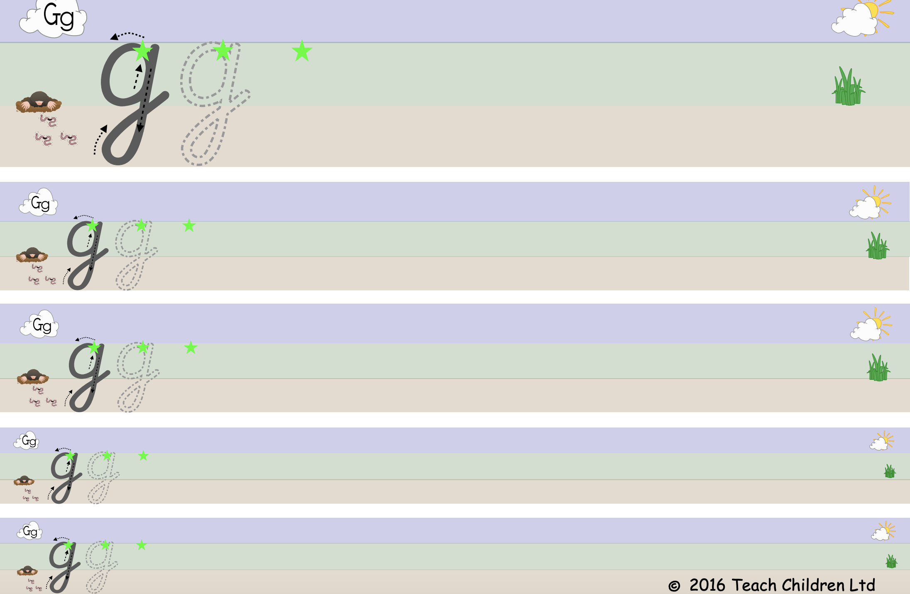

got, get, go, gel

Friday 26th June 2020

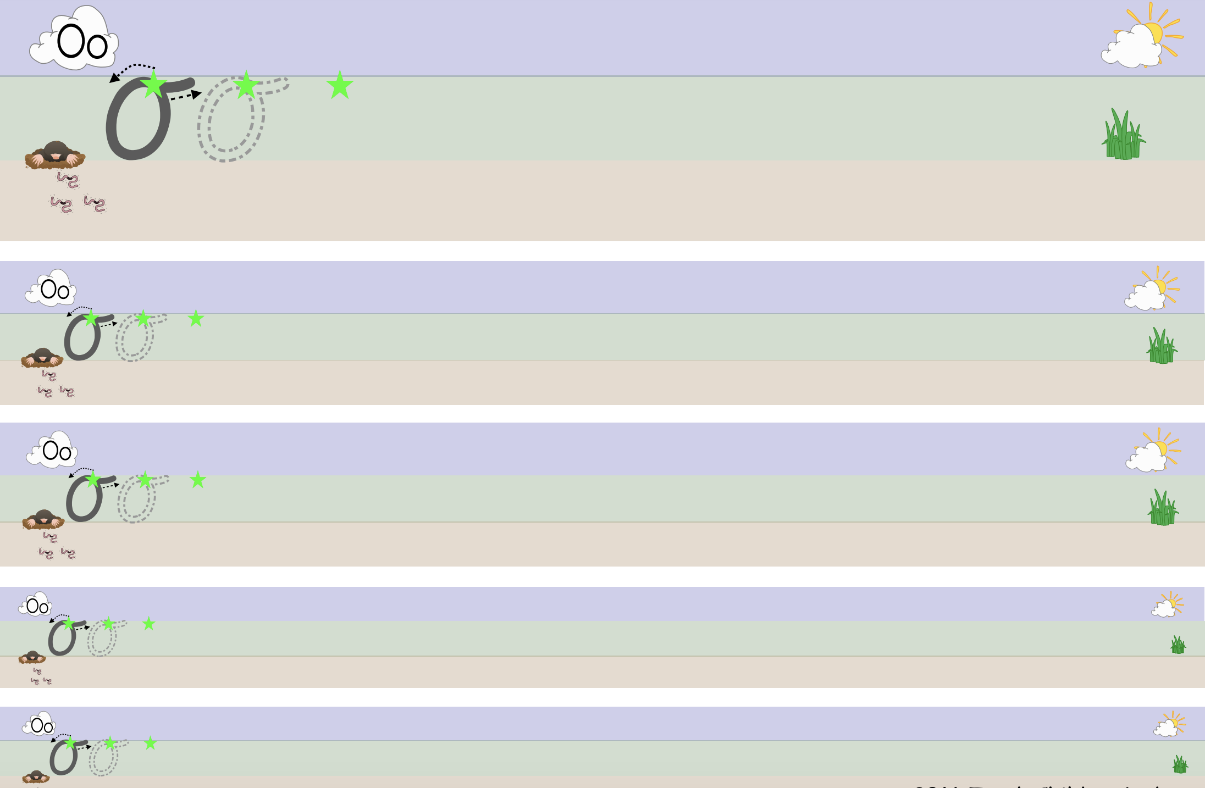

on, of, oil, out

