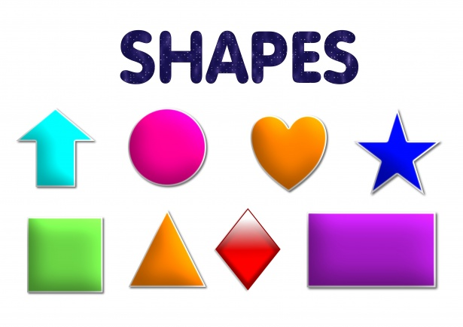
Monday activity
Learn the name of these shapes

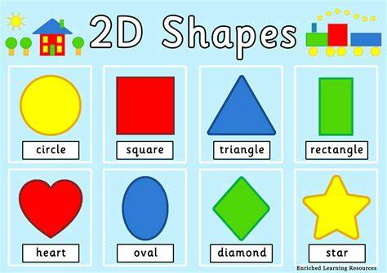

Play this activity with your child.
https://www.topmarks.co.uk/ordering-and-sequencing/shape-patterns

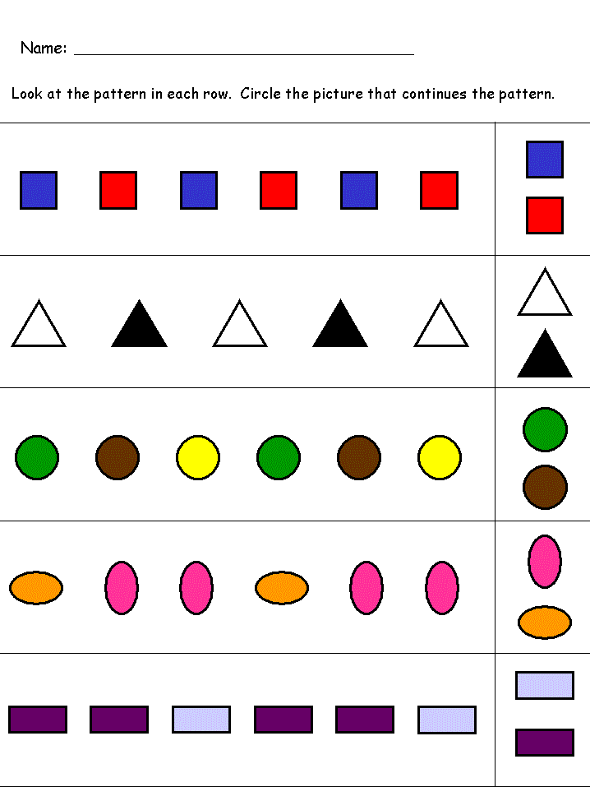
Tuesday activity
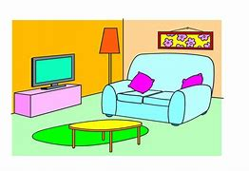
Shapes are everywhere, look around the house and see if you can spot any shapes.

Can you find any shapes in this picture?
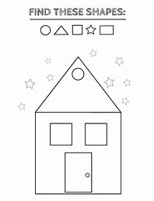

Draw the shapes
Wednesday activity

Can you draw the following shapes on a paper?

Match the shapes together.
Thursday activity

Friday activity
Can you create a picture?
Draw some shapes and cut them out and create a picture.
Here is an example below.

