Week 13
Monday 15th June 2020 - English comprehension – Year 3 & 4
L.O: To answer reading comprehension questions by deducing and inferring information. Read the extract, then read the questions and find evidence from the text to answer the questions.
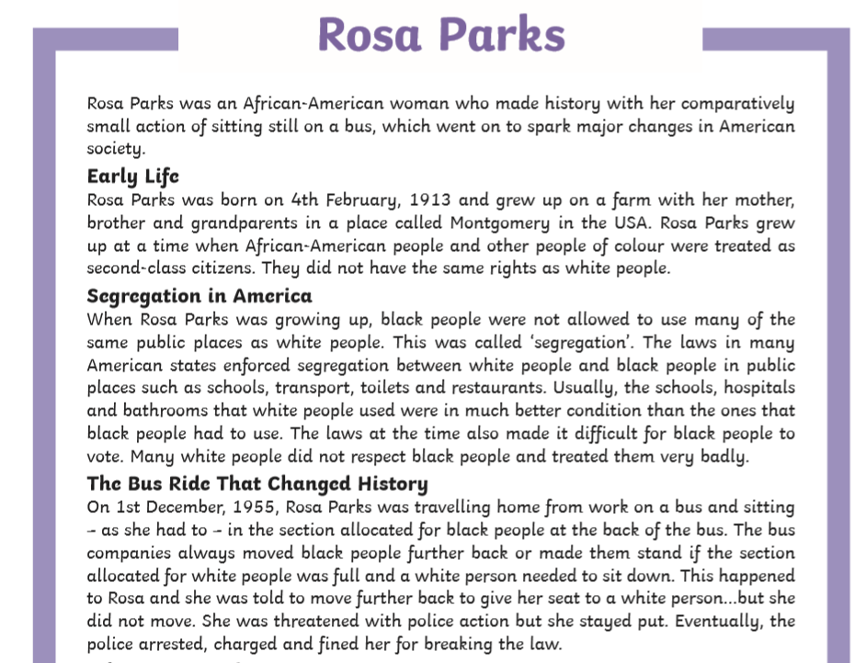
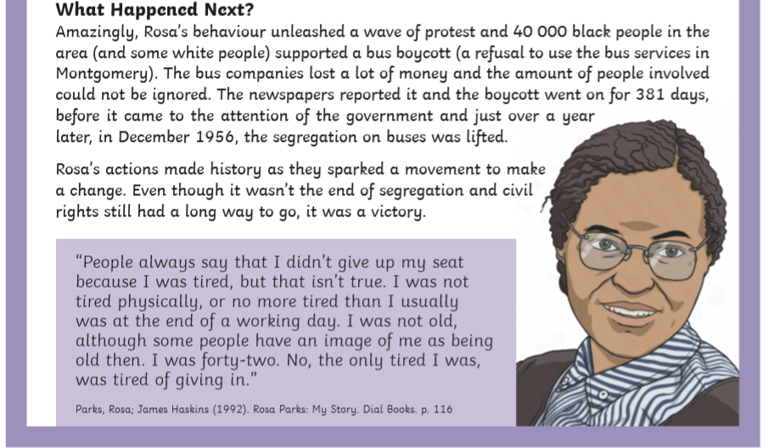

Questions- Year 3 can answer questions 1 to 7
Year 4 should attempt to answer all the questions.
- Please answer in full sentences e.g. Where did Rosa Grow up?
- Answer- Rosa grew up in_____________________________
Rosa Parks Questions
- Where did Rosa grow up?
_________________________________________________________________________________________________

- What is ‘segregation’? _______________________________________________________________________________

- How were the facilities provided for black and white people different?
________________________________________________________________________________________________
___________________________________________________________________________________________________
___________________________________________________________________________________________________
- How old was Rosa when she did not move on the bus?

____________________________________________________________________________________________________

_____________________________________________________________________________________________________
- If you boycott something, what are you doing?
_________________________________________________________________________________________________________
____________-______________________________________________________________________________________________
- In 1955, how were the buses in Montgomery segregated?
_______________________________________________________________________________________________________

________________________________________________________________________________________________________

- In ‘The bus Ride That Changed History’ section, why has the author used an ellipsis?
________________________________________________________________________________________________________

_________________________________________________________________________________________________________

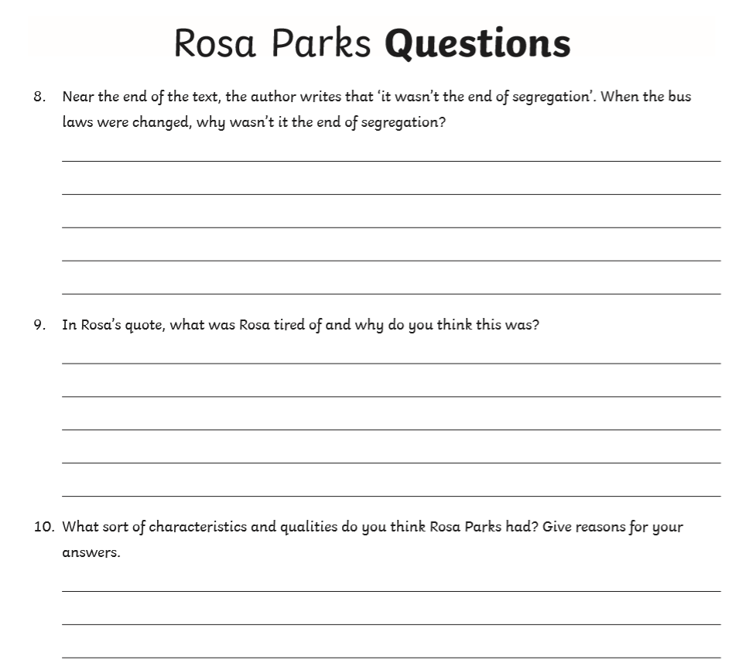

Tuesday 16th June 2020
LO: I know what adverbs are used for.

Adverb Word Blank
cheerfully – sadly – shyly- happily – gently – angrily – hungrily
TASK 1 Look at the sentences below. Underline the adverb in each one. Write the sentences in your book.

- He smiled happily as he collected his prize.
- She frowned angrily as a bird snatched her food from her hand.
- He walked to school quickly because he was running late.
- Carefully, she looked for her coat in the school cloakroom.
- Thankfully, it would be his turn in line soon.

TASK 2: Answer each question with an adverb. Use the Adverb Word Bank to help you.
Example: How did you walk to school? Answer: I walked to school cheerfully.
- How did your brother play?
- How did your friend say goodbye?
- How did the boy bark?
- How did the kite fly in the breeze?
- How did your teacher tell you off?

Tuesday 16th June 2020
Spellings
Write and learn the following words in your book.
Write the words 5 times.
Use each word in a sentence.
Do not forget to use a capital letter and full stop in your sentences.
Challenge- can you use at least 2 of the words from the list in a sentence?
Example- My friends mention that they occasionally visit Makkah to perform Umrah.
- mention
- minute
- natural
- naughty
- notice
- occasion
- occasionally

Week 13
Wednesday 17th June 2020
English writing – Year 3 & 4: Task: LO: To write a playscript continuing the conversation between the friends.

Click on this link for more information: https://www.bbc.co.uk/bitesize/topics/zkgcwmn/articles/z6hhcqt
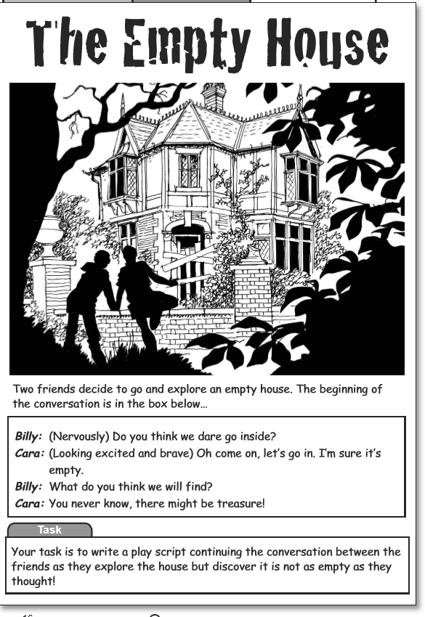
Your task is to write a playscript continuing the conversation between the friends as they explore the house but discover it is not as empty as they thought.

Do not forget to:
- Use capital letters and full stops.
- Include lots of adjectives (describing words) and adverbs (to describe the verbs)
- Read each sentence to check if it makes sense.
- Use a wide range of punctuation including at least 3 of the following: full stop and capital, question mark, exclamation mark, apostrophe and comma.
- Use more sophisticated connectives, (e.g. although, however, nevertheless, despite, contrary to, as well as etc).

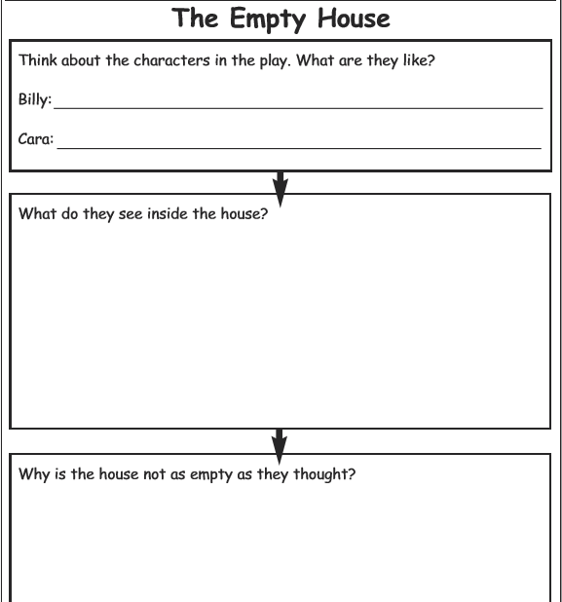

Success Criteria
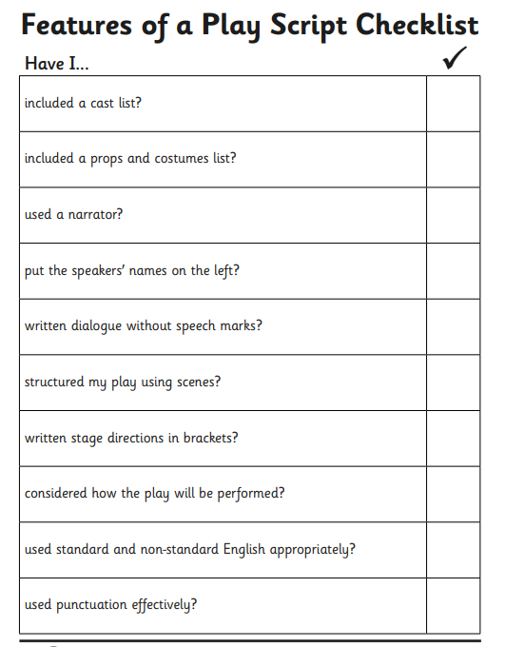

Continue the playscript

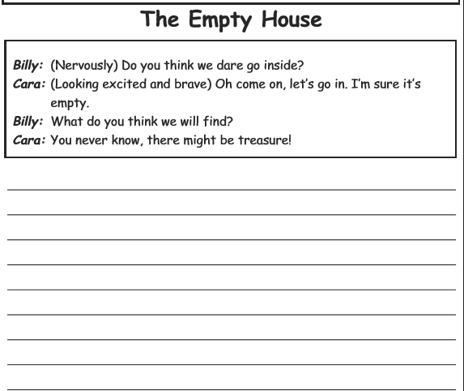

Week 13
Thursday 18th June 2020
Reading and book review – Year 3 & 4
Click on the link and listen to the story of ‘Kid Normal’. Write A book review about the story.
https://stories.audible.com/pdp/B07533YSBN?ref=adbl_ent_anon_ds_pdp_pc_pg-1-cntr-0-19
Book review by: ________________________________________________________
Title:_____________________________________________
Author: ___________________________________________
Non-fiction Fiction
What is the book about?
______________________________________________________________________________________
_____________________________________________________________________________________
Who would this book be suitable for? Age/interests

______________________________________________________________________________________
What was your favourite part? (Describe)
______________________________________________________________________________________
Year 4 challenge: Would you/would you not recommend the book to someone else? Why?

Week 13
Friday 19th June 2020
Comprehension: Read the biography of Martin Luther King Jr and answer the questions in your home learning book. Make sure you date your work and write the title. Remember answers should be written in full sentences.
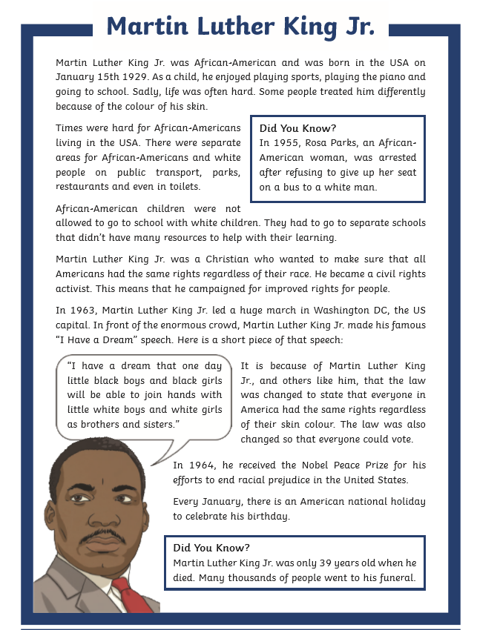

Questions:
- Where was Martin Luther King JR. Born and raised

- Australia b) Africa c) America

- What did Martin Luther King Jr become? Tick one.

- a bus driver b) a civil rights activist c) a musician
