Summer 2
Reception Writing Tasks

Dear Parents/Carers,

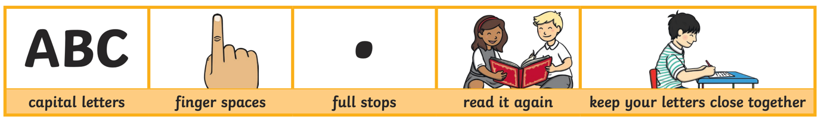
Your child will be expected to complete one writing tasks each day. Please ensure your child is writing in full sentences independently.

Encourage your child to use the above key when writing their sentences.

Success Criteria:
Has your child used capital letters?
Has your child used finger spaces after each word?
Has your child used a full stop at the end of their sentence?
Can your child read what they have written, and does it make sense?
Has your child made sure they have written their letters correctly in a way that can be understood and read by others?

Monday 15th June 2020

The following sentences are missing capital letters and full stops. Can you add the capital letters and full stops in the correct places in the following sentences?

- sam is going to the zoo

___________________________________________________________________________

- my mum told me that i need to clean my room

- the baby wanted to eat her lunch

_____________________________________________________________________________

- i like to play in my garden

_____________________________________________________________________________

Tuesday 16th June 2020

Can you write some interesting facts about a mini beast?

You could find out where it lives, what it likes to eat, how many legs it has got, if it flies or crawls. Don’t forget your phonics, finger spaces, full stops and capital letters!

Write a list of all the mini beasts you know.
Can you draw a picture to go with each of your creepy crawlies?

Wednesday 17th June 2020
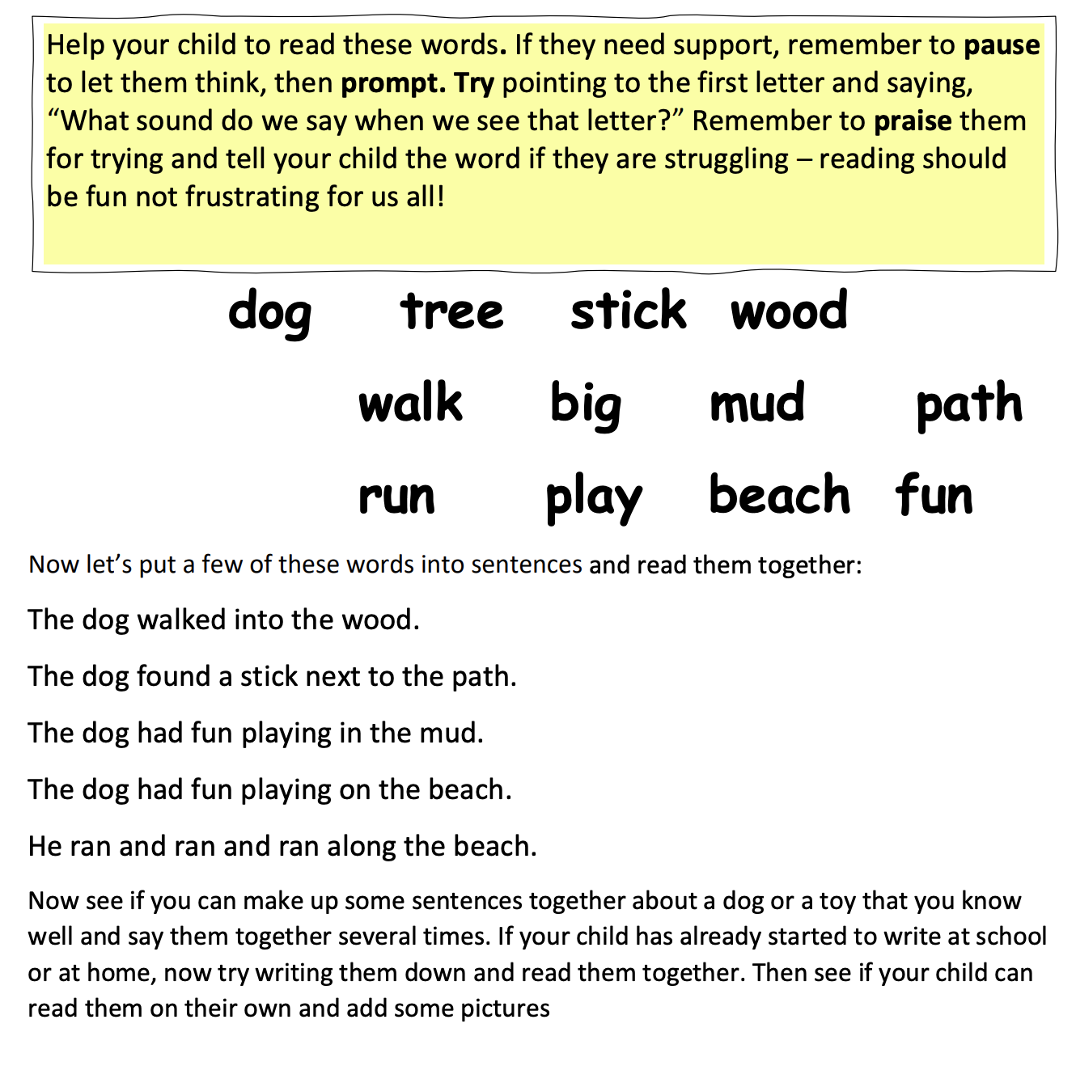

Thursday 18th June 2020
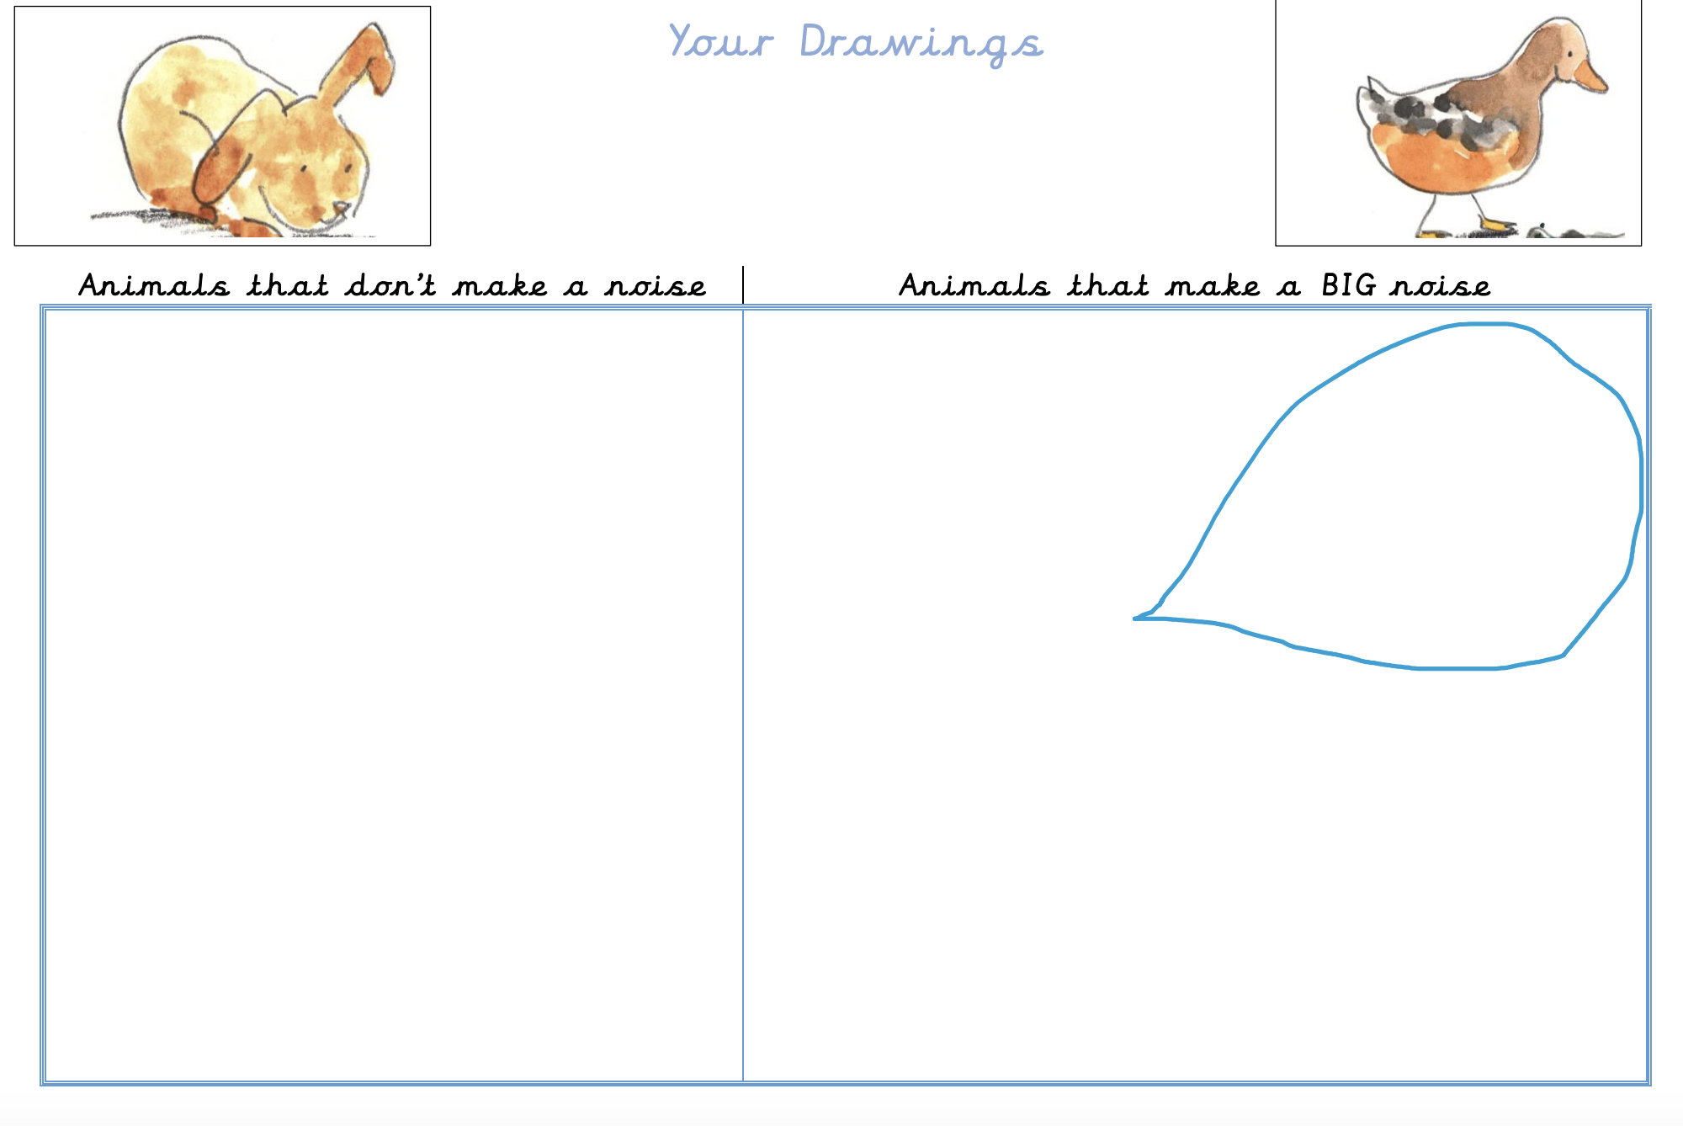

Friday 19th June 2020

Read the story ‘The Three Bill Goats Gruff’

Discuss the story. Who are the characters and what are they like? Look at the pages where the dogs are introduced. Read words which describe them. Now think about what or how each goat must have been thinking or feeling and write them down in the speech bubbles.
