Week 12- Monday 8th June 2020
Year 3 & 4
2 Times Table Test
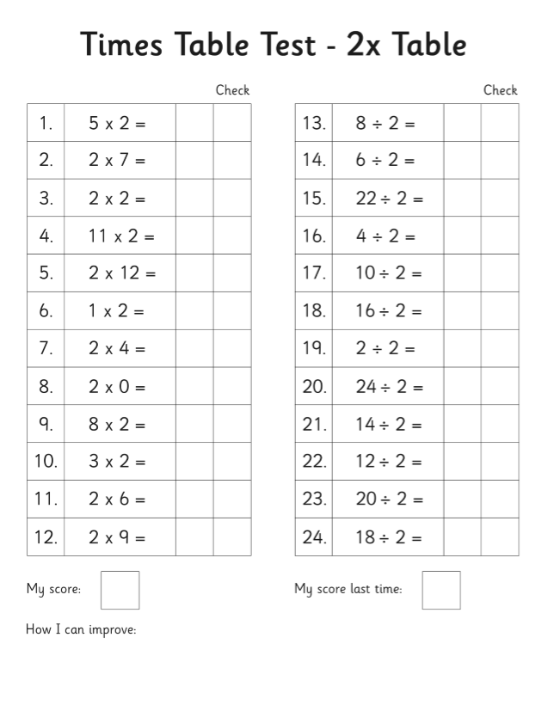
Now learn and answer the 12 times table questions!

Year 4
Year 4 Challenge
