**Monday 8th June 2020**

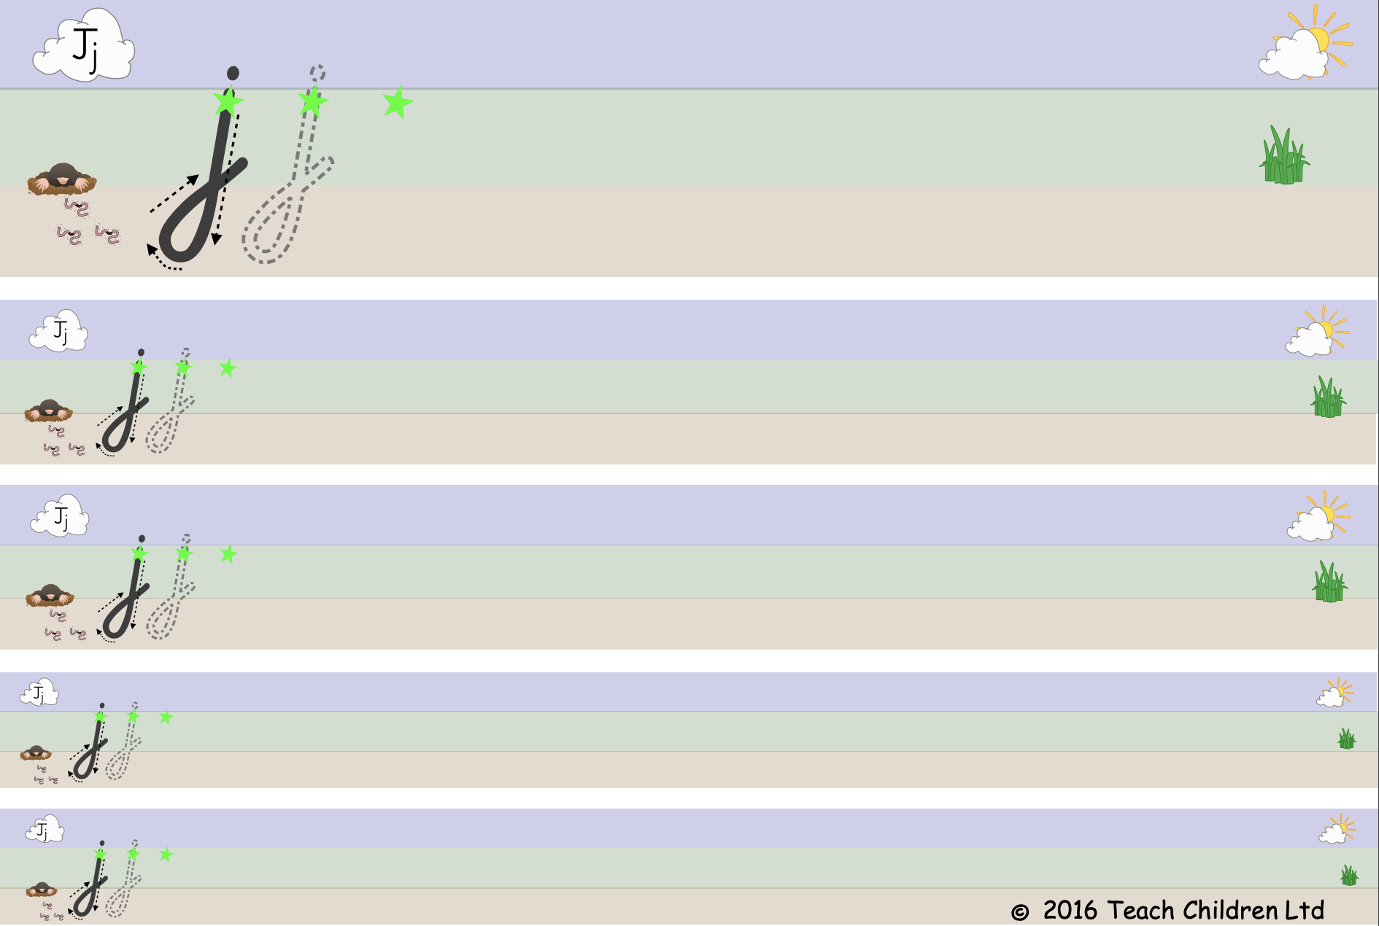

**Tuesday 9th June 2020**

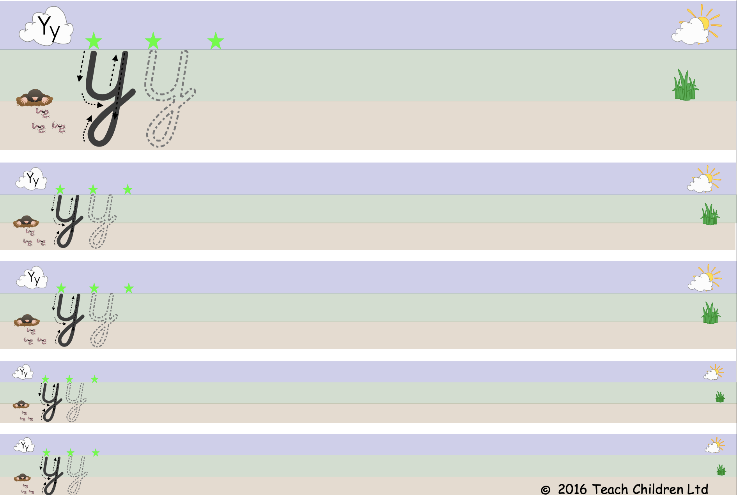

**Wednesday 10th June 2020**

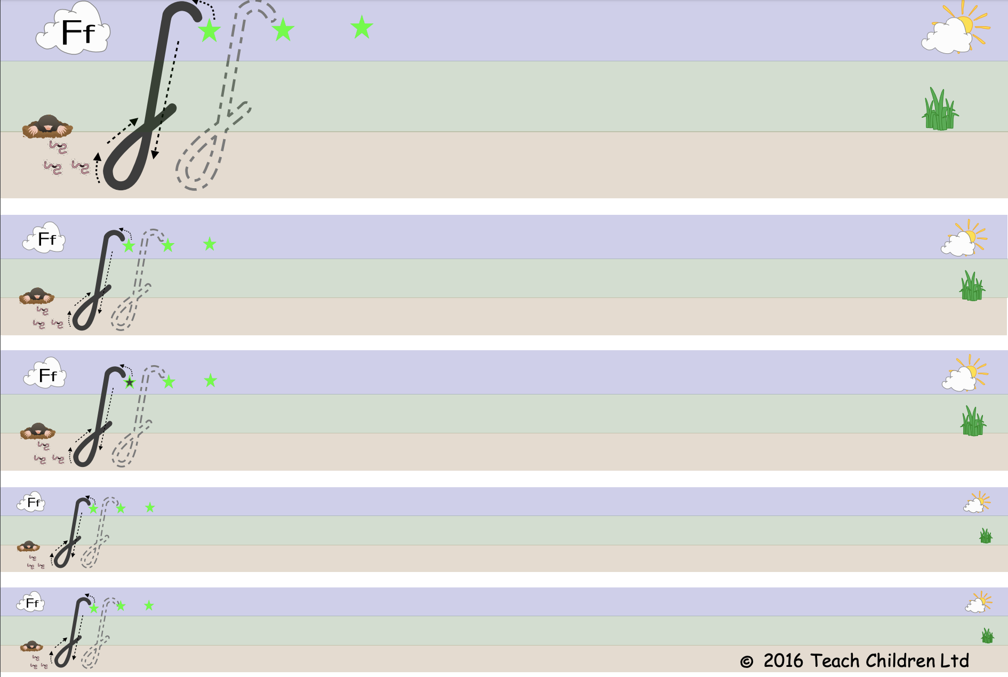

**Thursday 11th June 2020**

**Friday 12th June 2020**

