Summer 2
Reception Writing Tasks

Dear Parents/Carers,

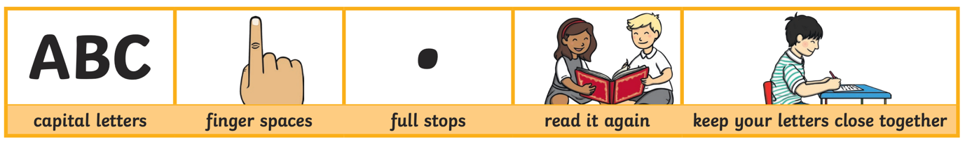
Your child will be expected to complete one writing tasks each day. Please ensure your child is writing in full sentences independently.

Encourage your child to use the above key when writing their sentences.

Success Criteria:
Has your child used capital letters?
Has your child used finger spaces after each word?
Has your child used a full stop at the end of their sentence?
Can your child read what they have written, and does it make sense?
Has your child made sure they have written their letters correctly in a way that can be understood and read by others?

Monday 8th June 2020

giant beautiful shiny tiny sticky rusty

Can you write 3 sentences using the adjectives from the above word bank. You can use more than one in your sentence!

Tuesday 9th June 2020

What words rhyme with the following words?

Bear ________________

Chair ________________

Hot ________________

Fall ________________

Light ________________

Cold ________________

Wednesday 10th June 2020
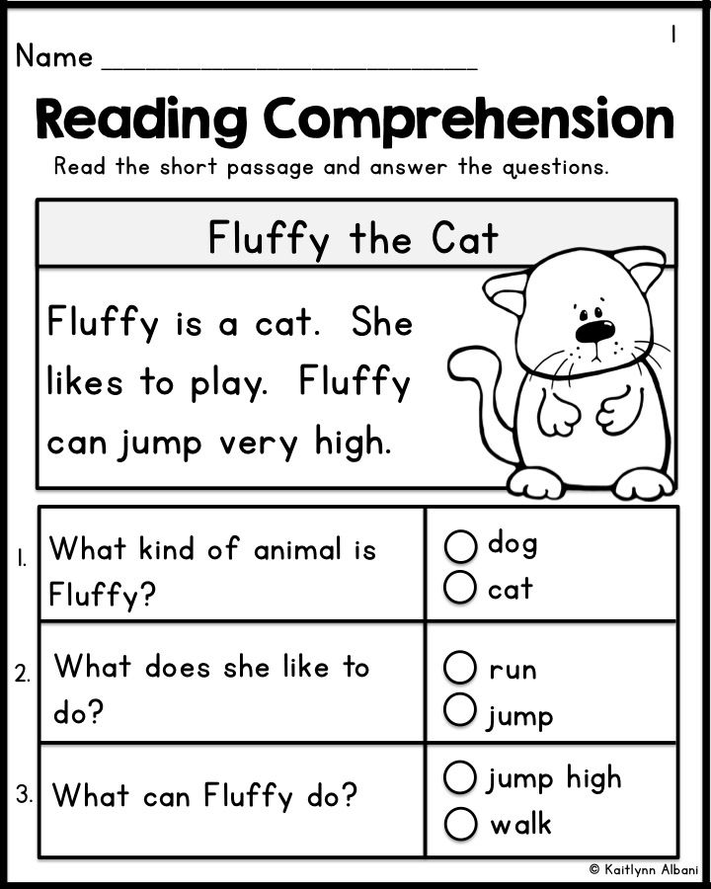

Thursday 11th June 2020
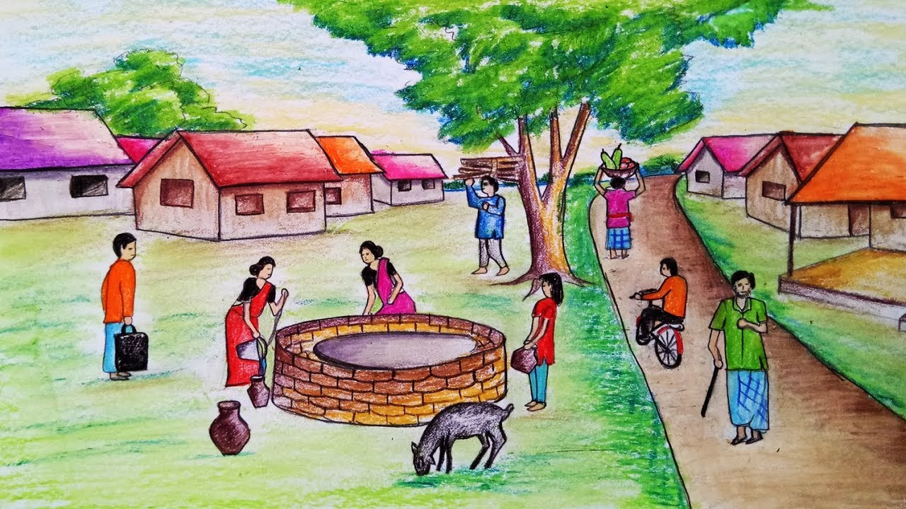

Look at the following picture. What can you see in the picture? What are the people doing? Can you see any animals? What colours can you see? Now think about these questions and see whether you can write at least 3 sentences to tell me what you can see in the picture. Remember to use adjectives!!

Friday 12th June 2020

Today I want you to think of your favourite story, it could be any story. Your task is to write the beginning of the story all by yourself in your own words.

You might want to use ‘Once upon a time…………………’ to start of your story or you can think of your very own opening sentence.

____________________________________________________________________________________________________________________________________________________________________________________________________________________________________________________________________________________________________________________________________________________________

