Week 9 Monday 18th May 2020
Year 3 & 4
10 Times Table

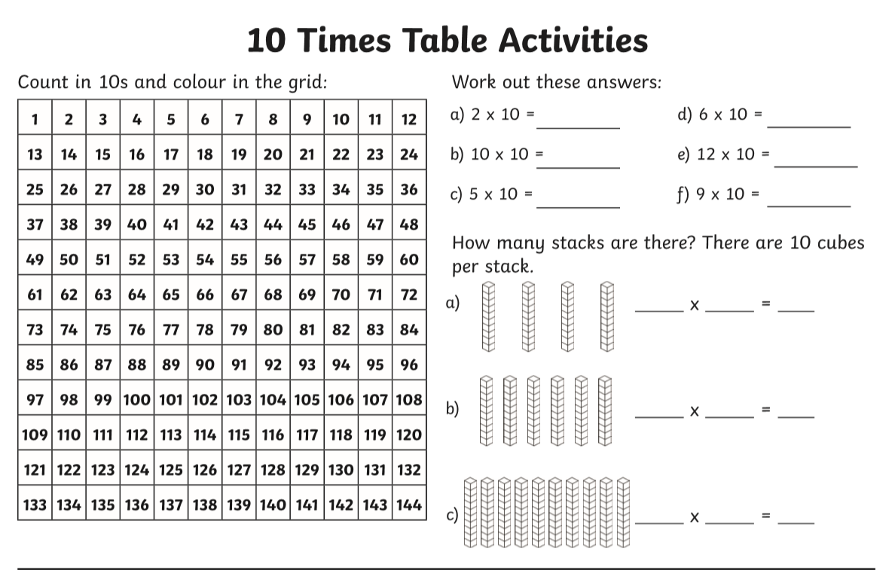
Year 3 – Challenge
90 divide by 10 =
80 divide by 10 =
40 divide by 10 =
60 divide by 10 =

Now learn and answer the 11 times table questions!

Year 4
Year 4 Challenge

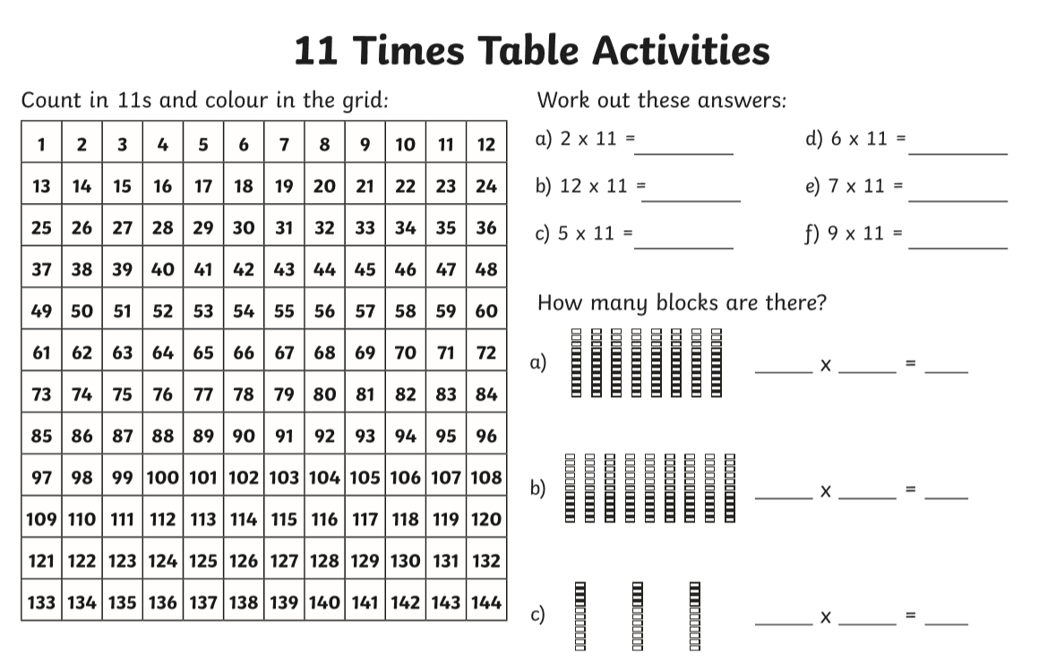
88 divide by 11 =
99 divide by 11 =
77 divide by 11 =
55 divide by 11=
66 divide by 11 =

