Week 9
Monday 18th May 2020 - English comprehension – Year 3 & 4
L.O: To answer reading comprehension questions by deducing and inferring information. Read the extract, then read the questions and find evidence from the text to answer the questions.
Sutton Hoo: An Anglo-Saxon Mystery?
Just outside the town of Woodbridge in Suffolk (in the East of England), there was a field with many grassy mounds. This site is called Sutton Hoo. No-one knew how old the mounds were and people wondered what might be buried inside them.
The Discovery
In 1939, a group of archaeologists began to excavate (dig up) the largest mound and were amazed at what they found. They discovered the remains of a Saxon boat which was around 27 metres long. As the ship had been made out of wood, it had rotted away but the archaeologists could still see the outline where the wood had made the soil darker.
The Artefacts
Inside the ship, many rare and valuable artefacts were found including a bronze helmet, a sword and a shield. Other things found were:
- cups
- buckles
- coins
- jewellery
What is the mystery?
Only very important Saxons would have been buried in ships with so many valuable treasures but archaeologists can’t be sure who was buried at Sutton Hoo. Some people believe it was King Raedwald who was a leader of a tribe in the area.

Questions- Year 3 can answer questions 1 to 5
Year 4 should attempt to answer all the questions.
Please answer in full sentences e.g. Why do you think the author has used bullet points to list some of the artefacts found?
Answer- The author has used bullet points to list some of the artefacts because ……….
- What can be found at Sutton Hoo?
_____________________________________________________________________________________________________
_____________________________________________________________________________________________________
- Where is Sutton Hoo?
_____________________________________________________________________________________________________
_____________________________________________________________________________________________________
- Do you think the boat was large or small? Why do you think that?
_____________________________________________________________________________________________________
_____________________________________________________________________________________________________
- How do you think the archaeologists felt after discovering Sutton Hoo? Explain why.
_____________________________________________________________________________________________________
_____________________________________________________________________________________________________
_____________________________________________________________________________________________________
- Why do you think the author has used bullet points to list some of the artefacts found?
_____________________________________________________________________________________________________
__________________________________________________________________________________________________________
- Look at where it says “began to excavate (dig up)” in the 2nd paragraph. Why do you think the author put words in brackets?
_____________________________________________________________________________________________________
_____________________________________________________________________________________________________
_____________________________________________________________________________________________________
- Explain why the author might have chosen the title “Sutton Hoo: An Anglo Saxon Mystery”?
_____________________________________________________________________________________________________
_____________________________________________________________________________________________________
_____________________________________________________________________________________________________

Tuesday 19th May 2020
LO: I am learning and practising homophones (Where, Wear, Were, We’re).
Where, Wear, Were, We’re (We are)
Complete these sentences using the correct words. The first four have been done for you.
Year 3: Answer questions 1-10
Year 4: Answer questions 1-15
Examples:
1. Where are you going after school?
2. Do you know what we’re doing today?
3. Please wear your coat as it will rain soon.
4. We were going to go swimming, but it was closed.

1. That is ________ I used to live when I was young.
2. The children ______ very tired after their day out in the huge park.
3. “I like to _____ red as it’s my favourite colour,” replied Sumayah.
4. Hurry up, ________ going to be late if you don’t be quick.
5. We _________ freezing cold as we waited for the golden tickets.
6. She will always ________ her brown, wavy hair in pigtails.
7. _______ very excited to go back to Buttercup Primary School.
8. “Do you know _______ I can find the dinner hall?” asked Ayesha.
9. I am going to _________ my new, sparkly hijab today.
10. The children ________ very well behaved on the school trip.
11. “I know ________ India is on the map!” said Talhah.
12. They _______ learning about rocks, soils and fossils in Science.
13. Muslims go to the Masjid ______ they pray together.
14. ________ going to celebrate Eid at the end of Ramadan.
15. We ______ learning Quran at home with our families.

Challenge: Now write 4 of your own sentences using the homophones
(where, wear, were, we’re) correctly.

Week 9
Tuesday 19th May 2020
Spellings
Write and learn the following words in your book.
Write the words 5 times.
Use each word in a sentence.
Do not forget to use a capital letter and full stop in your sentences.
Challenge- can you use at least 2 of the words from the list in a sentence?
Example- I had many grammar lessons in February to improve my writing.
- February
- forward
- forwards
- fruits
- grammar
- group
- guard
- guide

Week 9
Wednesday 20th May 2020
English writing – Year 3 & 4: Task: LO: To write an information sheet to explain the different ways seeds are scattered.
Please click on this link for more information: https://www.bbc.co.uk/bitesize/topics/zxfrwmn/articles/z28dpbk

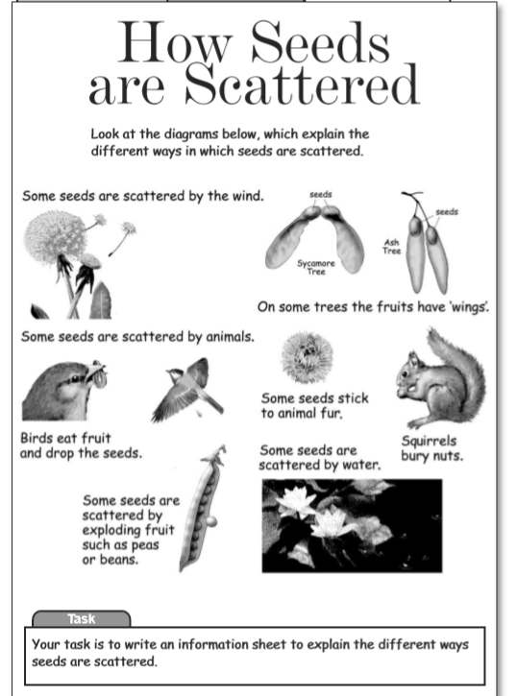

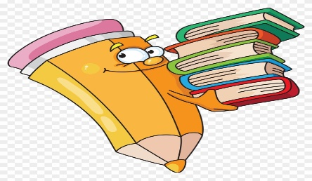
Do not forget to:

Success criteria for information sheet
- I can think of and write three subheadings?
- Can I write fact on how seeds are scattered which link to the subheadings?
- Can I write a caption for the photograph?
- Can I write ‘Did you know fact correctly?
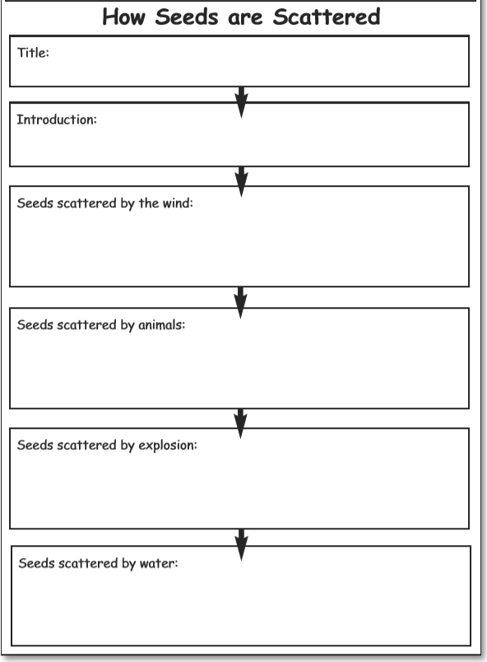
Week 9
Thursday 21st May 2020
Reading and book review – Year 3 & 4
Choose a book to read and answer the following questions about your book.
Book review by: ________________________________________________________
Title:_____________________________________________
Author: ___________________________________________
Non-fiction Fiction
What is the book about?
______________________________________________________________________________________
_____________________________________________________________________________________
Who would this book be suitable for? Age/interests

______________________________________________________________________________________
What was your favourite part? (Describe)
______________________________________________________________________________________
Year 4 challenge: Would you/would you not recommend the book to someone else? Why?

Week 9
Friday 22th May 2020
Comprehension: Read the narrative and answer the questions in your home learning book. Make sure you date your work and write the title. Remember answers should be written in full sentences.

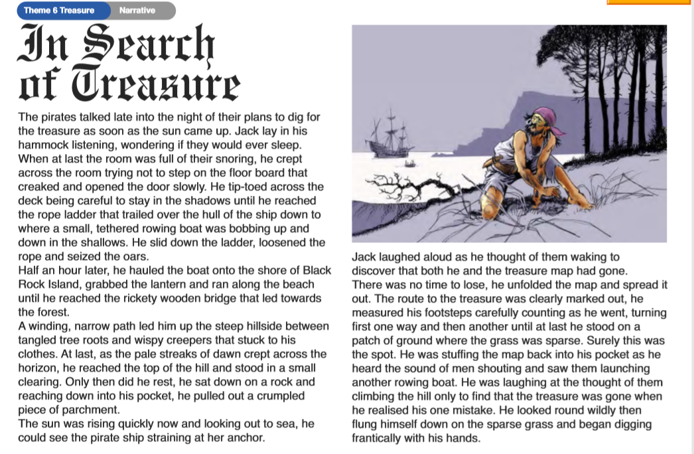

Questions:
Choose the best word or group of words to fit the passage and put a ring around your choice.
- The pirates planned to dig for treasure as soon as the
- Sun
- Moon
- Earth
- sea
came up. When they were asleep Jack
    - tramped 2) dashed 3) crept 4) tip-toed
across the room. He slid down the ladder into the
    - boat. water. deck. sand.

- Why did ‘Jack lay in his hammock listening?
- How did Jack know the other pirates were asleep?
- Why did Jack ‘stay in the shadows’ until he reached the rope ladder?
- Why was the rowing boat ‘bobbing up and down’?
- What are ‘the pale streaks of down’?
- How do you think the other pirates reacted when they discovered Jack had taken the treasure map?

Year 4 Challenge: Write your own story about what happens next to jack and the other pirates?

