**Week 9**

**Monday 18th May 2020**

**English comprehension – Year 1 & 2**

**A New Pet** 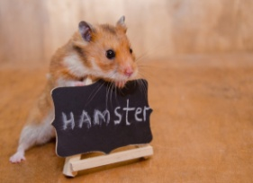

Tom was six. He lived in a flat with his Mum. The flat was on the top floor. It was very high up!

One day, Tom said to his Mum, “Mum, can I have a dog?”

But Mum shook her head and said, “No Tom, you can’t have a dog. There are no dogs allowed in a flat.”

Tom wanted to cry. Then he said, “Mum, can I have a cat?”

But Mum shook her head and said “No Tom, you can’t have a cat. There are no cats allowed in a flat.”

Now Tom did start to cry, “I want my own pet!” he shouted.

Mum patted Tom on the back and gave him a kiss, “Don’t cry Tom, I will see what I can do.”

The next day, when Tom got home from school, there was a small cage on the table. Tom was excited! He ran to look in the cage. In the cage was an orange hamster! Mum put the hamster in Tom’s hands.

Tom smiled and said, “I will call it Rusty. Thank you, Mum!”

**Questions**

Please answer the questions in full sentences.

Year 1- Answer questions 1-7

Year 2- Answer questions 1-10

1. **How old is Tom?**
2. **Where does Tom live?**
3. **What pets did Tom want?**
4. **How does Tom feel when Mum says “No?” How do you know this?**
5. **How does Mum try to make Tom feel better?**

1. **Why was Tom excited when he saw a cage on the table?**
2. **What was in the cage?**
3. **Why did Tom call his pet, ‘Rusty?’**
4. **How do you know Tom is happy about his new pet?**

1. **Do you have a pet or would you like one? What kind of pet?**

**Week 9**

**Tuesday 19th May 2020 English Spag – Year 1 & 2**

Spelling, Grammar and Punctuation

**LO:To use the correct punctuation**

**Task 1**: Add the correct punctuation on the end of these sentences. Pick either a question mark, exclamation mark or a full stop.

What time do you go to bed

James went swimming with his family

How beautiful you look today

**Task 2**: Place in this sentence where you think any commas should be:

I bought some cheese vegetables and milk.

**Task 3**: Correct this sentence by adding capital letters and full stops:

yesterday I woke up very early on a Tuesday morning first I had some breakfast with my sister lily

**Task 4**: In the sentence below write an **A** above the words that are adjectives, **N** for nouns and **V** for verbs:

**Samantha bought a pretty dress. The tree is ancient, tall and strong.**

**Challenge for Year 2**

Task: Add the missing verbs in the correct tense below:

Last week I ____________ a cold. (catch)

Yesterday we ____________ in my swimming pool. (swim)

Today I am ______________ in a race. (run)

Next summer I ______________________ Spain. (visit)

An hour ago, they ____________ to the park. (go)

**Week 9**

**Tuesday 19th May 2020**

**Spellings**

**Write and learn the following words in your book.**

**Write the words 5 times.**

**Use each word in a sentence.**

**Do not forget to use a capital letter and full stop in your sentences.**

**Challenge- Can you use at least 2 of the words from the list in a sentence?**

**Example- I have seen less people out at night.**

* **don't**
* **about**
* **much**
* **people**
* **sister**
* **seen**
* **night**

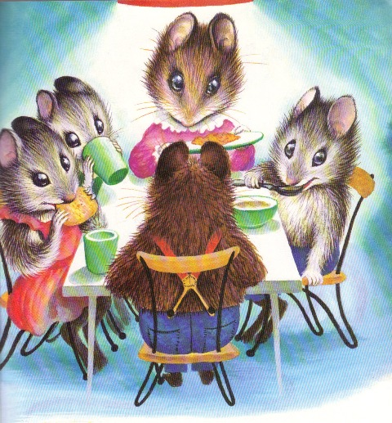**Week 9**

**Remember to use:**

* Capital letters and full stops
* Read your sentences to see if it makes sense
* Check your spellings

**Wednesday 20th May 2020**

**English writing – Year 1 & 2**

**L.O: To continue writing a story.**

**Task:**

* Read the first paragraph
* Write the second paragraph (the middle of the story)
* Year 2 : Write the second and third paragraph (the middle and end of the story)

For quite a long time now a family of mice have been living in a cosy barn. In the family there is a mummy, a daddy and three baby mice. Mummy mouse is the family cleaner, she cleans all the mousey bedrooms and all the nooks and crannies in the barn. Daddy mouse works as a builder. He works very long hours and is often very tired. Sometimes the 3 baby mice help mummy mouse with the cleaning. However, they love to play and make lots of noise.

**Sentence starters**

**Word bank**

mouse outside broken seen hunting awful

enormous together family

difficult next eventually success

One day, the family decided to....

To their surprise......

They felt....

**Week 9**

**Thursday 21st May 2020**

**Reading and book review – Year 1 & 2**

**The Boy who drew Cats by Anushka Ravishankar (click on the link below to listen to it)**

<https://stories.audible.com/pdp/B085GKQ9DZ?ref=adbl_ent_anon_ds_pdp_pc_pg-1-cntr-0-27>

**Answer these questions below**

**What did you like about the book?**

**What was your favourite part? (Describe)**

**Who was your favourite character and why?**

**Draw a picture of your favourite scene.**

**Yr 2 challenge: What rating would you give out of 10 for this book and why?**

**Week 9**

**Friday 22nd May 2020**

**English spelling**

**Spelling**

**Write and learn the following words in your book.**

**Write the words 5 times.**

**Use each word in a sentence.**

**Do not forget to use a capital letter and full stop in your sentences.**

**Challenge- can you use a question mark in your sentences?**

**Example- ‘Mum, why do you look purple all of a sudden?’**

* **the**
* **mum**
* **they**
* **asked**
* **purple**
* **looked**
* **called**