**Week 8**

**Friday 15th May 2020**

**Year 6**

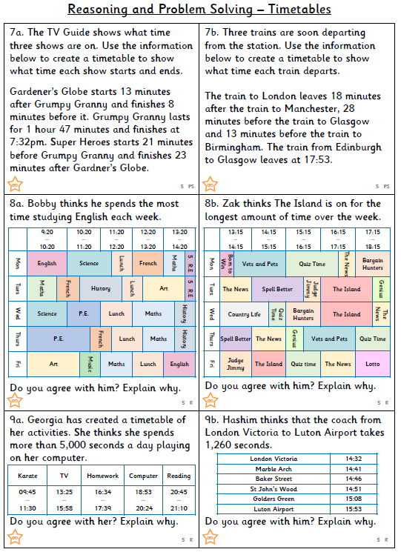

**Challenges**

