Week 8 Monday 11th May 2020
Year 3 & 4
8 Times Table

Year 3 – Challenge 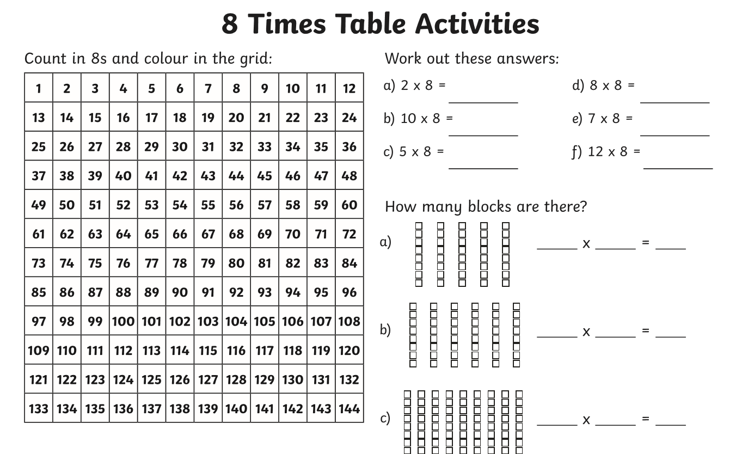
64 divide by 8 =
80 divide by 8 =
40 divide by 8 =
16 divide by 8

Now learn and answer the 9 times table questions!
Year 4
Year 4 Challenge
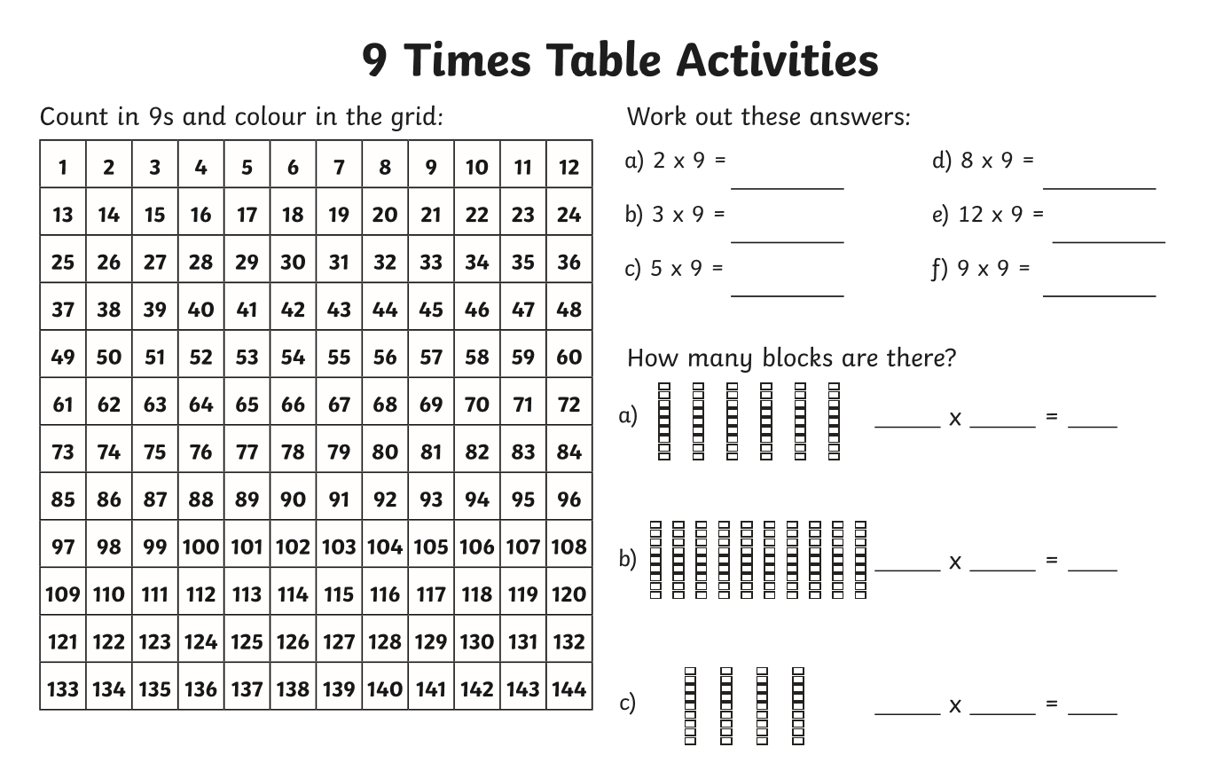
18 divide by 9 =
90 divide by 9 =
72 divide by 9 =
45 divide by 9 =
63 divide by 9 =

