**Week 8**

**Monday 11th May 2020**

**English comprehension – Year 1 & 2**

**Super Samuel**

Samuel put on his shining silver mask. He flapped his bright, red cape in front of the mirror and smiled joyfully to himself. His outfit was blue with a silver star shining in the middle of his chest. His boots were white with lightning flashes around the top. This is the best costume, he thought. I’m sure to win the contest. Samuel skipped downstairs happily.

“Here I come to rescue you!” Samuel shouted and he made a superhero pose.

“Nice costume, it’s fantastically bright!” said Samuel’s dad.

“I’m a superhero,” said Samuel proudly.

“Samuel,” said Mum, “I need you to watch and look after Martha at the party.”

Samuel looked at his little sister. “But Mum, superheroes don’t have little sisters.”

“Well this superhero has a sister,” said Mum.

“What will Martha’s costume be?” asked Dad.

“I’m not sure,” said Mum.

Samuel had an idea. “Right, I know!”

Samuel took Martha upstairs to his room. He dug through his wardrobe and found his soft blue baby blanket. He put it around Martha’s shoulders. Then he used some silver card to make Martha an eye mask to match his mask and tied it on with ribbon. There were lots of different superheroes at the party and they all had a lovely time playing party games, it was quite a sight! Then when it was time for the competition prize draw Superhero Samuel and his sidekick Supergirl Martha won first prize!

**Task - Answer the questions below in full sentences**

Why was Samuel dressed as a superhero?

__________________________________________________________________________________________________________________________

What did Samuel’s mum tell him to do at the party?

__________________________________________________________________________________________________________________________

Name all four characters in this story.

|  |  |
| --- | --- |
| 1. | 2. |
| 3. | 4. |

When does this story take place? Circle your answer.

1. at the party **b.** before the party

**c.** after the party **d.** at Samuel's house

What did Samuel put on Martha when he dressed her up as Supergirl?

__________________________________________________________________________________________________________________________

What was Martha’s eye mask made from?

__________________________________________________________________________________________________________________________

If you were a superhero what superpower would you like to have and why?

_______________________________________________________________________________________________________________________________________________________________________________________

**Week 8**

**Tuesday 12th May 2020 English Spag – Year 1 & 2**

**Correct Word**

**LO: To use the correct word**

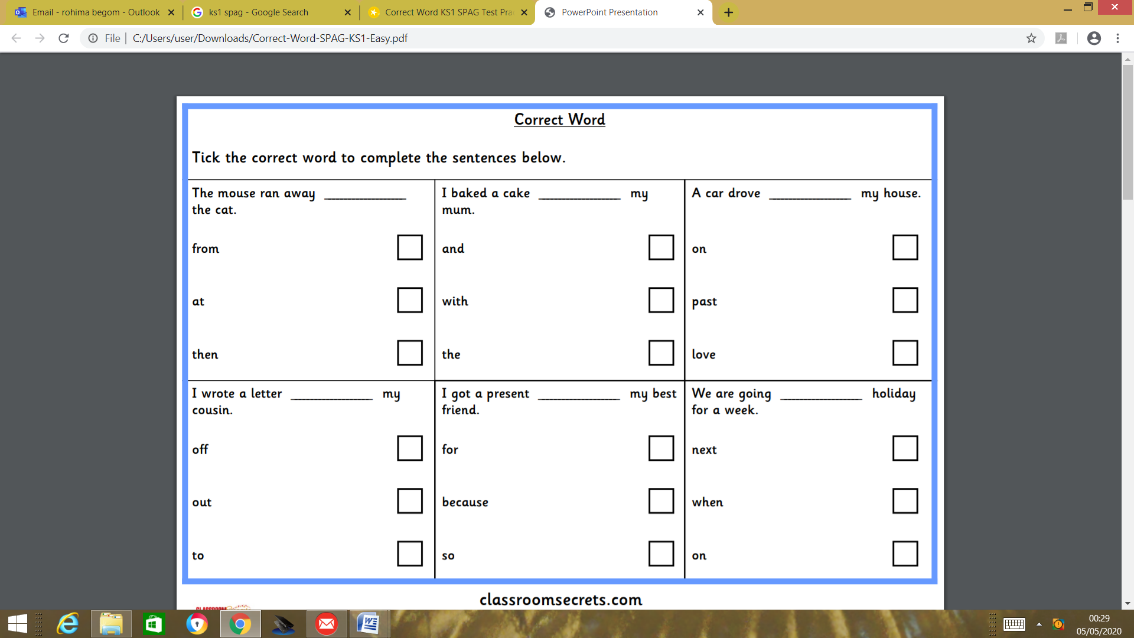

**Challenge for Year 2** Underline the type of word in the sentences below

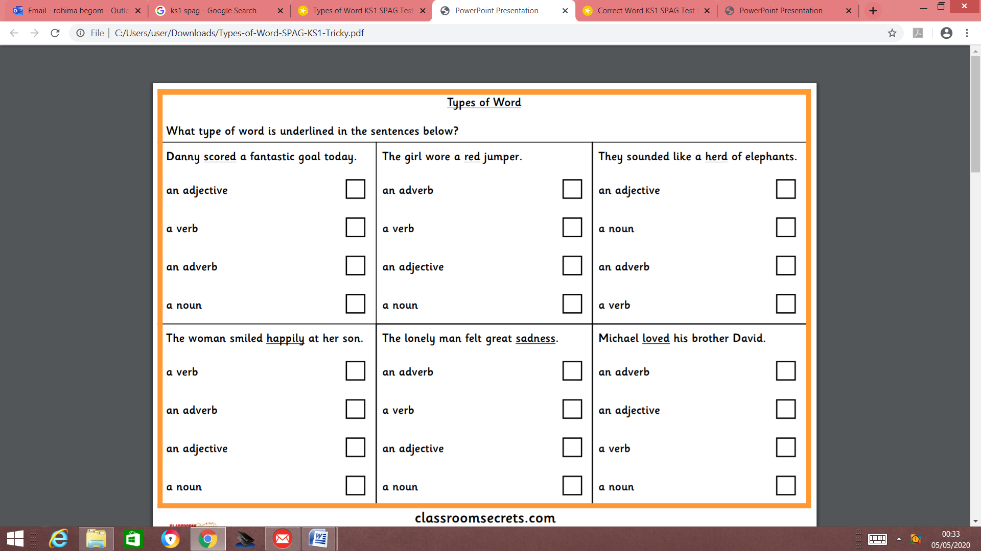

**Week 8**

**Tuesday 12th May 2020**

**Spellings**

**Write and learn the following words in your book.**

**Write the words 5 times.**

**Use each word in a sentence.**

**Do not forget to use a capital letter and full stop in your sentences.**

**Challenge- Can you use at least 2 of the words from the list in a sentence?**

**Example- I would like half of the pizza again.**

* **come**
* **some**
* **you**
* **there**
* **hold**
* **again**
* **half**

**Week 8**

**Wednesday 13th May 2020**

**English writing – Year 1 & 2**

**L.O: To describe your ideal holiday.**

**Think about:**

* Where might you go?
* What would you do?
* Who would you go with?

**Wordbank**

Palm trees blue sea sandy beaches fun delicious food

plane family friends activities sandcastle hotel hot weather

**Check**:

* Capital letters and full stops
* Does your sentence make sense?
* Have you explained why it would be

your ideal holiday?

**Sentence starters**

**If I chose a holiday place, I would choose.........**

**I would go with ..................................**

**There would be.......................................**

**The activities that I would like to take part in are....**

**Week 8**

**Thursday 14th May 2020**

**Reading and book review – Year 1 & 2**

**Coronavirus-A book for children by Professor Graham Medley (click on the link below to listen to it)**

<https://stories.audible.com/pdp/1839941537?ref=adbl_ent_anon_ds_pdp_pc_cntr-2-1>

**Answer these questions below**

**What do you understand about the book?**

**How can you help the grown ups at home? (Describe)**

**What can you do to make this situation better?**

**Draw a picture of how cornavirus spreads.**

**Yr 2 challenge: Would you recommend this book to your friend and why. Give your reasons.**

**Week 8**

**Friday 15th May 2020**

**English spelling**

**Spelling**

**Write and learn the following words in your book.**

**Write the words 5 times.**

**Use each word in a sentence.**

**Do not forget to use a capital letter and full stop in your sentences.**

**Challenge- can you use a comma in your sentences?**

**Example- I have found my black, thick cardigan to wear.**

* **own**
* **found**
* **always**
* **second**
* **think**
* **black**
* **before**