Positional language
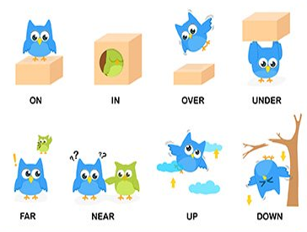
Monday
Activity 1
Play a little game with your child, place their toys around your home and ask them to tell you where you have placed them. Use positional language with them for example, on top, under, between, besides, over etc
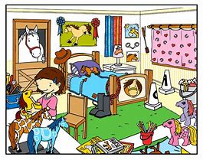

Activity 2

Mark making with your child, get your child to draw their favourite animal.

Firstly, ask your child to draw a household furniture for example, a chair or their bed.

Then ask them to draw their favourite animal on or around the furniture. Here is a example below

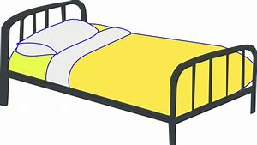

Ask your child:

What is your favourite toy?

Go and get your toy?

Can you draw you toy?

What position is your animal in, is it on the top or bottom?

Tuesday

Where is the monkey?

https://www.youtube.com/watch?v=idJYhjGyWTU

Where is the bear?
https://www.youtube.com/watch?v=WzIcu6tbEko
Watch the videos with low volume as there is music playing in the background
Ask your child where is the animal, use positional language

Wednesday
Where is the ball?

Directions: Look at each ball. Discuss where the ball in the picture.
Use the words: top bottom middle inside outside

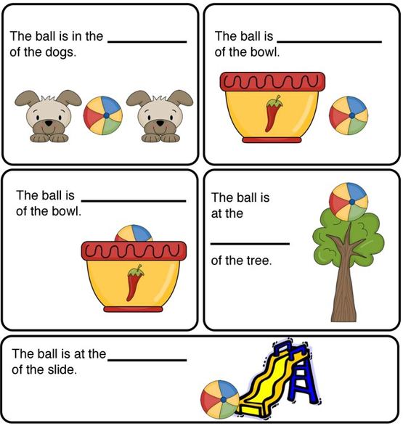

Thursday

Play another game – put a chair in the middle of your living room and place a teddy in different position and ask them what position is it in, e.g. under, above, next to etc.

Ask your children these questions:

Is the teddy bear under the chair?
Is it in the box?
Is the teddy bear sitting on top of the chair?
Is it beside the chair?

Friday 