Week 7
Monday 4th May 2020
Reading comprehension

Week 7
Monday 4th May 2020
Reading comprehension
Read the text and answer the questions using evidence from the text.
Yr 5- Answer questions 1-5
Yr 6- Answer questions 1-8

Retrieving Information
- Use a dictionary to find the meaning a) perpetual
b) tended
- Find and copy a phrase that shows it is warm in the forest.
- What are the most talented types of witches called?
Making Inferences
- Use evidence from the text to explain how Hazel feels when she sees Ginger Tom.
- Does Hazel find magic easy? Give two reasons for your answer.
- What might be causing the “foul smell”?
Writer’s Choices
- How does the writer show that Hazel is a caring girl?
- Why do you think the writer chose to start with a quote from another book?
Challenge Question (extended answer)
- What do we know about Hazel and her life? Use quotes from the text to back up your answer.
Tuesday 5th May 2020
English grammar- Answer the questions in full sentences.
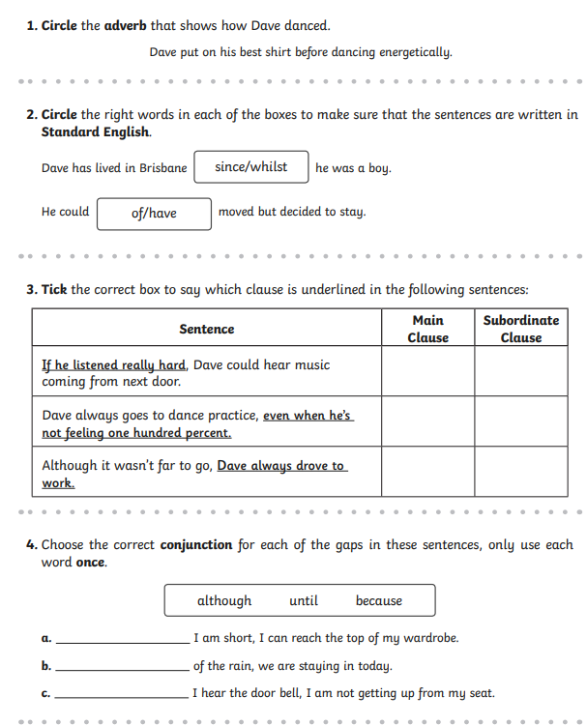
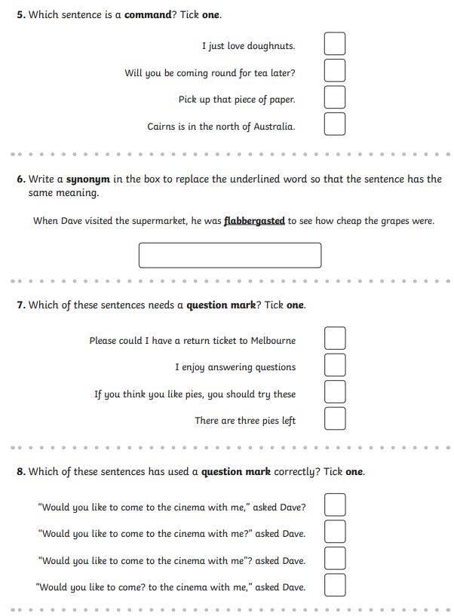
Week 7
Wednesday 6th May 2020
English Writing- Year 5
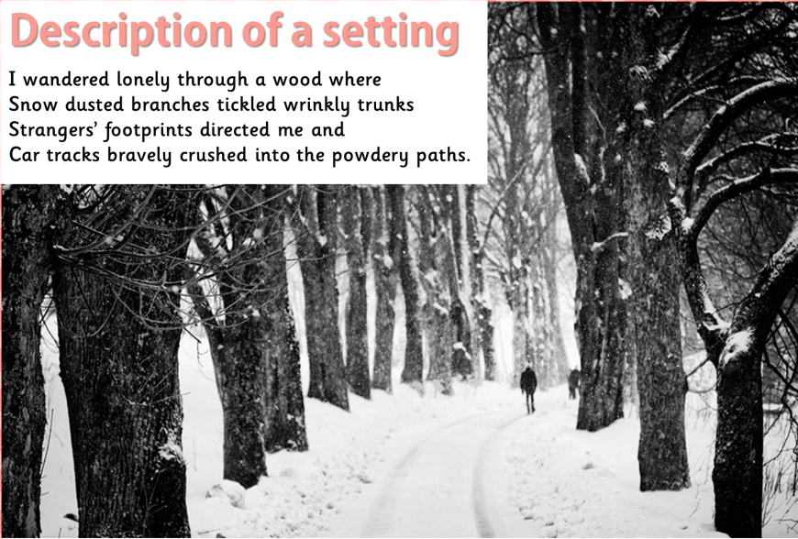

Task:
The paragraph above describes the things you would see in this scene.
Add your own paragraphs, but focus on:
- The sounds that you might hear

- The smells that you may smell

- The touches you may feel

- Any tastes in your mouth

Remember to write in the first person e.g. First person is the I/we perspective

English writing- Year 6
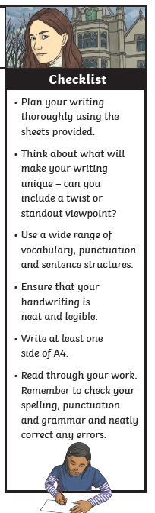
Task- Continue the story

‘It was only then that I realised that things were not quite as they seemed’…

Use punctuation to show division between clauses, to indicate, to vary pace, to create atmosphere or to sub-divide (e.g. commas, colons, semicolons, dashes, ellipses)
Week 7
Thursday 7th May 2020
English- Spelling (Copy the sentences with the correct spelling word. Learn the correct spelling)
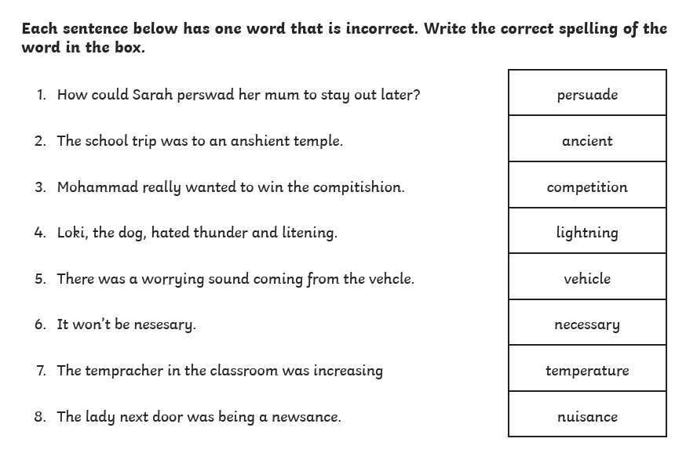
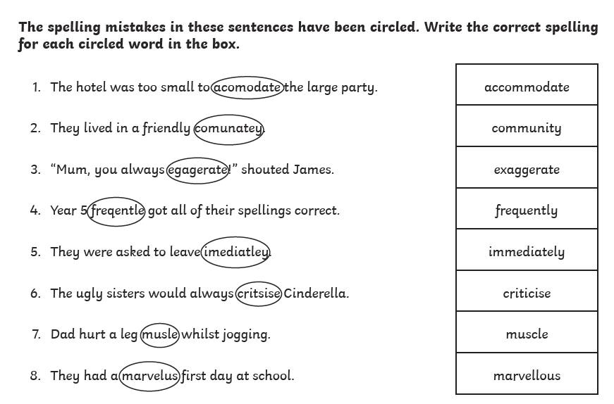
Challenge: Write your own sentences using the correct spelling words. Make sure the words are used in the right context.
Week 7
Friday 8th May 2020
English comprehension

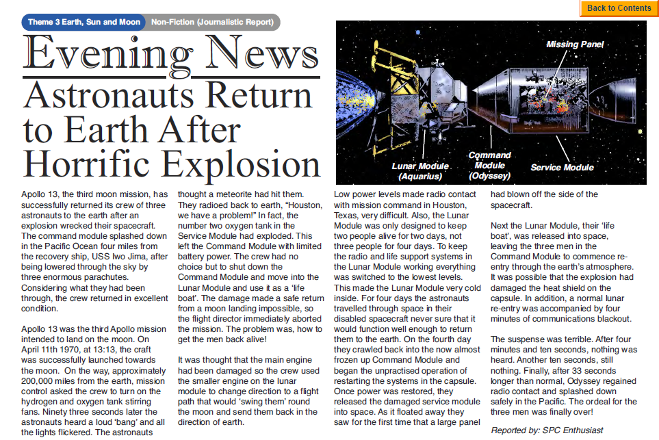
Questions
Use evidence from the text to answer the questions in full sentences.
Yr 5- Answer questions 1-7
Yr 6- Answer questions 1-9

- Where was Apollo 13 heading for?

- Name the three parts of the Apollo 13 spacecraft.

- What exploded in the Service Module?

- Why do you think that the Lunar Module was described as a ‘lifeboat’?

- Which part of the spacecraft was the only part to return to the earth?

- What does the phrase ‘aborted the mission’ mean?

- How do you think the astronauts would have felt when they heard a large bang?

- What is meant by the sentence ‘considering what they had been through, the crew returned in excellent condition’?

- Why do you think the astronauts had not seen that a panel was missing until the Service Module was released into space?

Challenge
Imagine you are on a space mission and something goes wrong. Write a short newspaper account telling what happened.

