Week 11
Monday 1st June 2020
Year 5 and 6 Reading comprehension
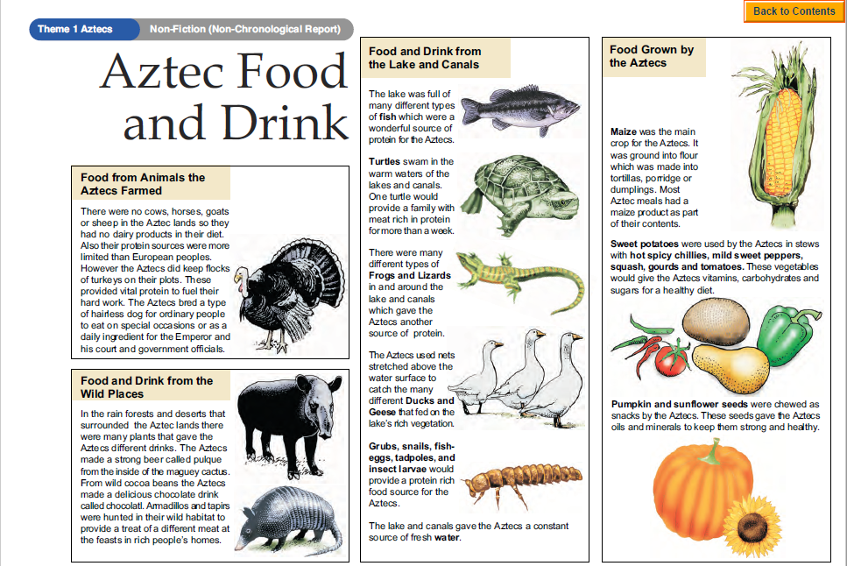
Questions
Year 5- Answer questions 1-7
Year 6- Answer questions 1-9
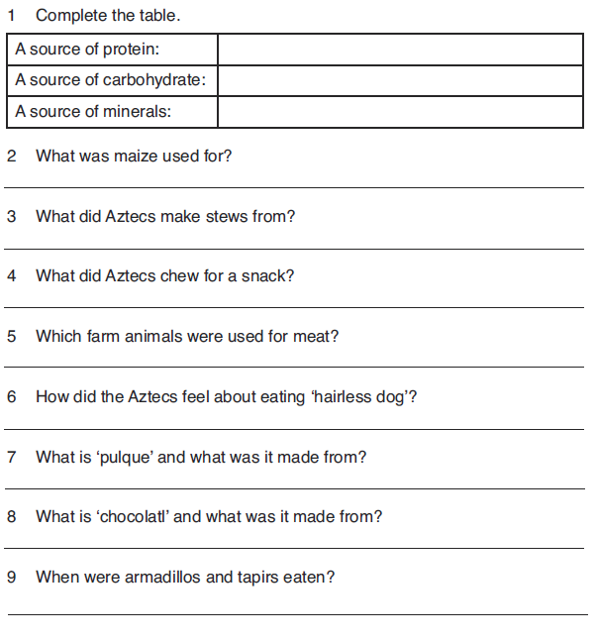Challenge: Write a short menu to describe the different food courses to be served at an imaginary Aztec feast.
Tuesday 2nd June 2020
English SPAG
Year 5
Colons often introduce an explanation. The phrase that comes after the colon usually explains or expands on what came before it. It is also used before a list, quotation, answer or to provide contrast.
- 'Life is like a box of chocolates: you never know what you're gonna get.' In this example from Forrest Gump, the phrase that follows the colon explains why life is like a box of chocolates.
- 'I love watching films after school: comedies are my favourite.' The phrase that follows the colon here expands on what the person loves about watching films.
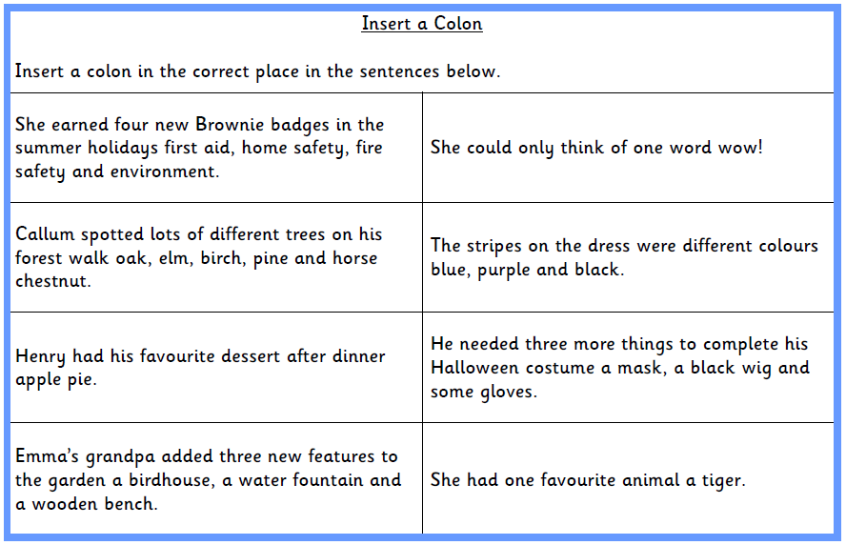

Year 6
Colons often introduce an explanation. The phrase that comes after the colon usually explains or expands on what came before it. It is also used before a list, quotation, answer or to provide contrast.
- 'Life is like a box of chocolates: you never know what you're gonna get.' In this example from Forrest Gump, the phrase that follows the colon explains why life is like a box of chocolates.
- 'I love watching films after school: comedies are my favourite.' The phrase that follows the colon here expands on what the person loves about watching films.
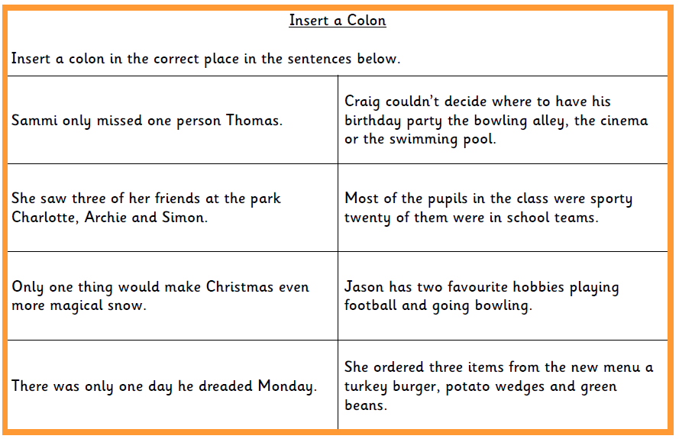
Wednesday 3rd June 2020
English Writing
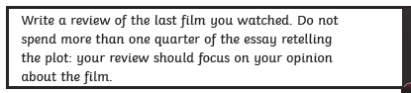
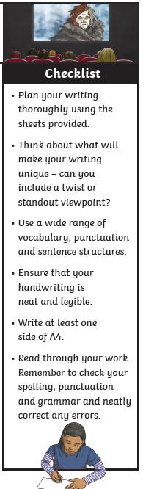
Writing a review

Please click on this link for more ideas about how to write a review:
https://www.bbc.co.uk/bitesize/guides/zqt7k7h/revision/2

If you have not watched a film at home, then please write a review on one
of the films you have watched in school.

Thursday 4th June 2020
Spellings
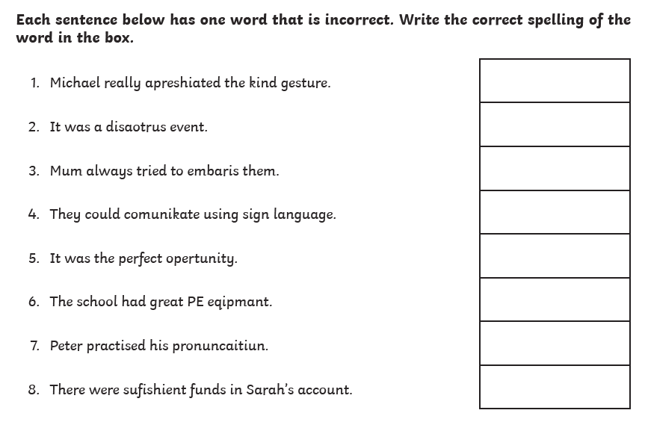

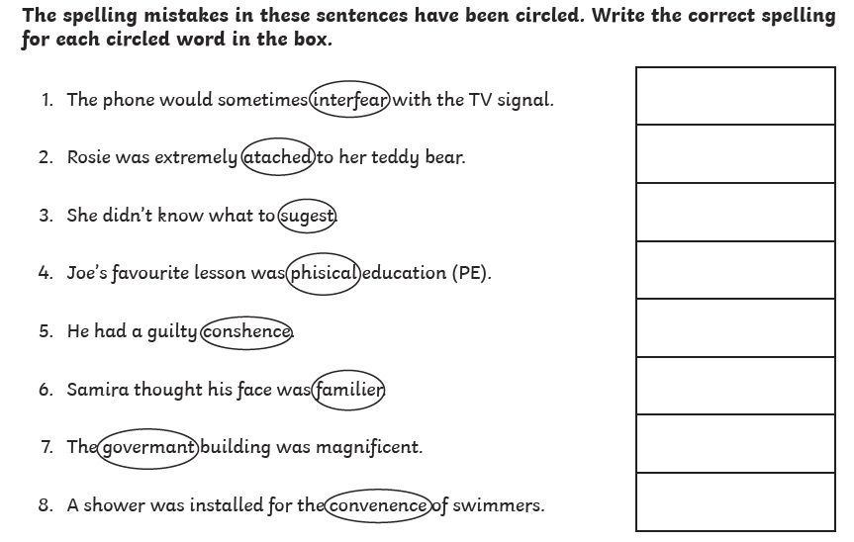
Now write a sentence using each word that you corrected. Make sure the word is written in the correct context
Friday 5th June 2020
Reading comprehension
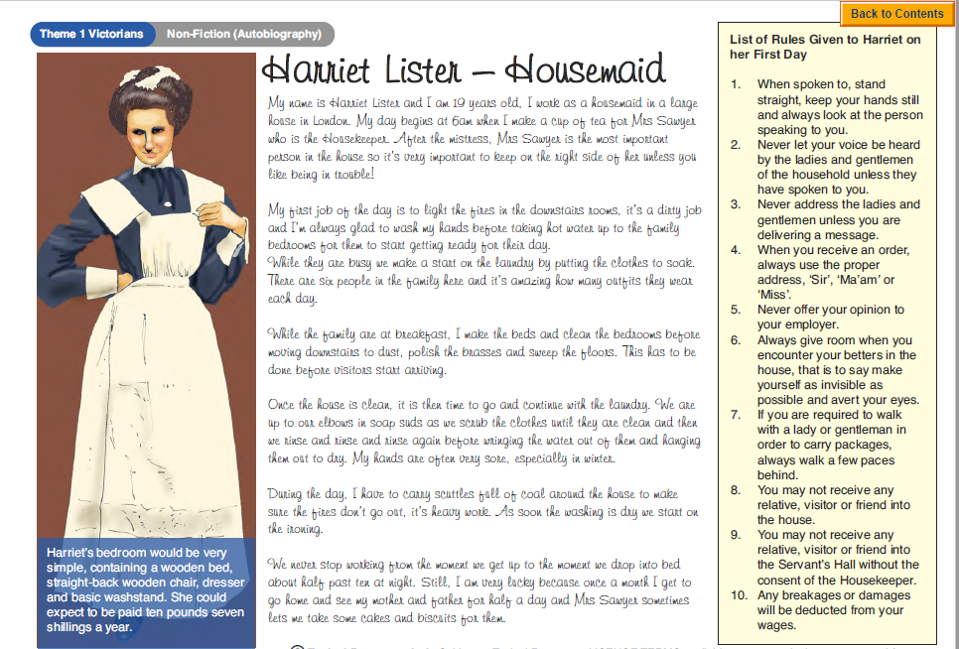
Questions
Year 5- Answer questions 1-7
Year 6- Answer questions 1-9
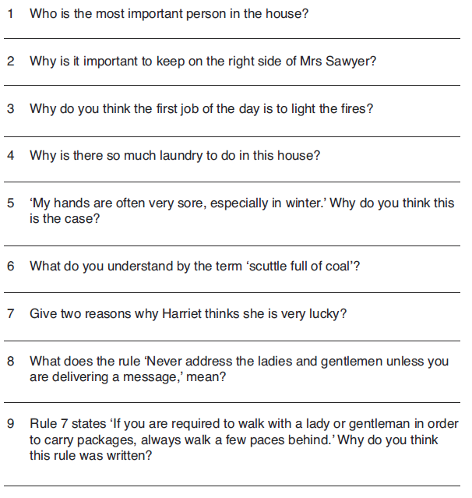
Challenge: Imagine you are a maid or a servant in a large Victorian house. Write a timetable for your long day fitting in as many jobs as you can.

