Week 11- Monday 1st June 2020
Year 3 & 4
6 Times Table

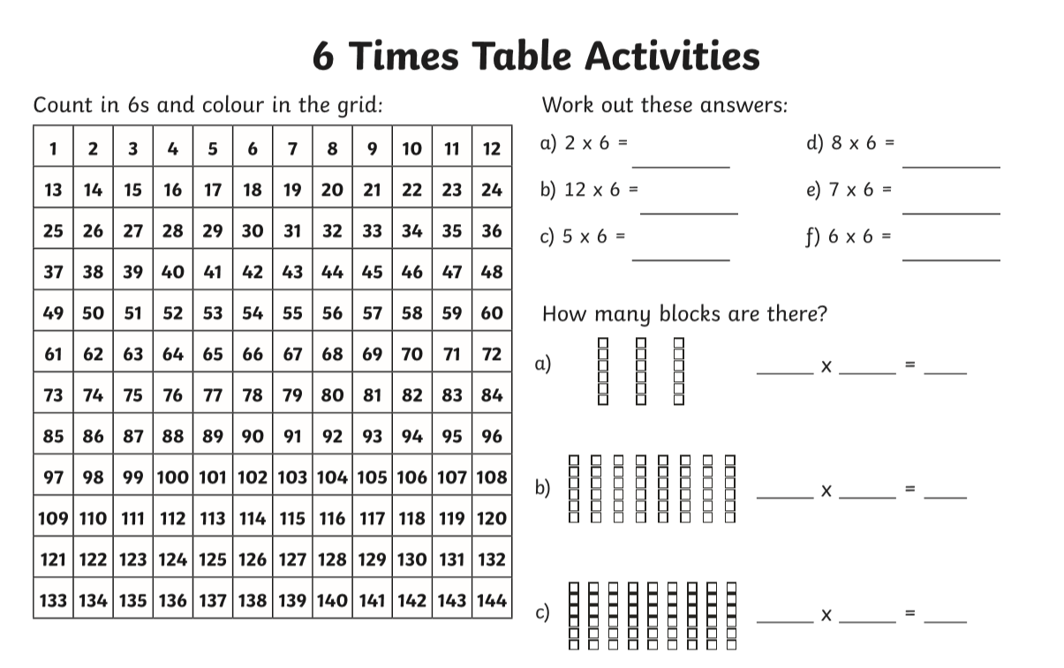
Year 3 – Challenge
66 divide by 6 =
42 divide by 6 =
30 divide by 6 =
36 divide by 6 =

Now learn and answer the 12 times table questions!

Year 4
Year 4 Challenge

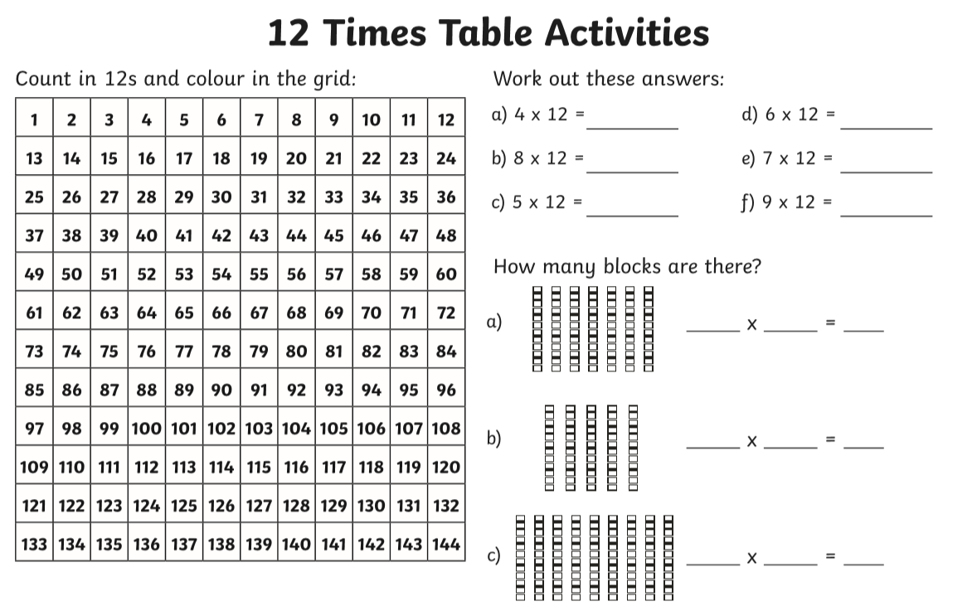
96 divide by 12 =
36 divide by 12 =
84 divide by 12 =
60 divide by 12=
72 divide by 12 =

