Week 11
Monday 1st June 2020 - English comprehension – Year 3 & 4
L.O: To answer reading comprehension questions by deducing and inferring information. Read the extract, then read the questions and find evidence from the text to answer the questions.
Viking Myths
Vikings loved to tell stories and recite poems. Lots of their stories are about the Norse gods. Here is one called “Loki’s children”:
The Norse God of mischief Loki and the Giantess Angroboda had three monstrous children. The eldest was the wolf Fenrir; the second was Jormungand, greatest of serpents; and the third was a daughter called Hel. Hel's looks were quite likely to single her out. Although most of her body was normal, from her hips down, every inch of Hel's skin looked decayed and greenish-black. Her expression was always the same: gloomy, lazy and selfish.
"Expect nothing from them but the worst," one of the gods said. "Expect them to harm you and endanger you.” And so the gods agreed that Loki's children must be captured. So a group of gods crossed by night into Jotunheim, the world of the giants. They burst into Angroboda's hall, gagging and binding her and they then kidnapped her children and carried them back to Asgard, the home of the gods.
The god Odin was in no doubt as to what should be done with the serpent. He picked up Jormungand and hurled him into the ocean surrounding Midgard, the world of men. Jormungand hurtled through the air smashing through the iron face of the water. There he lived and there he grew.
Odin was just as sure what to do about the serpent's sister. He took one look at Hel and hurled her out of Asgard down into the mist and darkness of Niflheim, the world beneath the worlds. As she fell she heard Odin's order that she should look after the dead, all those in the nine worlds who died of illness or old age.
Fenrir was dealt with as well, but that’s another story . . .

Questions- Year 3 can answer questions 1 to 5
Year 4 should attempt to answer all the questions.
- Please answer in full sentences e.g. Why do you think Odin punished Hel by making her look after people?
Answer- Odin punished Hel by making her look after people because …………………………….
- Give the names of Loki’s 3 children
__________________________________________________________________________

- Where were the children taken to when they were captured?
__________________________________________________________________________
__________________________________________________________________________

- Read the sentence about Jormungand being thrown into the water. Is he travelling quickly or slowly?
How do you know?
______________________________________________________________________________________
______________________________________________________________________________________
_________________________________________________________________________

- Describe Hel’s looks and personality in your own words:
__________________________________________________________________________
__________________________________________________________________________
__________________________________________________________________________

- Why do you think Odin punished Hel by making her look after people?
__________________________________________________________________________
__________________________________________________________________________
__________________________________________________________________________

- How do you think Loki and Angroboda felt when their children were taken away?

- What do you think might happen to Fenrir?
Tuesday 2nd June 2020
LO: I can add modifying nouns and adjectives to create expanded noun phrases.
Look at the sentences below. The noun phrases are very short. Can you improve the sentences by expanding the noun phrase? The first one has been done for you.
Expanded Noun Phases Year 3: 1-10 Year 4: 1-15

Example:
The _____ car ______ drove down the _______ road.
The impressive, red car with huge, black tyres drove down the winding, narrow road.

- There was a _____ spider climbing up the ______wall.
- India has lots of _____ temples and _______ rivers.
- The _____ rainforest is home to many ___ animals and ____ birds.
- The _____children chased the ______cat around the playground.
- The _____ volcano erupted and splattered ____ lava everywhere.
- ______ rocks can be found underneath the _____ ground.
- In the ______ morning, the ____ sun was in the _____sky.
- Zaynab skated on the ______ lake and won a _____medal.
- Yunus helped make ______ cookies and _______ cake.
- Musa wrote a _____ story in his ______ homework book.
- Abdur Rahman found a ______ diamond in his ______ garden.
- Sabreen wore her ______ dress to the _______ party.
- Issa had a ________ dream about a ________ monster.
- Zahra and Maymunah went to the _____ park to feed the _______ ducks.
- Khadar read the ______ Quran before he went to his ____ bed.
Challenge: Now write 3 of your own sentences using expanded nouns. You can include prepositions to improve your sentence further and add more detail.
Example: There was a candle in the room – There was a luminous, golden candle in the spacious, grand room which sat on top of the polished, wooden table.

Week 11
Tuesday 2nd June 2020
Spellings
Write and learn the following words in your book.
Write the words 5 times.
Use each word in a sentence.
Do not forget to use a capital letter and full stop in your sentences.
Challenge- can you use at least 2 of the words from the list in a sentence?
Example- It was important to learn the history of Omar Bin Khattab our second Khaleef.
- heart
- height
- history
- imagine
- increase
- important
- interest

Week 11
Wednesday 3rd June 2020
English writing – Year 3 & 4: Task: LO: To write the story that follows the passage.
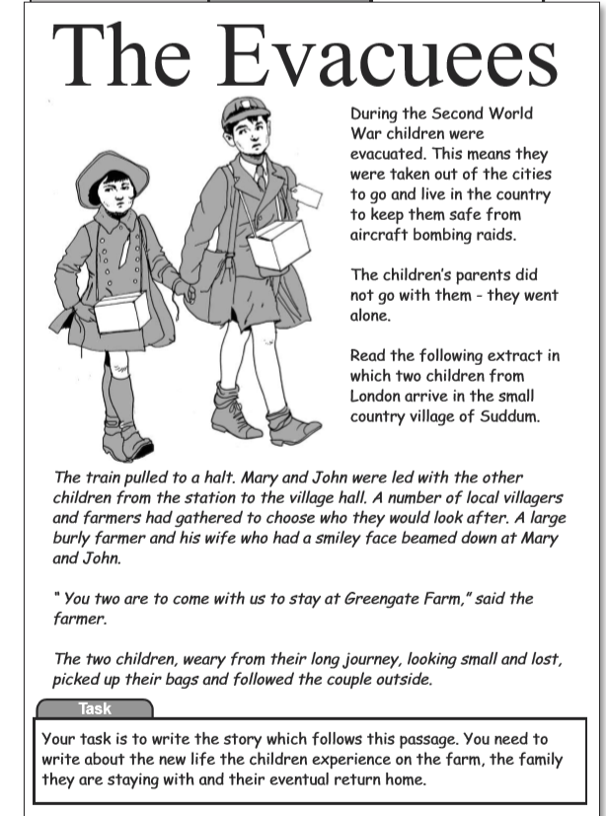

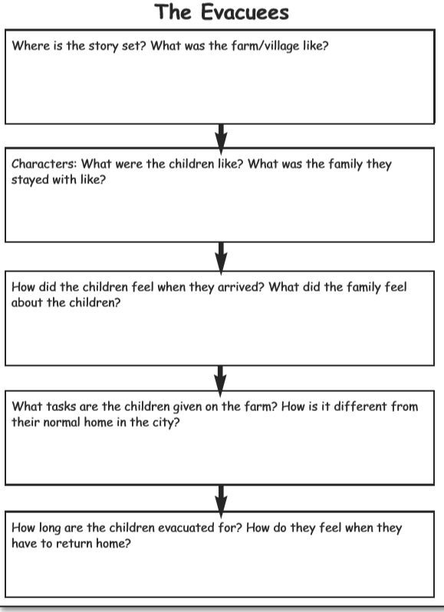
Do not forget to:
- Use capital letters and full stops.
- Include lots of adjectives (describing words) and adverbs (to describe the verbs)
- Read each sentence to check if it makes sense.
- Use a wide range of punctuation including at least 3 of the following: full stop and capital, question mark, exclamation mark, apostrophe and comma.
- Use more sophisticated connectives, (e.g. although, however, nevertheless, despite, contrary to, as well as etc).

Success Criteria
- I have described the setting and the atmosphere using descriptive language
- I have shown the feeling of my characters as they deal with the problem
- I have finished writing effectively to complete the story
- I have written in paragraphs and each paragraph contains a new idea or event.
- I have used time words to help the reader follow the story
- I have used speech carefully with the correct punctuation
- I have checked my work carefully and have corrected any spelling grammar or punctuation mistakes.

Week 11
Thursday 4th June 2020
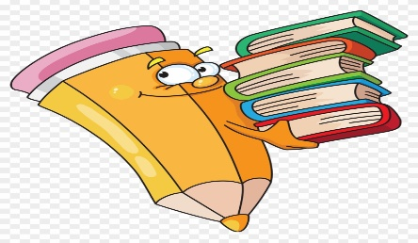
Reading and book review – Year 3 & 4
Choose a book to read and answer the following questions about your book.
Book review by: ________________________________________________________
Title:_____________________________________________
Author: ___________________________________________
Non-fiction Fiction
What is the book about?
______________________________________________________________________________________
_____________________________________________________________________________________
Who would this book be suitable for? Age/interests

______________________________________________________________________________________
What was your favourite part? (Describe)
______________________________________________________________________________________
Year 4 challenge: Would you/would you not recommend the book to someone else? Why?

Week 11
Friday 5th June 2020
Comprehension: Read the report and answer the questions in your home learning book. Make sure you date your work and write the title. Remember answers should be written in full sentences.

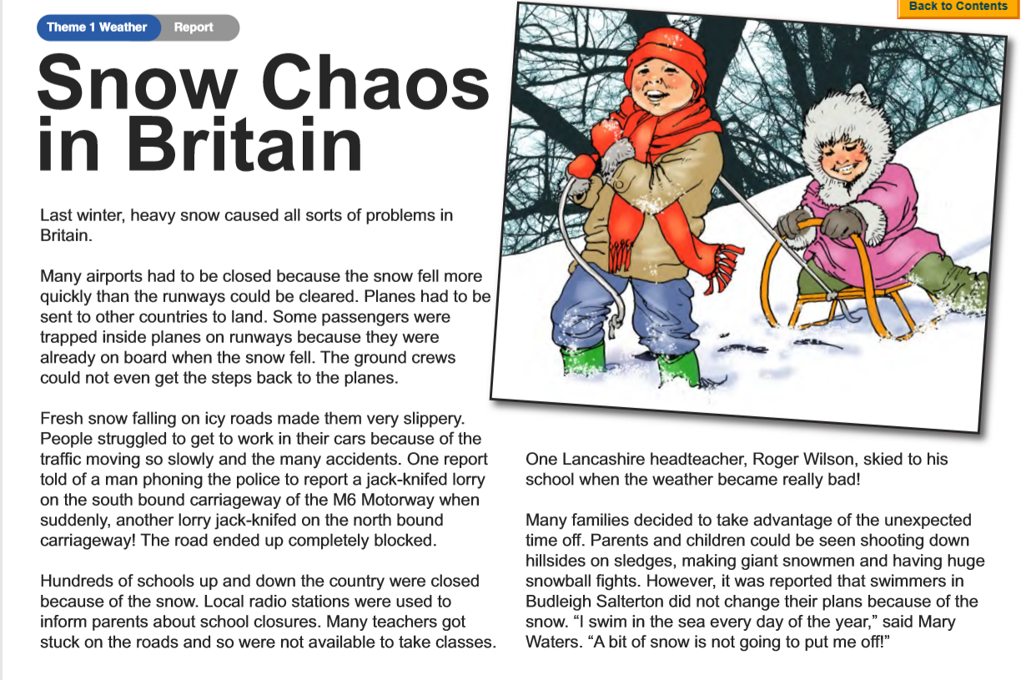

Questions:
Choose the best word or group of words to fit the passage and put a ring around your choice.
- Last winter snow caused problems in Britain. Many
- Roads
- Airports
- Docks
- Stations

were closed because runways could not be cleared fast enough. People struggled to get to work by
- Bicycles walking bus car
Because of the many accidents. The M6 motorway was completely blocked when

- Two
- Three
- Four
- Five
Lorries ‘jack- knifed’ in the snow.

- Which lady swimmer was not put off by the snow?

- What made the roads very slippery?

- How did parents and children know if their school was closed because of the snow?

- How did one headteacher get to school when the snow was bad?

- How do you think the people inside the plane felt when they were trapped by the snow?

- What does the phrase ‘take advantage of the unexpected time off’ mean?

Year 4 Challenge: Write about all the things you would do if you were unable to go school because of heavy snow.

