Summer 2
Reception Writing Tasks

Dear Parents/Carers,

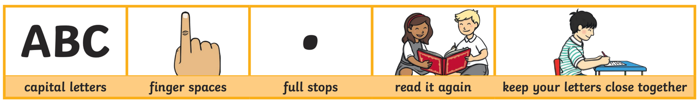
Your child will be expected to complete one writing tasks each day. Please ensure your child is writing in full sentences independently.

Encourage your child to use the above key when writing their sentences.

Success Criteria:
Has your child used capital letters?
Has your child used finger spaces after each word?
Has your child used a full stop at the end of their sentence?
Can your child read what they have written, and does it make sense?
Has your child made sure they have written their letters correctly in a way that can be understood and read by others?

Monday 1st June 2020

Can you tell us what you did to celebrate Eid with your family? We would love to hear what you have been doing.

__________________________________________________________________________________________________________

Tuesday 2nd June 2020

Can you highlight all the words that you can read and write independently?

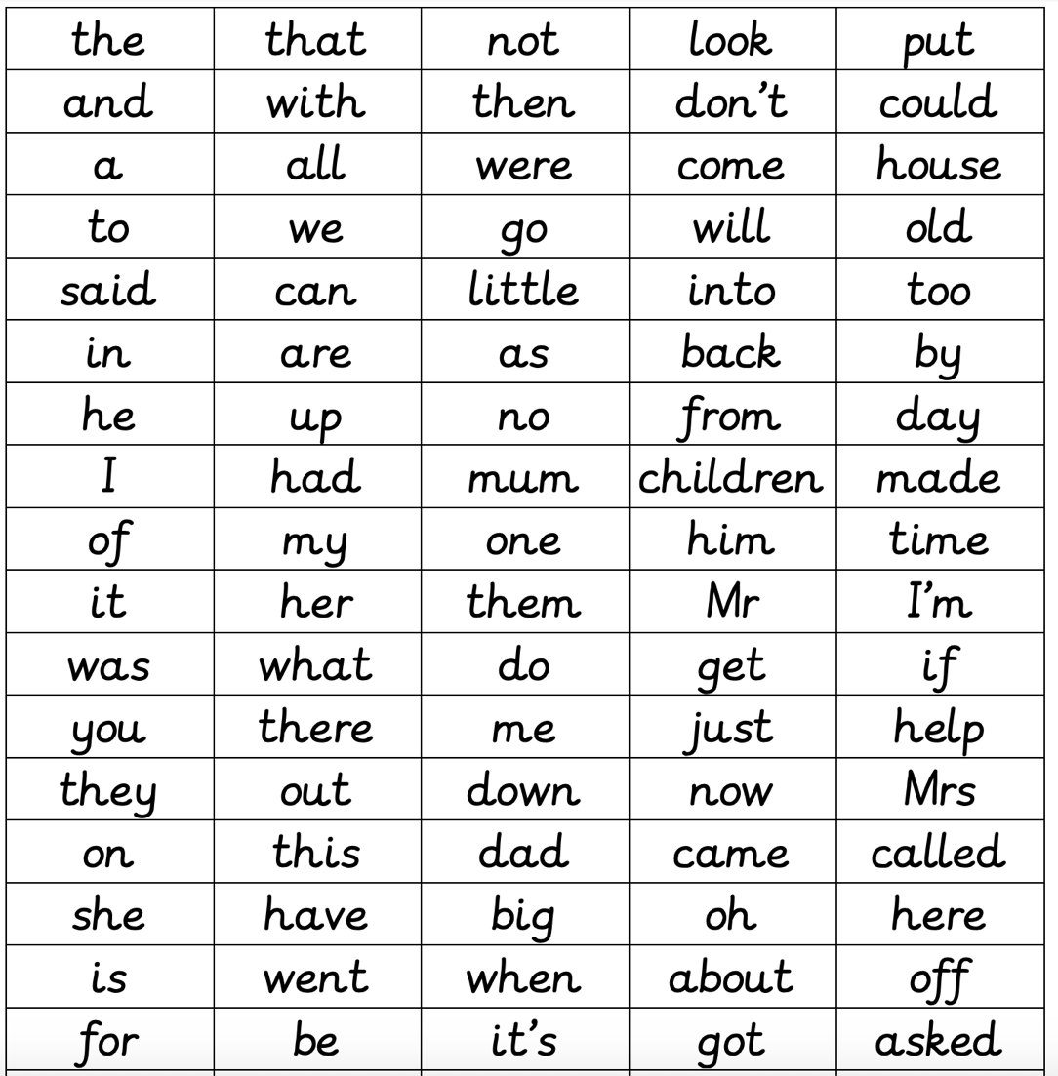

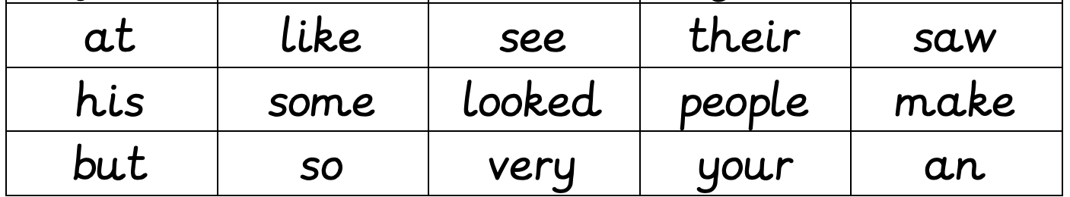

Wednesday 3rd June 2020

Read the following text and answer the questions on the next page:
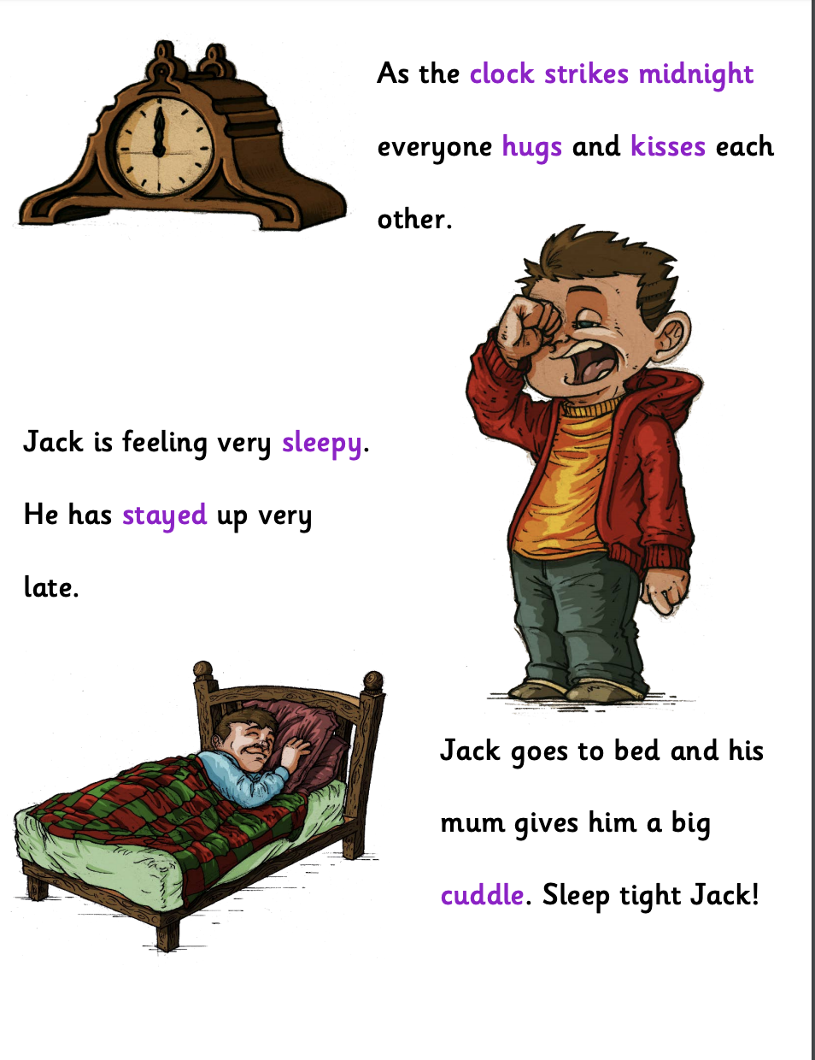
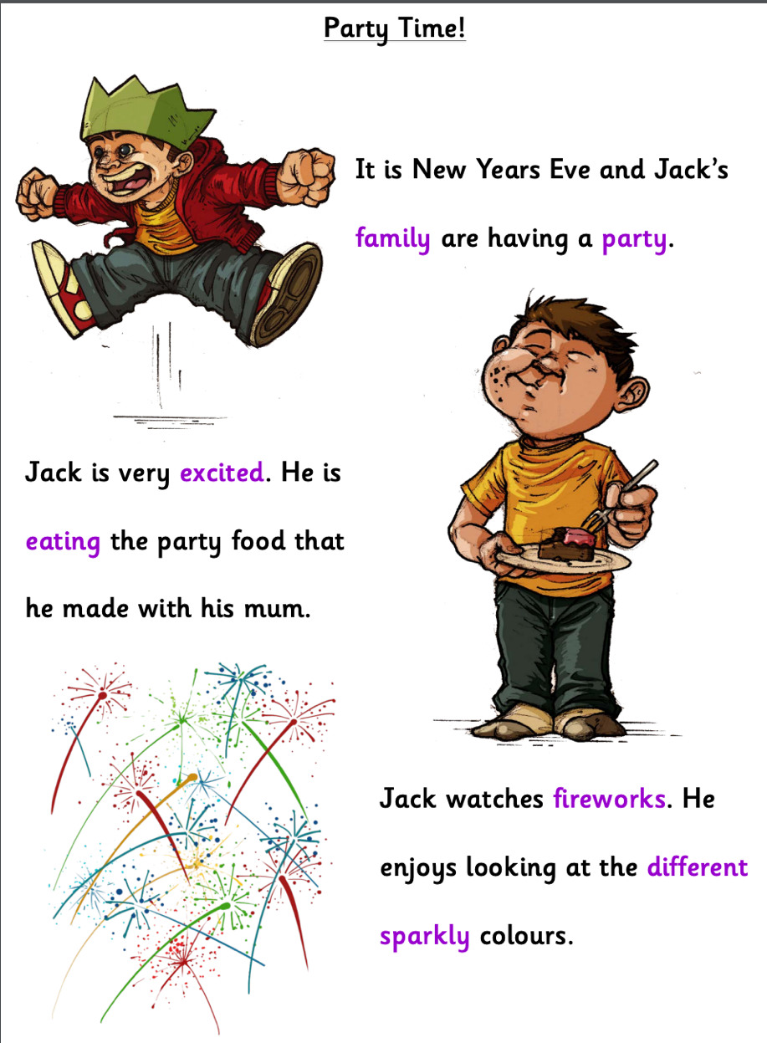

Answer the following questions:

What is Jack’s family doing?

________________________________________________________________________________

How was Jack feeling?

________________________________________________________________________________

Why is Jack’s family having a party?

_________________________________________________________________________________

Why did Jack go to bed?

_________________________________________________________________________________
Thursday 4th June 2020

Read the following words and match them to the picture. If you want, once you read the word you could draw a picture instead to match the word you read!

Sheep

Train

Horn

Purse

Light

Friday 5th June 2020

Look at the picture below. Can you write what you can see in the picture? Remember to use as many adjectives as you can!
