Week 6
Wednesday 29th April 2020
Year 6
Maths reasoning and problem solving
Please show your working out for each question

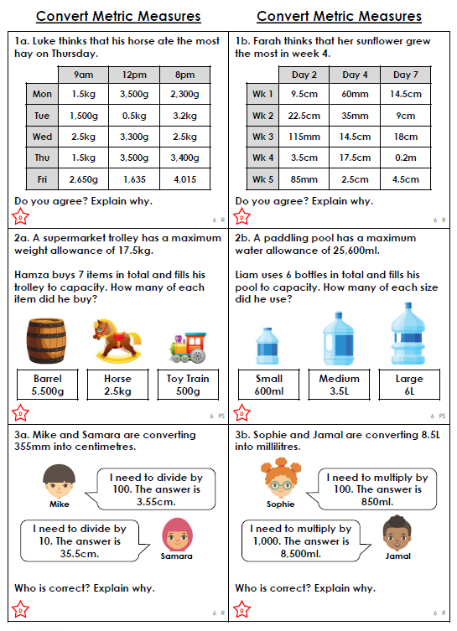

Please show your working out for each question

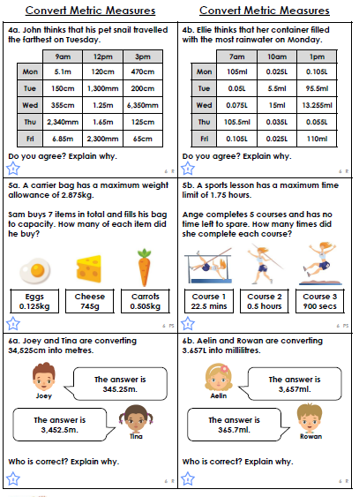

Please show your working out for each question

