Week 6
Friday 1st May 2020
Maths Reasoning and problem solving- Yr 5
Please click on this link for revision on metric units https://www.youtube.com/watch?v=1TlCcW_mugs
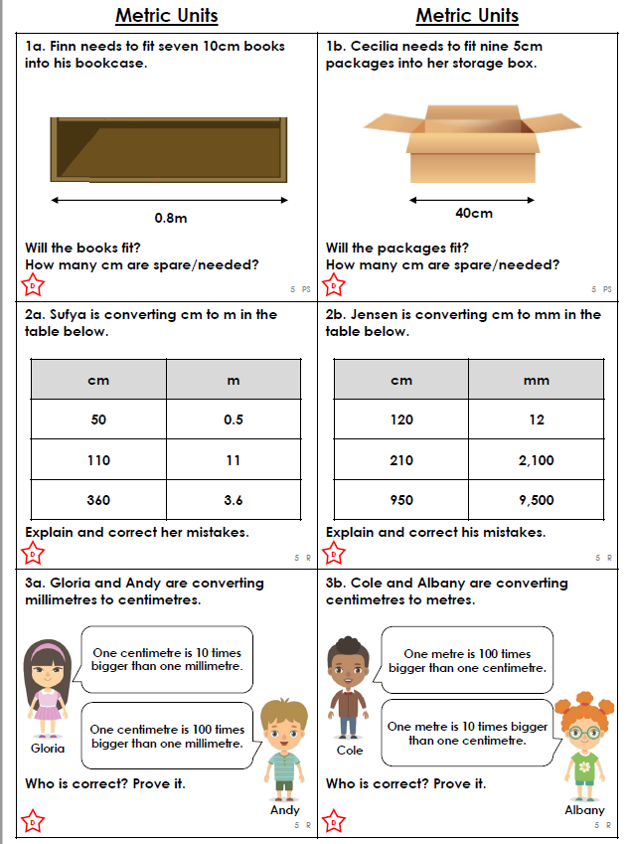
Please show your working out for as many questions
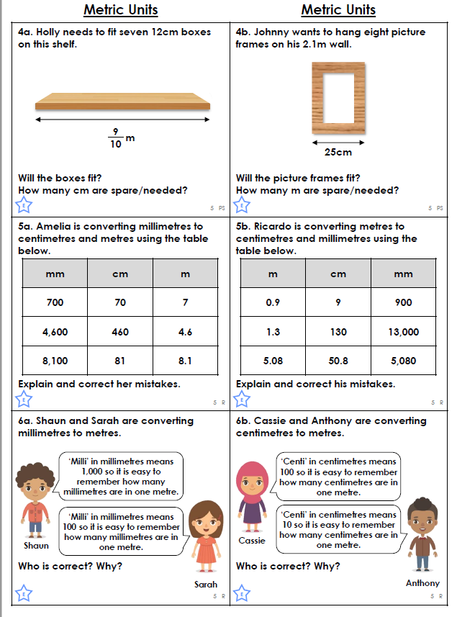
Please show your working out for as many questions

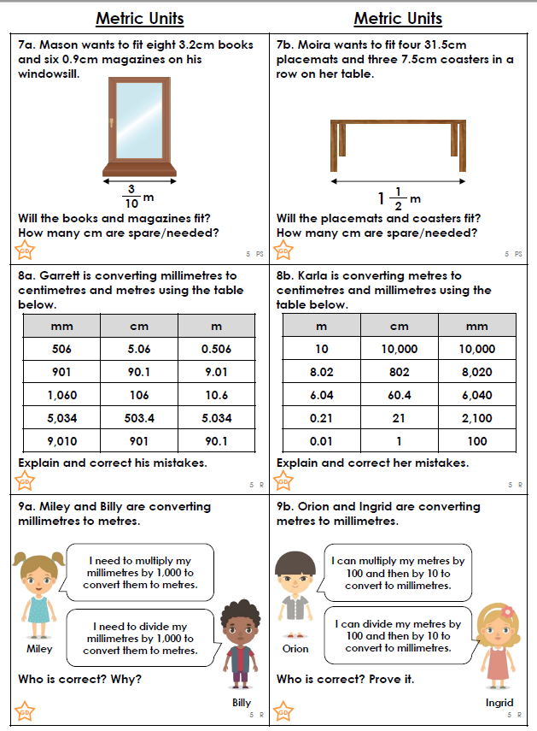

Please show your working out for as many questions

