Week 6 Monday 27th April 2020
Year 3 & 4
4 Times Table
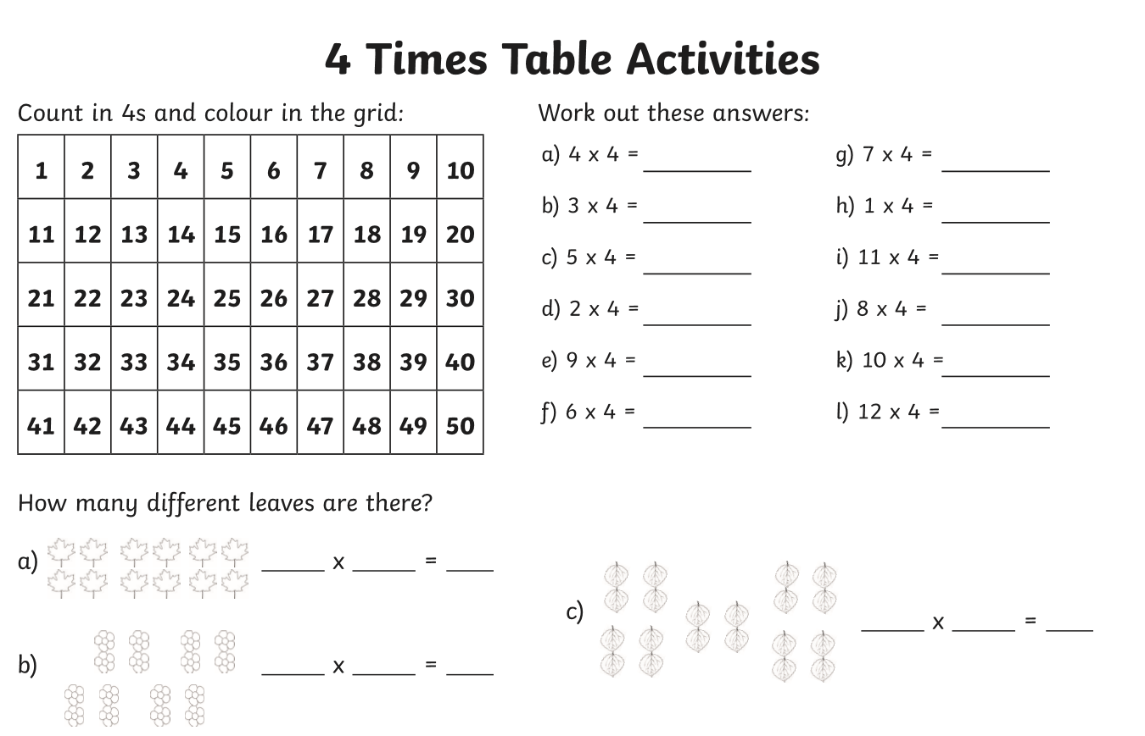
Year 3 – Challenge
40 divide by 10 =
36 divide by 4 =
44 divide by 11 =

Now learn and answer the 8 times table questions!
Year 4 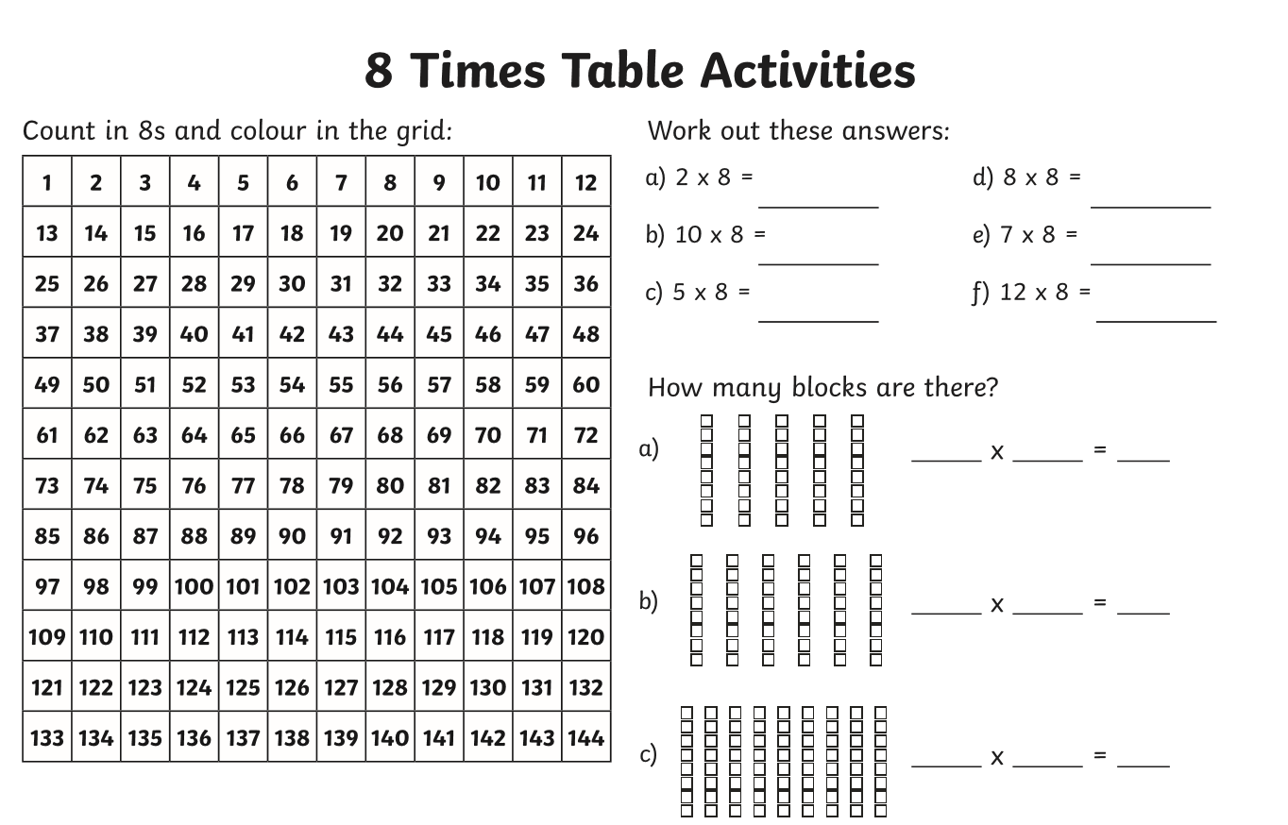
Year 4 Challenge
16 divide by 8 =
56 divide by 7 =
40 divide by 5 =
94 divide by 12 =
48 divide by 6 =

