Week 6 Reception Handwriting

Encourage your child to practice writing a letter a day in their neatest handwriting. Once your child has completed each letter, get your child to practise writing the following words below using cursive handwriting.

Monday 27th April 2020
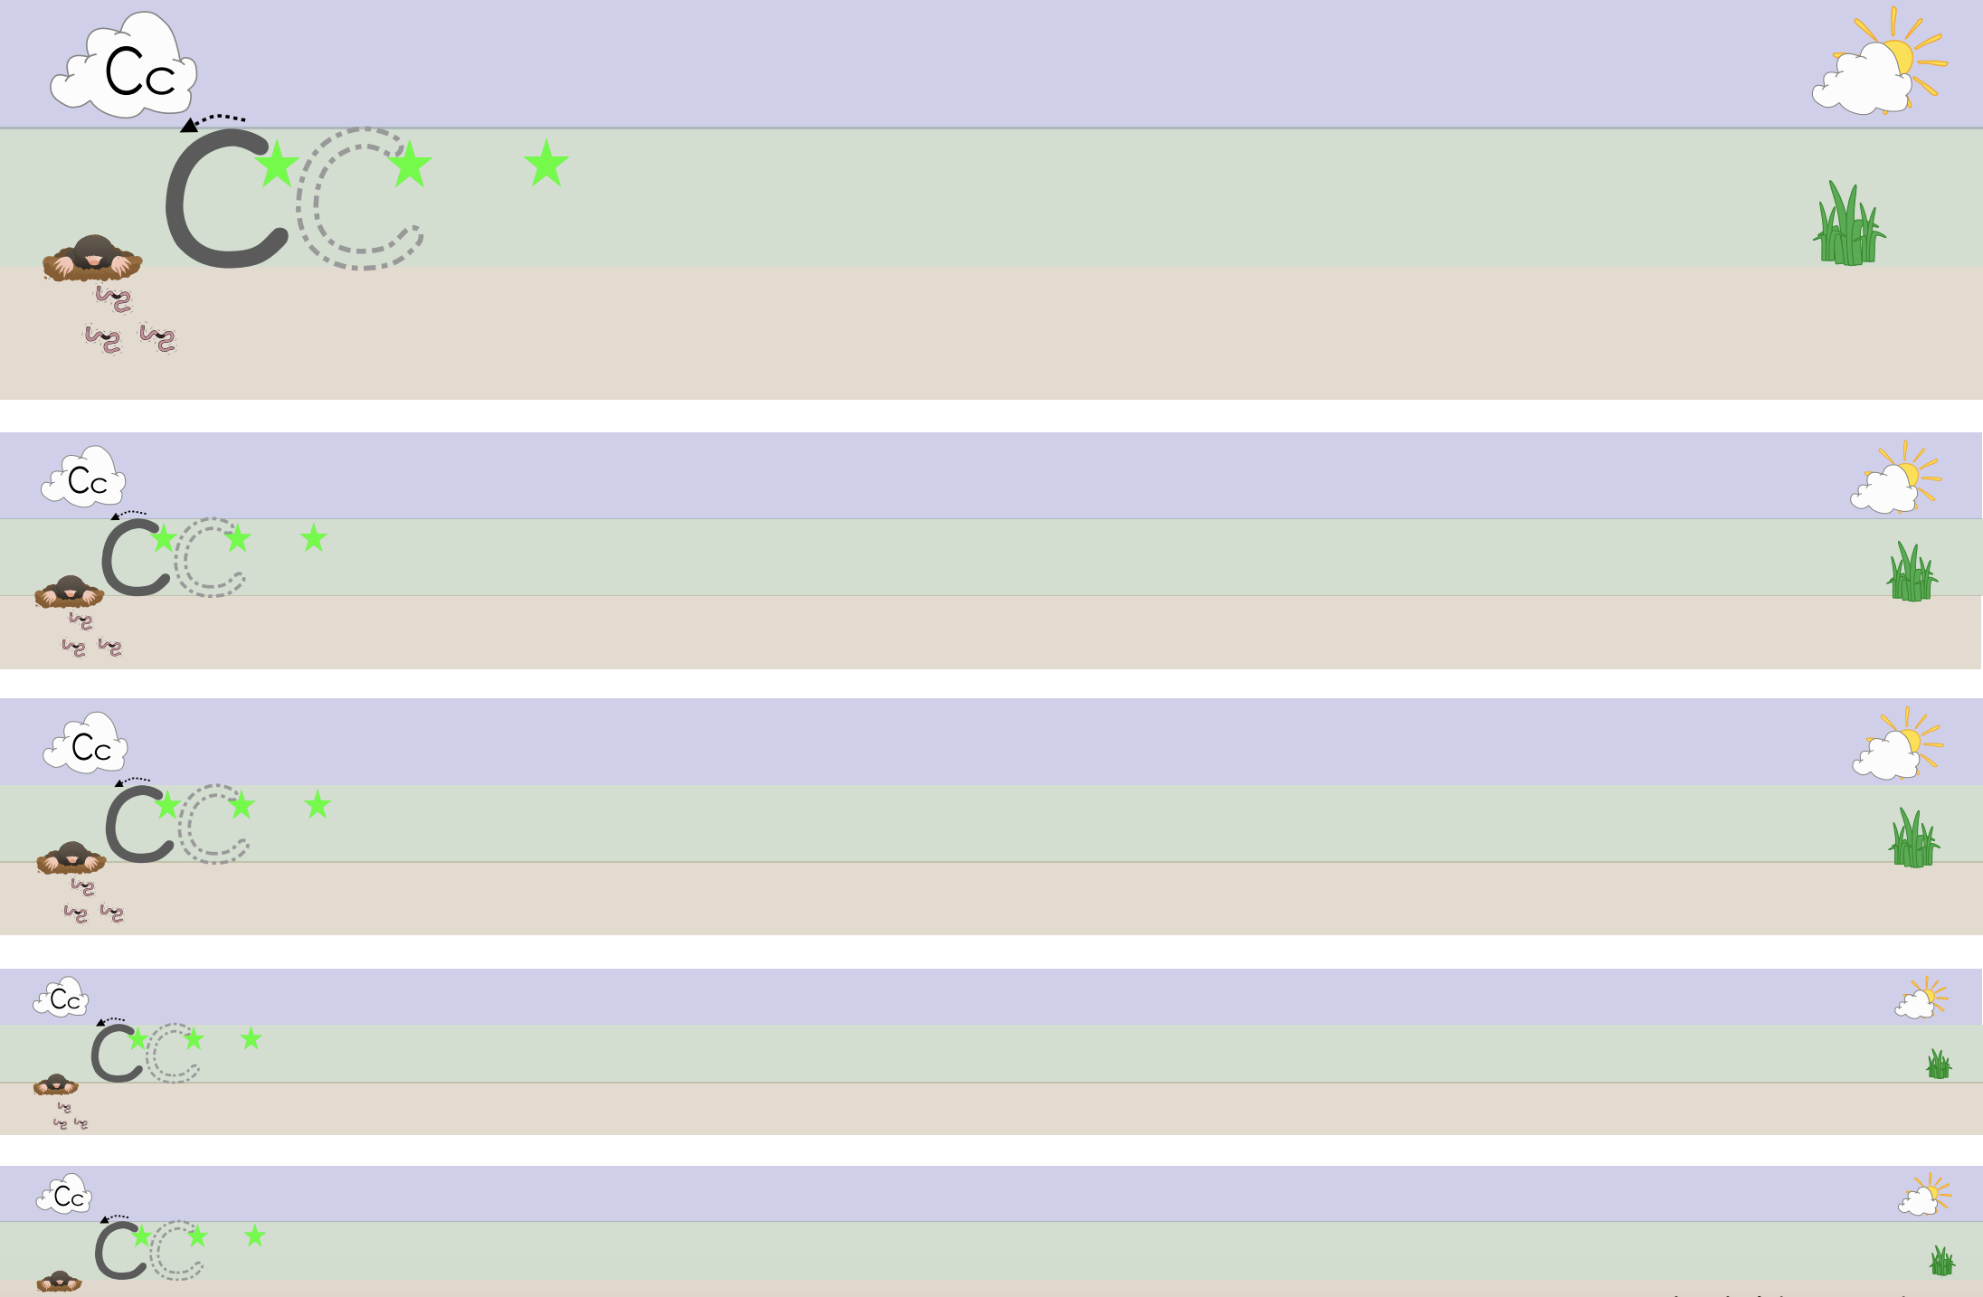

cat, can, cot, cup
Tuesday 28th April 2020

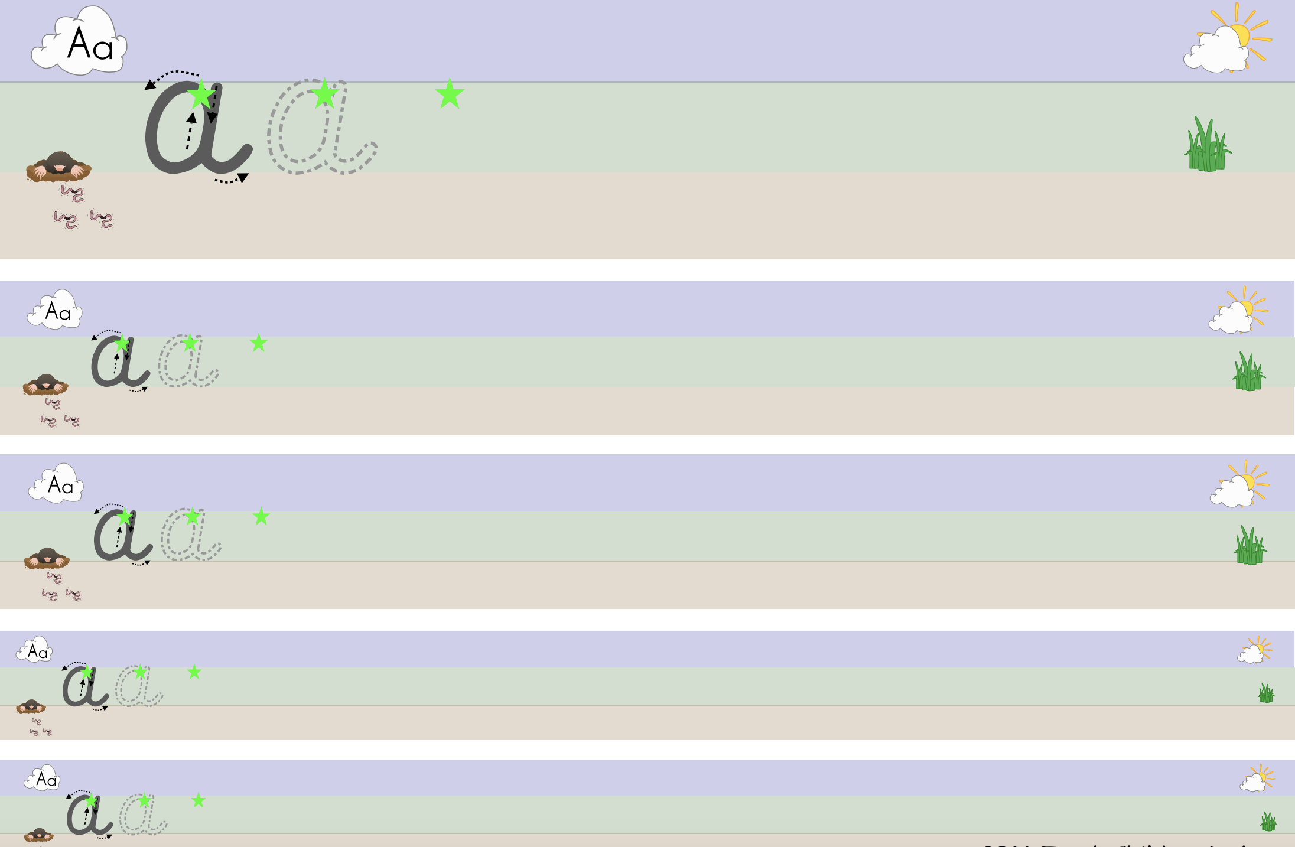

at, an, am

Wednesday 29th April 2020

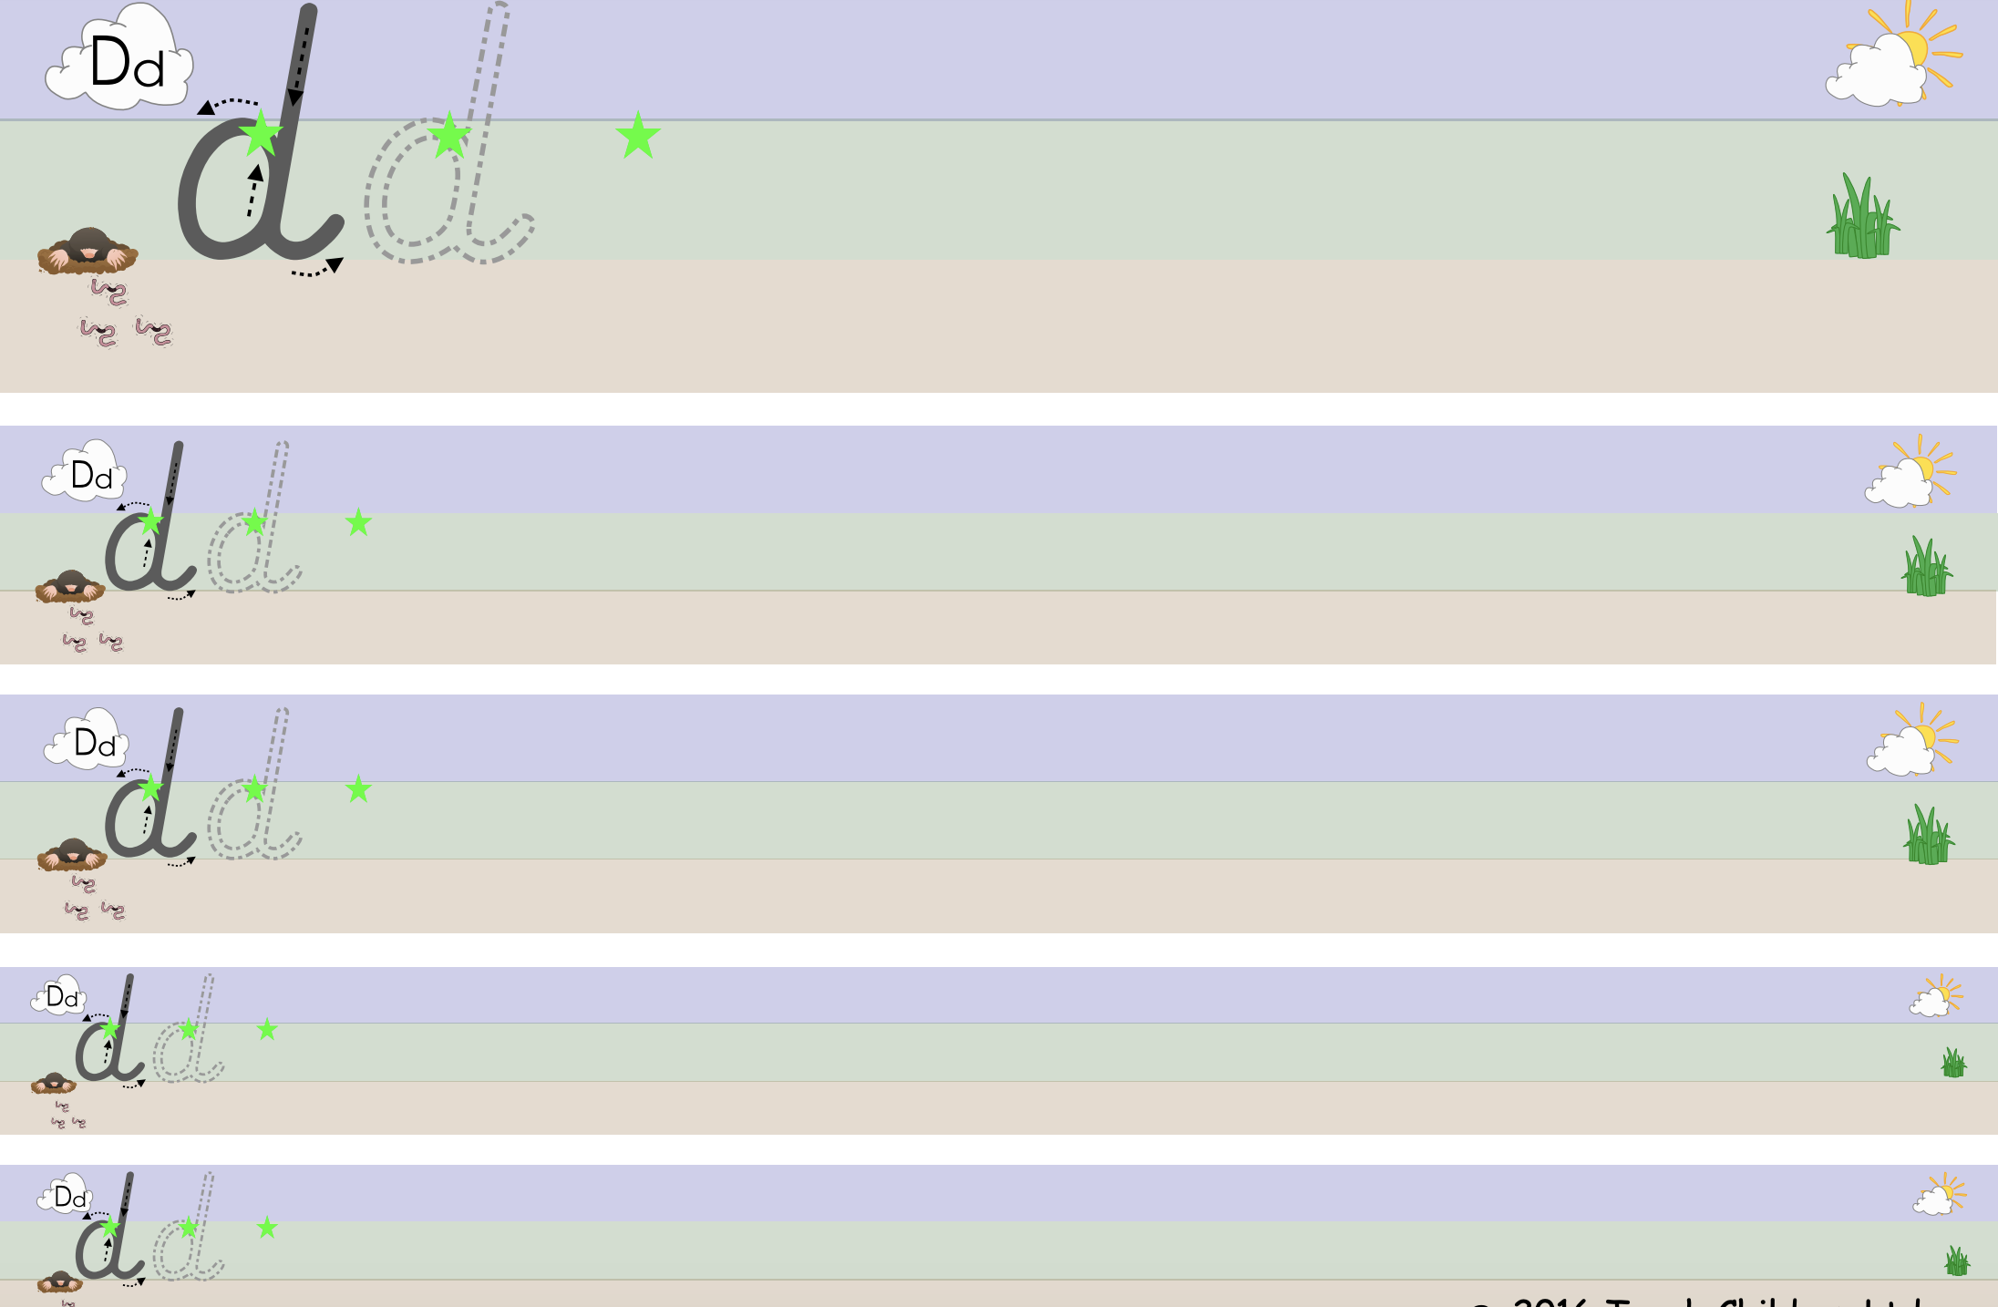

dog, dig, doll, dim

Thursday 30th April 2020
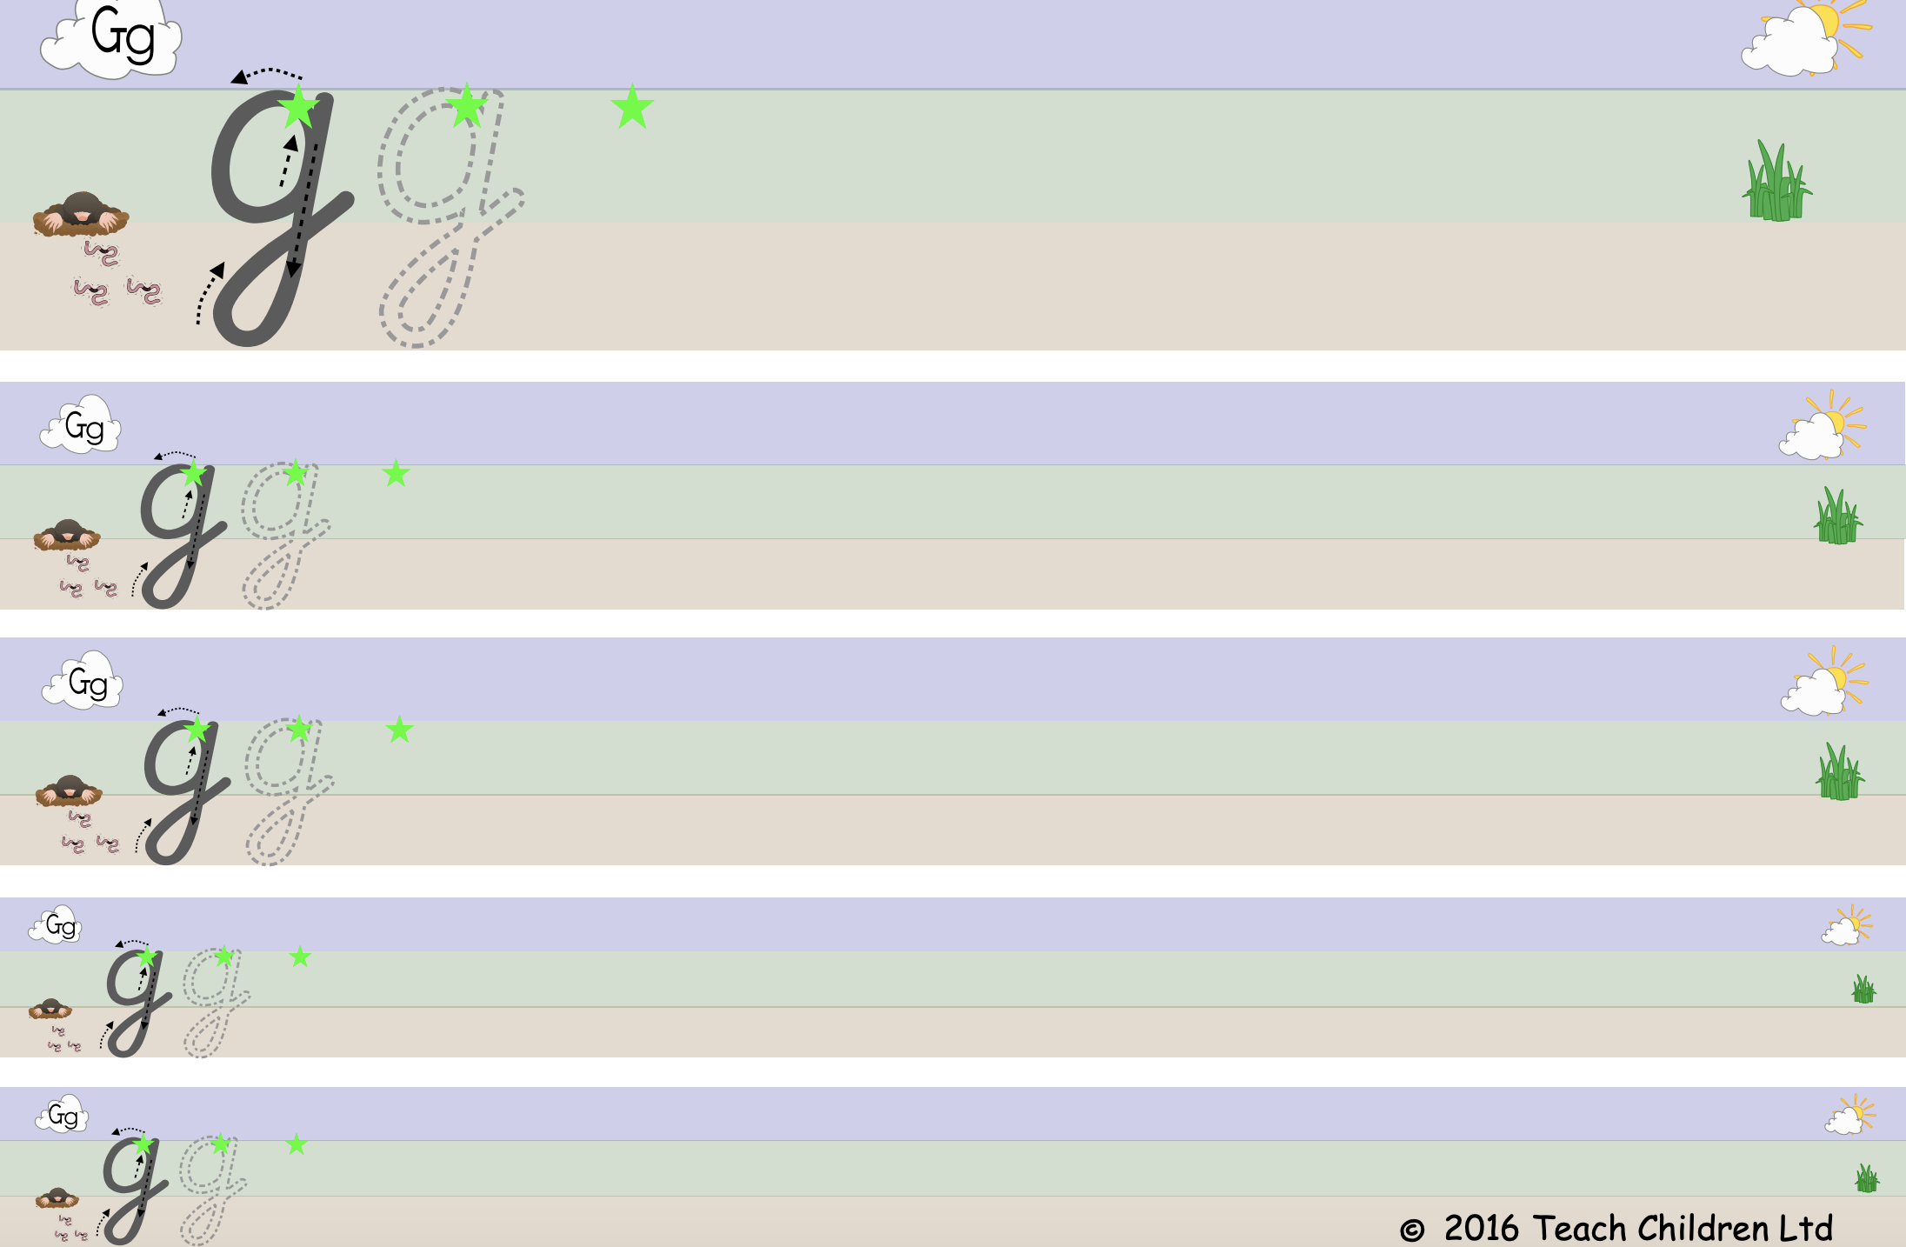

got, get, go, gel

Friday 1st May 2020

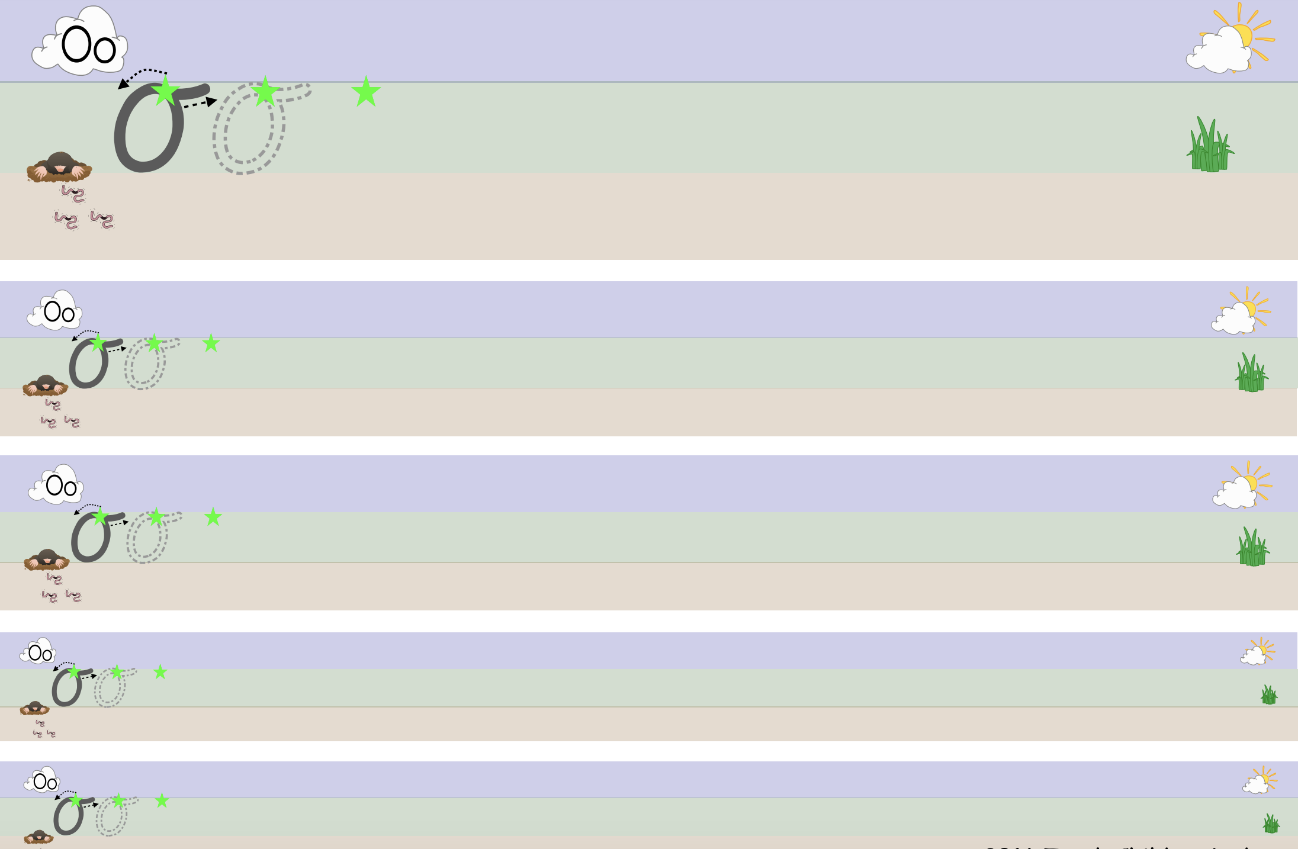

on, of, oil, out

