Key stage 1 and 2  Watch the movie and take part in some of these fun activities that are linked to the different subjects. | Lion King  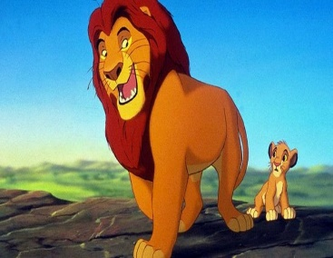  Please email the school with your child’s work stating their name and year group. We would love to celebrate their work on our school website.  Email: info@buttercupprimaryschool.co.uk
Geography | What continent is the movie set in? What oceans/seas are surrounding this continent?  Draw the continent outline and research the countries within. Add these to your map.
Science | Life cycles and Food chains  Choose an animal from the movie and draw a life cycle poster.  Design and draw a comic strip showing the food chain for the same animal.
English | Narrative with dialogue Write a side story linked to Timone and Pumba. It could be about an adventure that they go on together.
D&T/Art/ICT | Design and make puppets to retell the story. You can use different materials to make the puppets.  You can draw or paint one of the beautiful landscapes of Africa that are featured in the movie. Use the internet to research the different landscapes.
Islamic links | What rights have Islam given to animals?  Name some surahs that are named after animals and insects.  Read imam al Ghazali’s story below and answer the questions (KS 2)

Holiday work KS2
LO: To understand that time is precious
The story of life.
Imam Ghazali told a story of a man walking in the jungle. A roaring lion ran towards him and the man ran as fast as he could to escape from it. He noticed a well in front of him and he jumped inside hoping to escape from the lion.
As he was falling inside the well, he grabbed onto the rope and saved himself. The man was so relieved but when he looked down, he saw a big snake at the bottom of the well. It had its jaws wide open ready to swallow him up.
The man then looked up and saw two mice nibbling at the rope. A black mouse and a white were both chewing into the rope. The scary lion was still prowling outside the well.
The man's heart was pounding as he wondered how he could escape from this. Then he noticed a honeycomb in front of him which had delicious honey dripping from it. He stuck his finger into the honey and put it inside his mouth. It was delicious and for a moment he forgot about the lion, the snake and the two mice chewing at the rope.
Imam Ghazali explained that the lion is like the angel of death which is always looming above us. The snake was like his grave which all humans will face. The black mouse and white mouse were like the day and night which are always nibbling at our life (the rope). The honey was like this dunya which with its momentary sweetness makes us forget the death and the eternal life.
“He it is Who gives life and causes death, and to Him shall you all be returned.” Quran Yunus verse 56
- What have you learnt from this story?
- The honey was portrayed as distraction in this world, write a list of things that distract you from spending time effectively.
- Create a plan for yourself for the month of Ramadan. Here are some examples of the activities you can include: Reading 10 pages Quran, memorising a particular surah, helping parents with chores…

