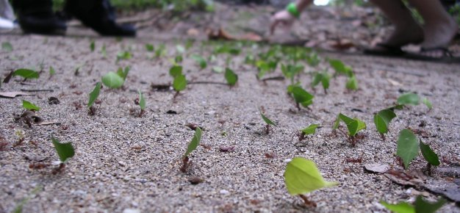

Carefully, read through the information and

guidelines on identifying and classifying

organisms in our local area to be able to

complete the related activity.

**\*You will need to use the review pack on**

**Classifying Organisms to help you complete the**

**challenge at the end**.

**Information and Activity Pack 3:**

**Identify and Classify Organisms in Our Local Area**

**Classifying Organisms**

**Learning Objective:**

**To be able to identify and classify organisms in the local area.**

**You are going to be exploring your local area to see what kind of organisms there are and what they are like.**

What kind of plants would you expect to see?

What kind of animals would you expect to see?

What kind of microorganisms would you expect to see? (Trick question!)

When you are looking at the plants and animals in the local area, you might not know straight away what each one is called. There are so many different types of trees, flowers and insects, for example, that sometimes you will need to do some research to identify what you see. To do this, you will need to gather some evidence so that you can remember the features of the organism. As long as you handle them carefully and put them back in their habitat, you can gather samples of insects and other small animals so you can research them once you get home.



You can also take a magnifying glass with you to study the organisms more closely. You can take photos too. If you don’t have a camera, you can draw labelled diagrams of the organisms. This is sometimes more useful than a photo as you can write notes about the features which you might not otherwise remember.



There are so many different types of trees and plants that it is sometimes really hard to tell them apart. Collecting leaf samples is a good way to identify an unknown tree as all leaves are different. If you can, collect leaves that have already fallen from the tree.



However, it is important not to pick wild flowers. They are delicate and need to stay in their habitat. You can take photos or draw diagrams though! 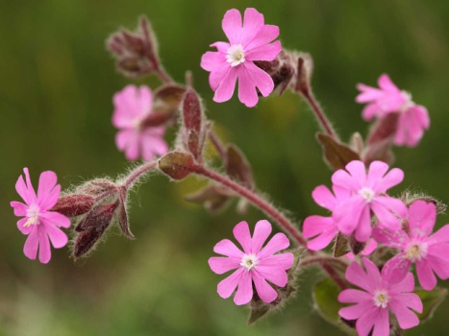

Once you are back home, if you need to find out what certain organisms are called, you can use lots of different sources of information to help you out. There are books with detailed illustrations to help you identify plants and animals. There are also lots of databases on the internet which can help you identify anything you are not sure about. You can always ask one of your family members!

 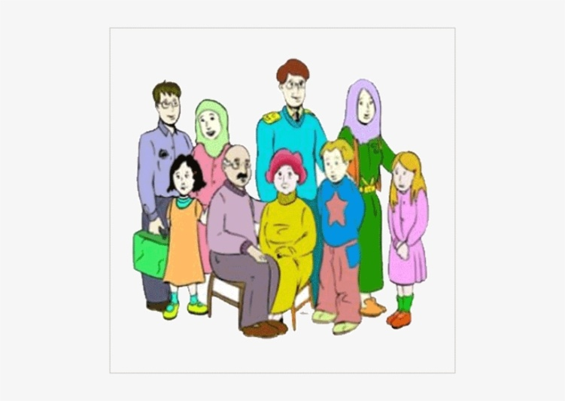

**The Organisms of our Local Environment**

|  |  |
| --- | --- |
| **Plant** | |
| **Mammal** | **Bird** |
| **Fish** | **Reptile** |
| **Amphibian** | **Insect** |
| **Mollusc** | **Crustacean** |
| **Arachnid** | **Myriapod** |
| **Echinoderm** | **Annelid** |
| **Micro-organism** | |

**Challenge:**

**Choose a country or location that is different to where you live. Use different sources of information to see if you can find at least one organism that fits into each of the categories below. Find more if you can!**

|  |  |
| --- | --- |
| **My chosen location is:** _________________________ | |
| **Plant** | |
| **Mammal** | **Bird** |
| **Fish** | **Reptile** |
| **Amphibian** | **Insect** |
| **Mollusc** | **Crustacean** |
| **Arachnid** | **Myriapod** |
| **Echinoderm** | **Annelid** |
| **Micro-organism** | |