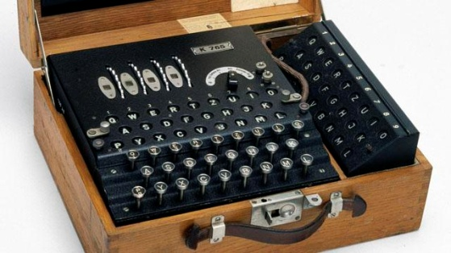
World War II code masters used fractions to code their information.
They would encrypt their messages using decimals and percentages to confuse their enemies. Can you crack the code?

A = 4/5 | B = 5/5 | C = 1/10 | D =1^{2/5} | E = 3/7 | F = 19/30 | G =7/5
H =1^{1/10} | I = 13/20 | J = 5/6 | K = 5/9 | L = 4/6 | P = 4/9 | N = 6/10
0 = 5/12 | M =1^{5/12} | Q = 1/12 | R =23/30 | S =7/8 | T = 1^{7/30} | U =1^{3/8}
V = 1/2 | W = 9/7 | X = 8/11 | Y = 7/12 | Z = 6/7
8. 1.6 – 5/6 =
9.3/2 – 0.7=
10. 0.66 – 1/6 =
11. 0.75 + 5/8=
12. 50% + 0.75 =
13. 80% + 0.6 =

1.5/6 + 40% =
2. 0.8 + 3/10 =
3. 1^{2/7} – 6/7 =
4. 125%– 3/8=
5. 0.75 + 2/3 =
6. 7/5 – 75% =
7. 1^{3/10} – 120% =

Use this cypher to crack the code
13

3

12

8

11

1

3

3

2

8

3

10

9

2

4

12
9
7

6
8
3
5
9

1

