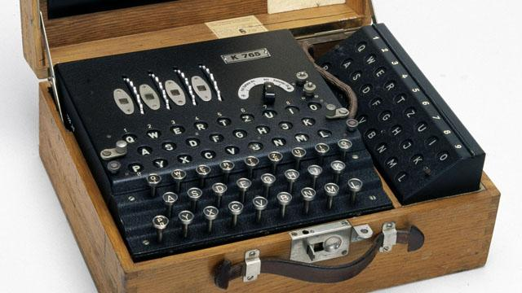
World War II code masters used fractions to code their information.
They would encrypt their messages using decimals and percentages to confuse their enemies. Can you crack the code?

A = 4/5 | B = 5/5 | C = 1/10 | D =1^{2/5} | E = 99/100 | F = 19/30 | G =7/5
H =42/100 | I = 5/6 | J =47/100 | K = 5/9 | L = 4/6 | M = 4/9 | N = 6/10
0 = 5/12 | P =1^{5/12} | Q = 1/12 | R =28/50 | S =7/8 | T = 1^{7/30} | U =1^{3/8}
V = 1/2 | W = 9/7 | X = 8/11 | Y = 7/12 | Z = 6/7
8. 75% - 0.19=
9.133% – 0.7=
10. 0.66 – 1/6 =
11. 75% + 0.625 =
12. 50% + 0.75 =
13. 80% + 0.6 =

1.5/6 + 40% =
2.0.4 + 2% =
3.0.49 + 50% =
4. 125%– 0.375=
5. 1.25 – 33% =
6. 150% - 0.66 =
7.1.3– 66% =

Use this cypher to crack the code
13

3

12

8

11

1

3

3

2

8

3

10

9

2

4

3
8
6

7
1
6
5
4

1

