Week 2
Monday 30th March 2020
English comprehension – Year 3 & 4

LO: To answer reading comprehension questions by deducing and inferring information.
Read the extract. Read the question and highlight the answer. Write the answer in full sentences.

‘Good gracious me!’ Aunt Spiker said, ‘What’s that awful noise?’
Both women swing round to look. The noise, of course, had been caused by the peach crashing through the fence that surrounded it, and now, gathering speed every second, it came rolling across the garden towards the place where Aunt Sponge and Aunt Spiker were standing.
The gaped. They screamed. They started to run. They panicked. They both got in each other’s way. They began pushing and jostling and each one of them was thinking only about saving herself. Aunt Sponge, the fat one, tripped over a box that she’d brought along to keep the money in and fell flat on her face.
Questions- Year 3 can answer questions 1 to 4
Year 4 should attempt to answer all the questions.
Please answer in full sentences e.g. What did Aunt Sponge fall on?
Answer- The Aunt Sponge fell flat on her face.

Write the answers in full sentences:
- What did the peach crash through?

- What was the peach rolling towards?

- Write 3 things that the Aunts did when they saw the peach rolling.

- Which Aunt tripped over a box?

- What had the Aunt brought the box along for?

- What did Aunt Sponge fall on?
Tuesday 31st March 2020
Grammar and Spellings
LO: To understand and practice the usage of commas in a series.
Read the sentence carefully and put the commas in the correct places. Present your work neatly and don’t forget your capital letters and full stops which you practised last week. Bismillah!
Example: I went to the shops to buy flour milk eggs and butter.
Answer: I went to the shops to buy flour, milk, eggs and butter.

- A notebook pencil eraser and marker fell out of her backpack.

- She needs to buy jam bread peanut butter and bananas at the grocery store.

- During summer camp we sang songs drew pictures and played games.

- The baseball team’s uniform colours are red gold black and white.

- Tracy checked out books from the library about penguins zebras elephants and lizards.

- John packed his flashlight tent water bottle blanket and snack for his camping trip.

- A new swing slide and monkey bars were built at the park.

- I collected purple pink blue and white seashells at the beach.

- This school year, Jennifer played softball basketball football and volleyball.

Challenge: Using commas instead of ‘and’ when writing a list.
Example: Under the sofa, I found an apple and twenty pence and a ticket and a brush.
Answer: Under the sofa, I found an apple, twenty pence, a ticket and a brush.
Leave the last ‘and’ so the sentence still makes sense.

- Allah created lions and bears and birds and horses and bugs.

- Fruit and vegetables are healthy and fresh and colourful and tasty.

- There are 5 pillars of Islam: Shahadah and Salah and Zakah and Sawm and Hajj.

- The six climates of India are: The Highlands and humid sub-tropical and tropical wet and dry and arid and semi-arid and tropical wet.

- There are many forces such as gravity and air resistance and magnetism and friction.

Answers:
- A notebook, pencil, eraser and marker fell out of her backpack.

- She needs to buy jam, bread, peanut butter and bananas at the grocery store.

- During summer camp, we sang songs, drew picture and played games.

- The baseball team’s uniform colours are red, gold, black and white.

- Tracy checked out books from the library about penguins, zebras, elephants and lizards.

- John packed his flashlight, tent, water bottle, blanket and snack for his camping trip.

- A new swing, slide and monkey bars were built at the park.

- I collected purple, pink, blue and white seashells at the beach.

- This school year, Jennifer played softball, basketball, football and volleyball.

Answers for Challenge Questions:

- Allah created lions, bears, birds and horses.

- Fruit and vegetables are healthy, fresh, colourful and tasty.

- There are 5 pillars of Islam: Shahadah, Salah, Zakah, Sawm and Hajj.

- The six climates of India are: The Highlands, humid sub-tropical, tropical wet and dry, arid, semi-arid and tropical wet.

- There are many forces such as gravity, air resistance, magnetism and friction.

Week 2
Tuesday 31st March 2020
Spellings
Write and learn the following words in your book.
Write the words 5 times.
Use each word in a sentence.
Do not forget to use a capital letter and full stop in your sentences.
Challenge- can you use at least 2 of the words from the list in a sentence?
Example- Someone accidently arrived my home by mistake.
- accident
- accidently
- actual
- actually
- address
- answer
- appear
- arrive

Week 2
Wednesday 1st April 2020
English writing – Year 3 & 4: Task- Write a short story about how you would feel if you were the woman in the house. Choose some of the emotive words below. Read the questions below to give you some ideas too.
JUST VISITING
Do not forget to:
- Use capital letters and full stops.
- Include lots of adjectives (describing words) and adverbs (to describe the verbs)
- Describe how the woman felt.
- Read each sentence to check if it makes sense.

Word banks: happy, sad, gloomy, miserable, lonely,
Glad, delighted, thrilled, jubilant

Questions to help you:
- What can you see? What do you think has happened/is happening/will happen? What do you wonder?
- Where did the house come from?
- How do you think it got here? (Which direction did it come from? How fast was it travelling?) Why is it surrounded by all of the bricks? What happened to the lampposts?
- Who is the woman inside the house? Was she bothered by the 'landing'? Give evidence to support your opinion.
- Why is she looking out of the window? What might she be thinking?
- Do you think she'll stay here for long? Why/why not?
- Do you think anyone else is in the house with her?
- Why do you think she came to this place? Where is this?
Challenge: If your house could travel, where would you travel to? Why?

Week 2
Thursday 2nd April 2020
Reading and book review – Year 3 & 4
Choose a book to read and answer the following questions about your book.
Book review by: ________________________________________________________
Title:_____________________________________________
Author: ___________________________________________
Non-fiction Fiction
What is the book about?
______________________________________________________________________________________
_____________________________________________________________________________________
Who would this book be suitable for? Age/interests

______________________________________________________________________________________
What was your favourite part? (Describe)
______________________________________________________________________________________
Year 4 challenge: Would you/would you not recommend the book to someone else? Why?
Week 2
Friday 3rd April 2020
Comprehension: Read the playscript and answer the questions in your home learning book. Make sure you date your work and write the title. Remember answers should be written in full sentences.
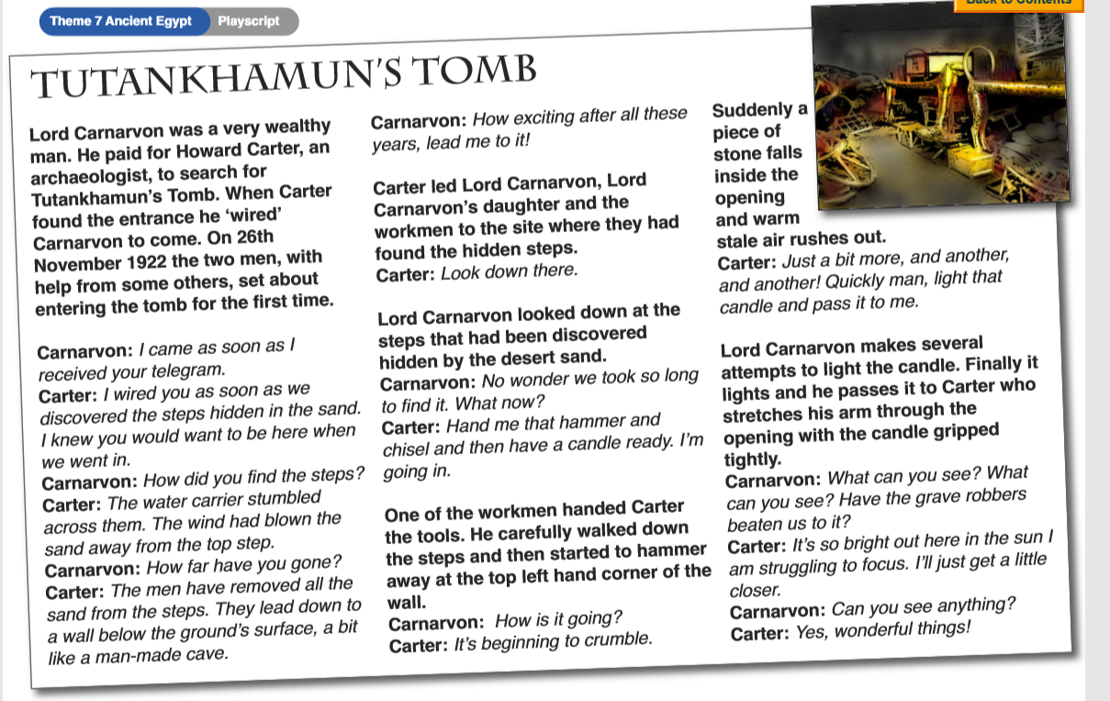
Questions
