Week 2 Year 2 Monday 30th March 2020
LO: To practice the 3 times table
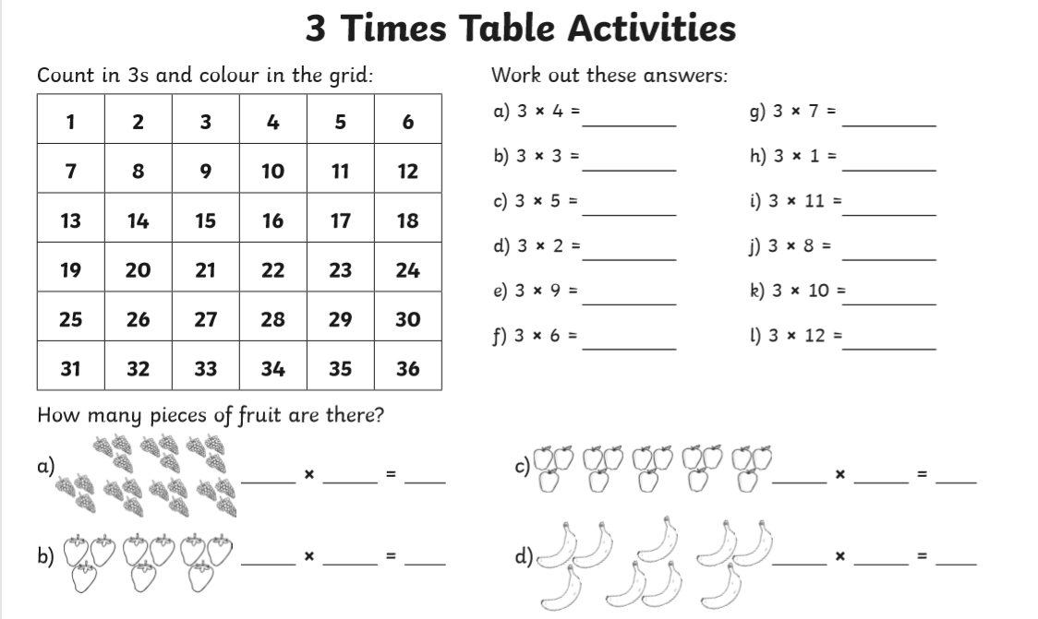

REMEMBER: Spend at least 10 minutes a day memorising your times table!

SPECIAL PRIZE:
If you memorise all of the times tables when you return to school

Week 2 Year 2 Tuesday 31st March 2020
L.O: To understand unit fractions

Challenge

Week 2 Year 2 Wednesday 1st April 2020
L.O: To find a fraction of the total

Make sure you explain your answer as best as you can.

Week 2 Year 2 Thursday 2nd April 2020
L.O: To understand unit fractions

Draw the table in your book

Week 2 Year 2 Friday 3rd April 2020
L.O: To find a fraction of the total

Make sure you explain your answer as best as you can.

