Monday 30th March 2020
Handwriting practise
Note-Practise writing the letter below in your best handwriting in your book. Do not forget your finger space.

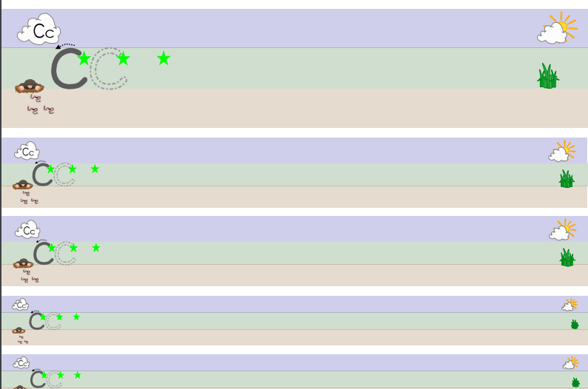

Tuesday 31st March 2020
Handwriting practise
Note-Practise writing the letter below in your best handwriting in your book. Do not forget your finger space.

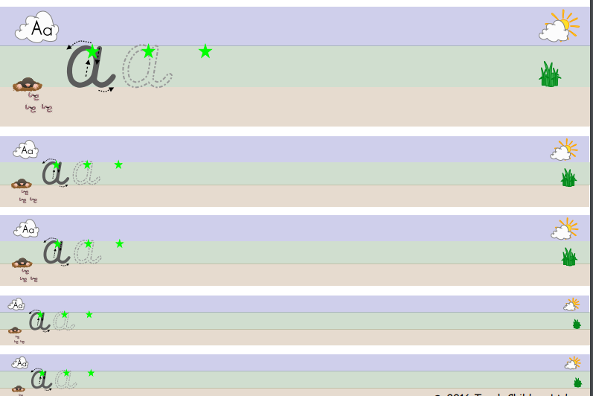

Wednesday 1st April 2020
Handwriting practise
Note-Practise writing the letter below in your best handwriting in your book. Do not forget your finger space.

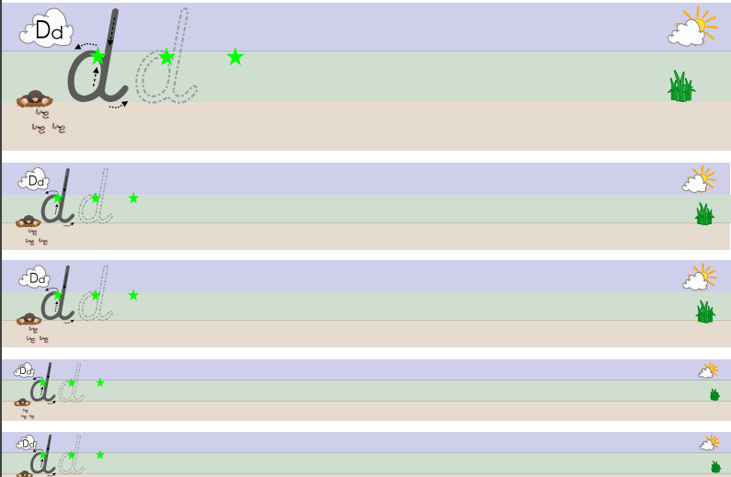

Thursday 2nd April 2020
Handwriting practise
Note-Practise writing the letter below in your best handwriting in your book. Do not forget your finger space.

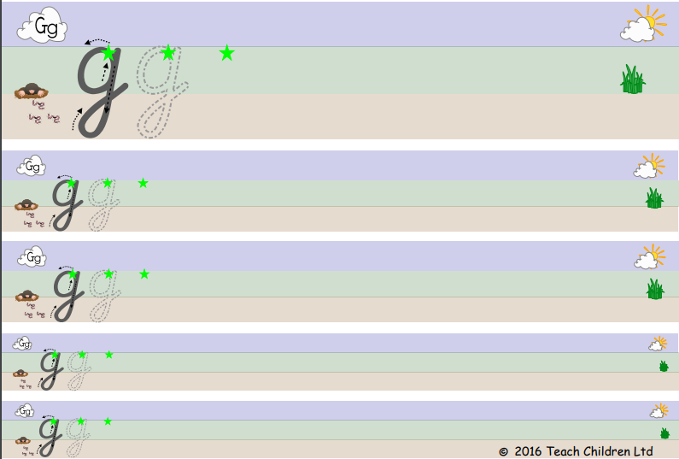

Friday 3rd April 2020
Handwriting practise
Note-Practise writing the letter below in your best handwriting in your book. Do not forget your finger space.

