Last time, we talked about how to make wudhoo in class . We make wudhoo before we pray.
But do we need to make wudhoo each time we pray?

No.
There are some things which we do which ‘break’ our wudhoo.¹
If we do these things which break the wudhoo and then we want to pray, we have to make wudhoo again.
What are those things that break our wudhoo? Let us talk about some of them.

1

If you go to the toilet, then that breaks your
wudhoo.

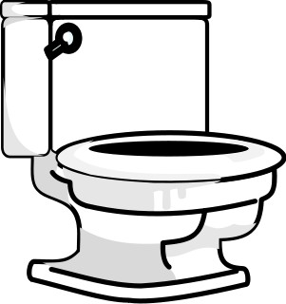

If you pass wind from your bottom, then that also breaks your wudhoo.

(Not that kind of wind!)

If you lie down and go to sleep, then that breaks your wudhoo.
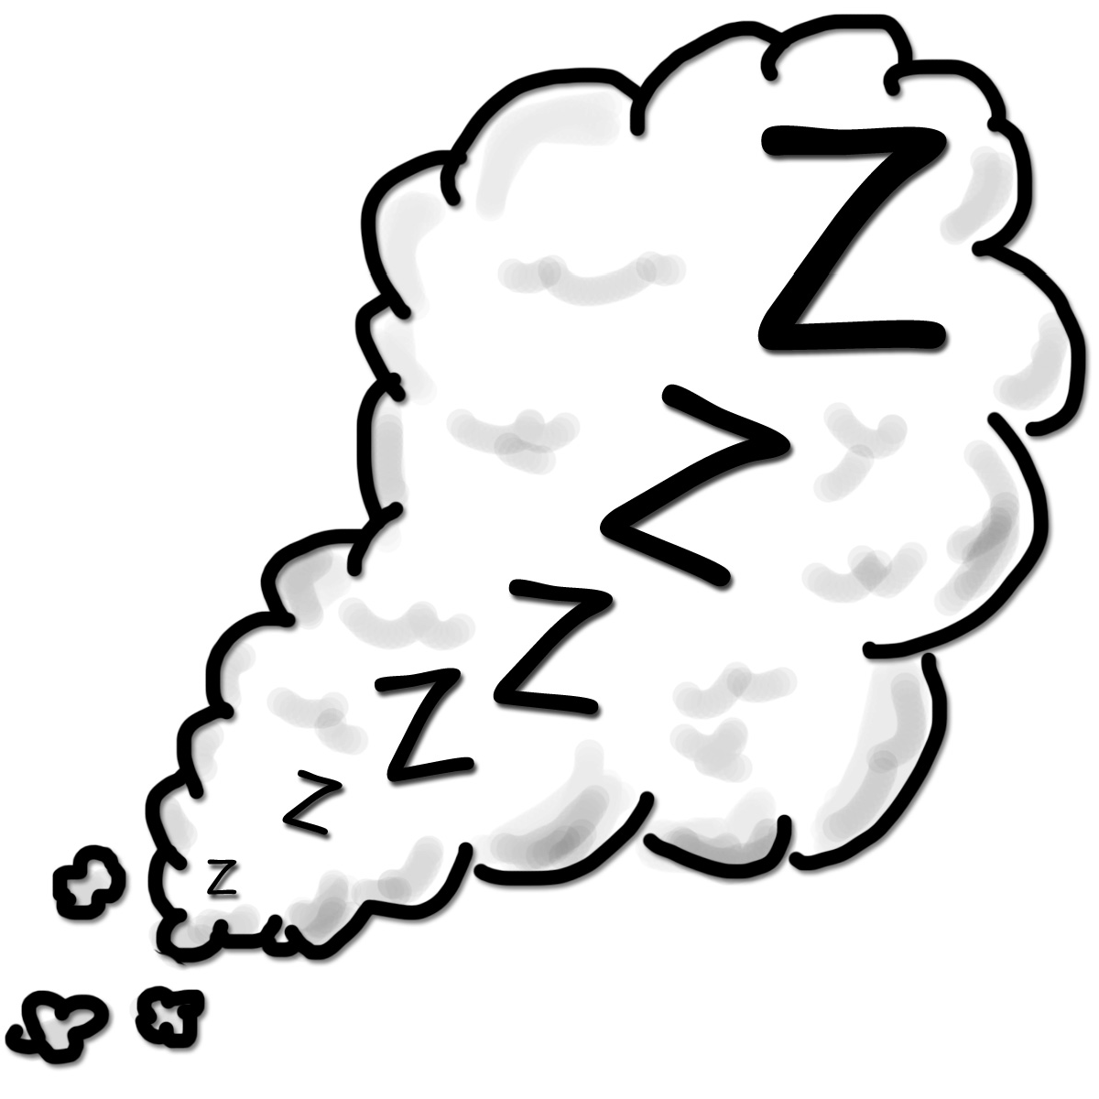

Sometimes if we are very poorly, our brains go to sleep in a different way. It is called being unconscious.
People cannot wake us up when we are like this until we get better.

That breaks our wudhoo as well.

What about things which do not break our
wudhoo?
If we vomit (we are sick) or if have a nosebleed, then that does not break our wudhoo.

If we take our clothes off to get changed, then that does not break our wudhoo.

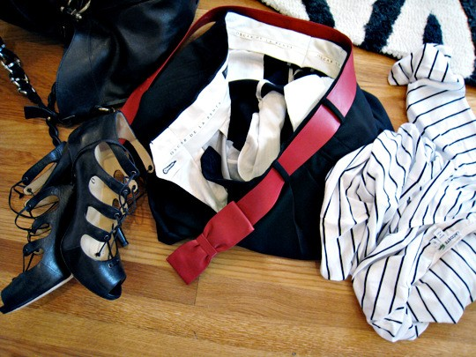

If we sweat after running around a lot, that does not break our wudhoo.

If we get mud on our hands that does not break our wudhoo.
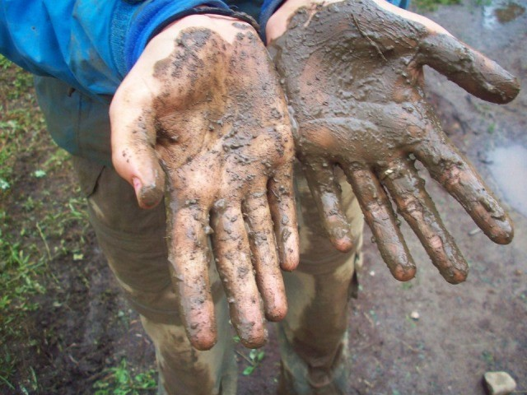

We just wash our hands to make them feel nice and clean.

Even though these things do not break our wudhoo, if we want to make wudhoo again anyway, then that is OK.
Allah has made it easy for us to make wudhoo. He has given us lots of water.

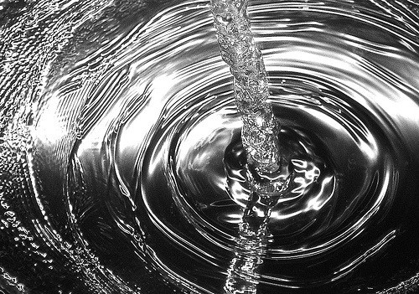

How kind Allah is to us.

Test yourself with a family member!

Say whether each of these will break your wudhoo:
- Going to the toilet
- Sweating when you are hot
- Taking your jumper off
- Going to sleep at night
- Doing a burp

Can you fill in the missing words?
When we make wudhoo, we use ***** to wash parts of our body. Some things that we do break our wudhoo; that means we have to do wudhoo again if we want to do our ******.
When we go to the toilet, our ****** is broken. When we go to bed at night or even during the day, and we fall ****** then that also breaks our wudhoo.
Many things do not break our wudhoo, like if we fall over outside and get *** on our hands.
How do we know what breaks our wudhoo? We know because our ******* told us about those things.

Revision:
  - How many times do we wash our face when we make wudhoo?
  - How many times do we wipe our head when we make wudhoo?
  - Do we wash all our legs when we make

wudhoo?

Key points for parents :

The things which nullify the wudhoo include:
  - Emissions from the front or back passage e.g. urine, stool, wind, preseminal discharge, etc.
  - Falling into a deep sleep
  - Loss of consciousness
  - Touching one’s private parts although parents should be aware that there is some difference of opinion between the scholars on this issue.
  - Eating camel’s meat

The teacher may also wish to highlight that not everything that the child considers to be dirty will break the wudhoo e.g. getting mud on the hands.
Likewise, not everything that breaks the wudhoo is something “dirty” e.g. going to sleep in a clean bed with clean clothes after having a shower will still cause the wudhoo to be broken.
This may be an opportunity to teach the child that one does not have to wait for the prayer to come before making wudhoo. The act of making wudhoo carries much reward in and of itself, even if the person is not going to pray his prayers immediately afterwards. ²

² It is narrated from some of the salaf that they would like to be in a continual state of wudhoo e.g. Bilal radi Allaahu ‘anhu – and this was one of the reasons why the Prophet sall Allaahu ‘alaihi wa sallam heard his footsteps ahead of his own in Paradise. (Saheeh al Jaami’ as Sagheer 7894)

