Shapes
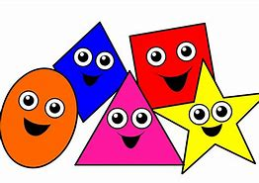
Have a look around your house what can you see.

What shape is your tv?

What shape is you table?

What shape is your clock?

What shape is your plate?

Draw your shapes

Can you draw a circle shape?

Can you draw a triangle shape?

Can you draw a square shape?

Can you draw a rectangle shape?

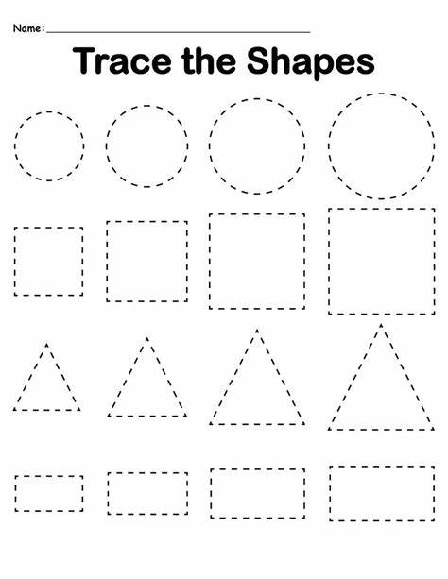

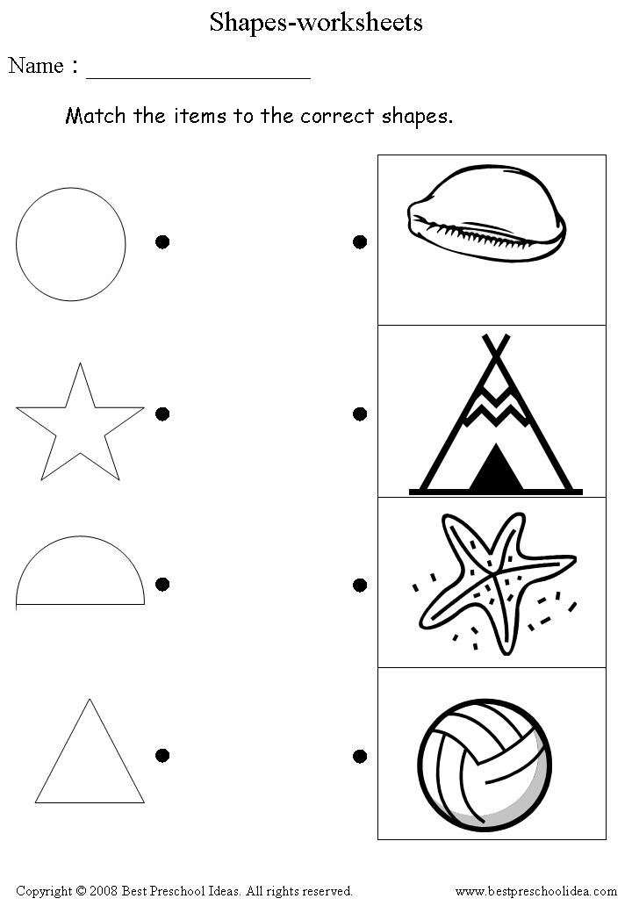
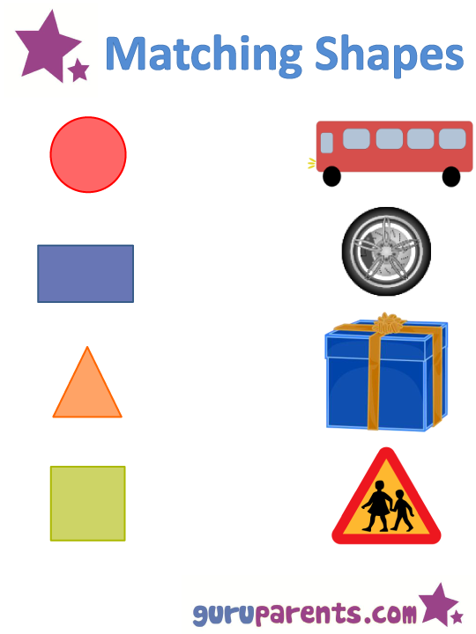

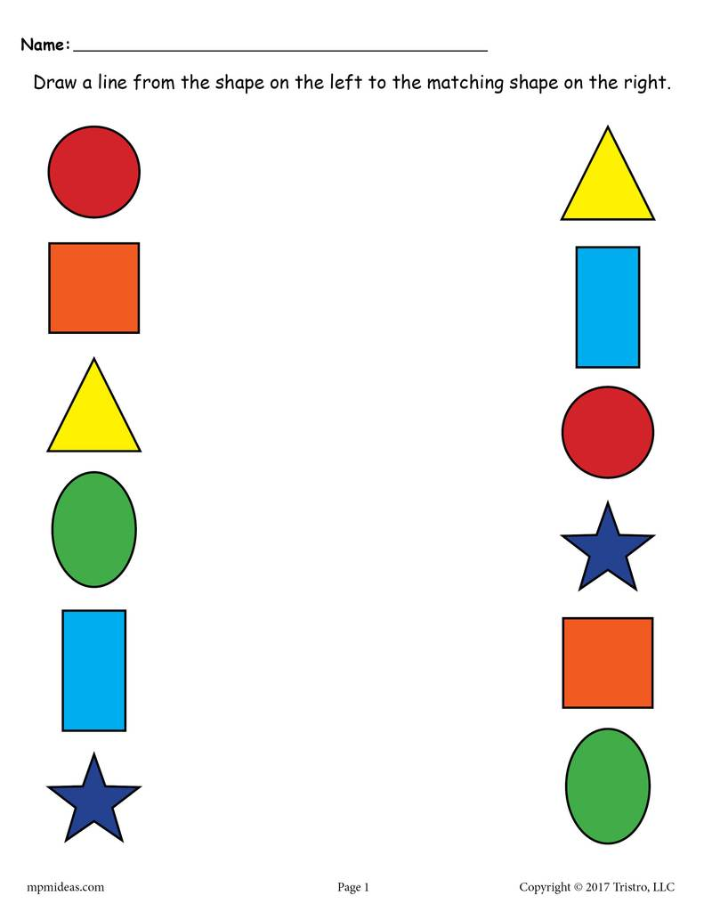

Shapes

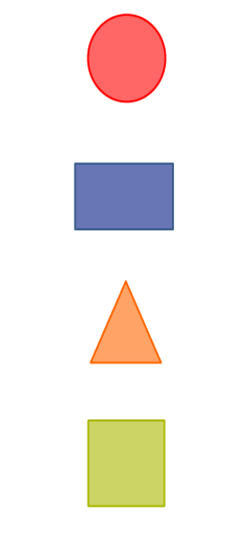
How many sides does a circle have?
What item shaped like a circle:
- A door
- A coin
- A car

How many sides does a rectangle have?
How many corners does a rectangle have?

How many sides does a triangle have?
How many corners does a triangle have?

How many sides does a square have?
How many corners does a square have?

