Wb. 30.03.20

Monday 30.03.20 – Reading Comprehension
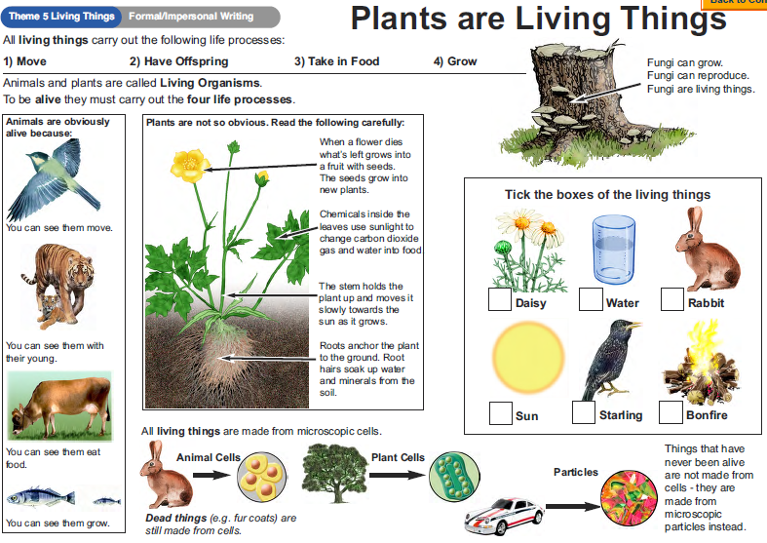
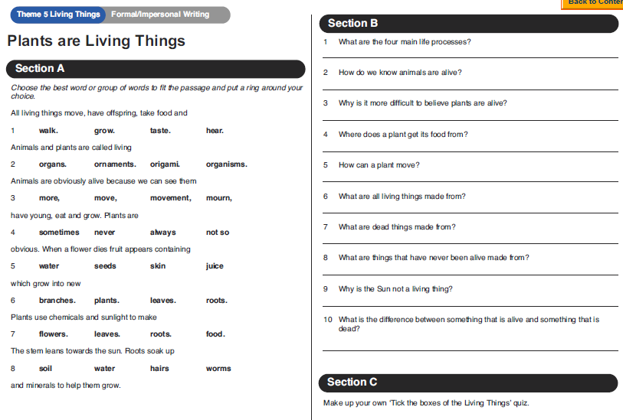

Tuesday 31st March 2020 – Grammar

Please complete the work on noun phrases by improving the sentences. Please start from D (Developing) and work your way up to GD (Greater Depth). Those who are in Commas, please make sure you find alternative adjectives for the activities in D (Developing).
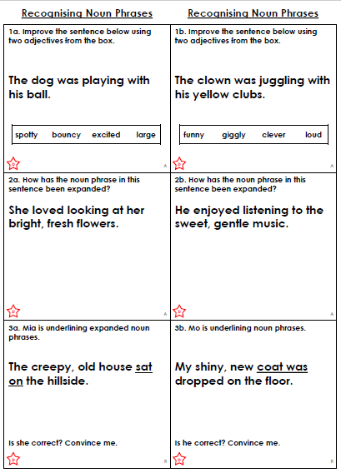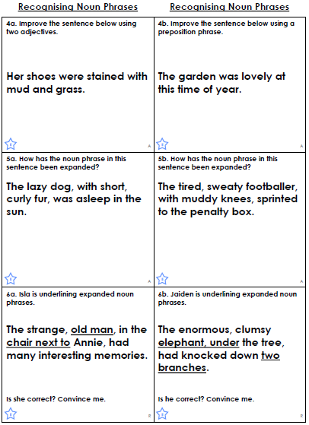
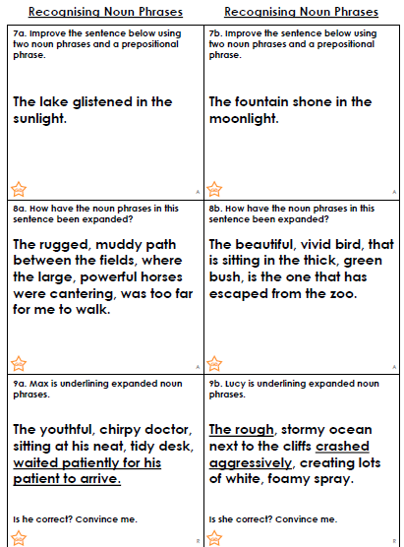

Wednesday 1st April 2020 – English Writing – Fantasy Story using expanded noun phrases

Please follow the link below to write your fantasy story based on this short clip. Remember to use what you’ve practiced/reviewed in Grammar this week (expanded noun phrases).

In you creative writing piece:
Must: include expanded noun phrases using strong adjectives
Should: use powerful verbs
Could: use different adverbials
Those who are in Commas, it is expected to see lots of powerful verbs and different adverbials (adverbials of time, place, and manner) as well, for description.

https://www.literacyshed.com/onceinalifetime.html

Once In A Lifetime

Set in a fantasy world very much like Adrift. A man is sailing in his boat, through the air! He hears a noise and suddenly gliding into view are some giant, flying turtles.

- Collect strong adjectives, noun phrases (adjectives with a noun) and expanded noun phrases (two adjectives with a noun)
- Collect verbs and adverbs to do with floating and sailing gracefully
- Think about the ending to the story, where do these turtles take him?

E.g. The fluffy light clouds drifted passed him as he pondered on where this mad but wondrous flying contraption would carry him. He longed to see pass the plump cotton balls that hung in the soft light purple skies; however, all he could make out through his glistening eyes was continuous endless skies before him.
*in black are examples of expanded noun phrases
* in red are examples of powerful verbs
* in green are adverbials of manner
Thursday 2nd April 2020 – Reading – Journal Writing

Choose a chapter book that you enjoyed and you know well.

- Think about how does the author set the atmosphere/mood at the beginning (what words, or punctuations do they use that may create the mood/feeling/atmosphere)?

- How are the characters described/ portrayed? Give some examples of this from the text.

- How is the setting of scene given to the reader? Give some examples of this from the text.

- Does the author give hints of the ending? Are you able to predict the future events before even finishing the book? How does the author do that? Give examples from the book.

- Why would you recommend this book?

- Finally, the overall rating of this book.

Friday 3rd April 2020 – Reading Comprehension
